WILLIAM TUDOR ApMADOC III
A Biography — Volume One: The Life
Sailor • Technologist • Photographer • Traveler
Compiled from official U.S. Navy service records, performance evaluations, letters of commendation and appreciation, academic and extracurricular records, professional recommendations, published photography credits, and passport and travel records.

Contents
Preface 3
Chapter 1 — Lake Country Beginnings (1952–1970) 4
Chapter 2 — Central Michigan, First Act (1970–1973) 7
Chapter 3 — The Navy Years: Atlantic Fleet (1973–1976) 8
Chapter 4 — The Navy Years: SEAL Team ONE and the Reserve (1976–1979) 18
Chapter 5 — Central Michigan, Second Act (1977–1981) 24
Chapter 6 — Four Decades in the Computer Industry (1981–2022) 27
Chapter 7 — The Photographer 36
Chapter 8 — A World Traveler (1985–2025) 38
Epilogue — The Trusted Resource 39
A Note on Sources 41

Preface
This biography of William Tudor ApMadoc III — known throughout his life simply as Tudor — is drawn entirely from primary sources: his United States Navy service record and performance evaluations, letters of commendation and appreciation from commanding officers and flag officers, school and extracurricular records, a published ACM conference paper, four decades of professional recommendations from colleagues and customers, documented photography credits and awards, and the entry stamps and visas of five passports spanning forty years.
Where this book quotes an evaluation, a citation, or a recommendation, the words are those of the original writer, reproduced from the source document and attributed. The result is a life told, in large part, in the words of the people who served with him, worked beside him, bought from him, and published his photographs.

Chapter 1 — Lake Country Beginnings (1952–1970)

From Wales to the Great Lakes
The name ApMadoc is Welsh — the old patronymic 'ap Madoc,' son of Madoc — and the family's documented story begins where the name does. John Maddock was born in Pembrokeshire around 1814; his son William was born on March 19, 1844, at Maesteg, Llangynwyd Parish, Glamorganshire, and baptized in 1848 under the anglicized family name, William Maddock. In 1864, at twenty, William emigrated to Utica, New York, and it is under the restored Welsh form of the name — William ApMadoc — that the family's American story is recorded. He married Elizabeth Jones, born January 12, 1843, in Ebenezer, Llanddeiniolen Parish, Caernarvonshire, Wales; both died in Chicago, William in 1916 (buried at Mount Hope Cemetery) and Elizabeth in 1923.
Their son William Tudor ApMadoc Sr. — the first to carry the name Tudor — was born in Utica on September 20, 1873, and took a degree from the University of Michigan in 1896. In 1908 he married Nelle Ina Gill, born in 1882 in Prairie City, Iowa, to a family with roots reaching back through Iowa to the Gills, Moores, Porters, and Stevenses of the mid-1800s. Their son William Tudor ApMadoc Jr. was born in Evanston, Illinois, on December 21, 1919, and made his career as a sales representative for Mead Johnson.
The maternal line came north by a different road. Fontie Claire Mahannah was born on May 19, 1922, in Memphis, Michigan, to Joseph Claire Mahannah — an Ohio-born son of a family that traces through Trumbull County, Ohio, to Nicholas Mahanna of Pennsylvania, born in 1802 — and Fontie Gray Harris, born in Mississippi in 1890. William Tudor ApMadoc Jr. and Fontie Claire Mahannah married in 1949 in Commerce, Michigan, and raised three children: Gwen Gray (born 1951), William Tudor III (born 1952), and Gill Claire (born 1955). The full documented family tree — 153 individuals across more than seven generations — appears in Appendix F.

Pontiac and Clarkston
William Tudor ApMadoc III — the middle child — was born on May 4, 1952, at St. Joseph Mercy Hospital in Pontiac, Michigan. The family lived in Walled Lake through the late 1950s, then moved to 6511 Cranberry Lake Road in Clarkston, Michigan — the address that would later appear on his Navy discharge papers — where Tudor would grow up, quite literally, on a lake.
The lake was his first economy. In early summer he caught baby turtles and sold them to the local Kresge store, an early sign of the entrepreneurial streak that would run through his boyhood: selling greeting cards door to door from ages twelve to fourteen, delivering newspapers at thirteen and fourteen, bagging groceries and stocking shelves at Rudy's Groceries at fifteen and sixteen, and selling magazine subscriptions door to door at seventeen and eighteen. From ages nine to fifteen he spent summers as a camper at Camp Mahn-Go-Tah-See, a YMCA camp in northern Michigan that would remain part of his life well into adulthood — he returned to work there in the summers of 1968 through 1972, and again from 1977 through 1980.

School Days in Clarkston
Tudor attended Clarkston Elementary School (grades one through five) and Clarkston Junior High (grades six through eight), then Clarkston High School for ninth grade, spent tenth grade at the Leelanau Schools in Glen Arbor, Michigan, and returned to Clarkston High for his junior and senior years.
His school records read like a catalog of restless energy. In elementary school there was a science fair exhibit on brine shrimp that took a blue ribbon in fourth grade, church choir, 4-H leather craft, Cub Scouts, school choir, and the AAA Safety Squad. Junior high brought the journalism club, the tennis team, projectionist duty, and a stint as library assistant.
Ninth grade at Clarkston High School established the pattern of everything that followed — technology, performance, photography, and organization, all at once. He joined the Audio-Visual Club and was elected its vice president in that first year, worked as audio technician for basketball games, and belonged to both the photo club and the French Club. The camera had arrived, and it would never really be put down.

The Leelanau Year
For tenth grade, he left home. The Leelanau School at Glen Arbor, Michigan, was a small college-preparatory boarding school founded in 1929 on the Lake Michigan shore, its wooded campus set where the Crystal River runs out into Sleeping Bear Bay — far up the northwestern coast of the Lower Peninsula, and a long way from the lake he had grown up on.
For a single school year, the record is remarkably dense. He was underclassmen editor and photographer for the yearbook Signpost, and a disc jockey and staff writer for radio station WELL — early practice at putting both words and images in front of an audience. He served as Social Representative, managed the basketball and tennis teams, and belonged to the Varsity Club. Onstage he appeared in The Music Man as a local townsperson. It was here that he started to get serious about photography, through the assistance of two mentors — one who really showed him the mechanics of how to take photos, as well as how to develop his own film and create his own prints; the other who showed him the artistic side of photography, composition, creative effects, and the rest.
The Report of Extra-Curricular Activities he compiled years later marks the year in the negative as much as the positive: his Audio-Visual Club membership is recorded as ninth, eleventh and twelfth grades, with tenth grade simply absent from the run. He returned to Clarkston High School for his junior and senior years.

Return to Clarkston
The Audio-Visual Club took him back and then handed him the top job: by twelfth grade he was its president, chairing the lunch music committee, the exchange trip committee, and the morning and afternoon announcements committee. He wrestled on the team in eleventh grade and managed the squad in eleventh and twelfth, keeping score for home meets and for the Oakland County tournament. In drama he moved behind the scenes, working lighting and set committees for Arsenic and Old Lace and Oklahoma! as a junior, and for Charley's Aunt and South Pacific as a senior.
He was photographer for the school paper Wolf Cry as a senior, a member of Hi-Y in eleventh and twelfth grades, an ALSAC marcher, lighting committee chairman for the Junior Miss Pageant, host for a student government exchange day with Pontiac Central, and a member of the Shortwave Listening Club of America under the call sign WPE 8 JTG.
Academically, his senior year showed a scientist in the making: a senior research topic on an enclosed ecological system for a mouse, genetics lab research preparing a chromosome slide, service as ecology lab assistant, and representative to the Rotary Club from the high school. And the research paper on the assassination of John F. Kennedy, begun that year at Leelanau, came in at 300 pages.

DeMolay
Parallel to school ran an intense career in the Order of DeMolay, the Masonic youth organization. Initiated into Cedar Chapter on November 16, 1966, and receiving the DeMolay Degree on December 27 of that year, he went on to a knighthood investiture in November 1969, the Degree of Ebon in April 1970, and the Degree of Anon in November 1971. He held office after office: Senior Steward (spring 1967), Treasurer (fall 1968 to spring 1969), Senior Deacon (spring 1970), District Representative (1970–1971), and District 10 Junior Deacon. In the Priory he served as Preceptor and then State Preceptor in 1970, was elected Marshal of Camelot Priory in spring 1971, became Illustrious Knight Commander of White Pine Priory in fall 1971 — having helped reactivate that Priory — and served as State Marshal that same fall.
He chaired committees for auditing, the chapter's 50th anniversary, road rallies, district and state awards programs, and Cedar Point outings; conducted schools of instruction across Districts 5, 6, and 10; served on investigation teams; and later set up the Central Michigan University DeMolay Club. His DeMolay honors included the Representative DeMolay award (February 1970), a leadership correspondence course, the Cross of Chivalry, the Brotherhood Cross, the Medal of Victory, and certificates of Progress, Achievement, and Chivalry. When he moved to Mt. Pleasant for college he affiliated with the Mt. Pleasant Chapter in February 1973, serving as its Senior Steward, District Representative, and District 5 & 6 Marshal before reaching majority — aging out — on his twenty-first birthday, May 4, 1973, barely a week after he entered the Navy.

Chapter 2 — Central Michigan, First Act (1970–1973)
In the fall of 1970 Tudor entered Central Michigan University in Mt. Pleasant, enrolled in the honors program for biology. The pace he had set in high school did not slacken. As a freshman he was elected corridor representative for the dorm council and dorm treasurer, sat in the Residence Hall Assembly, and chaired both the finance committee and the television, stereo, and appliance committee. He served as assistant instructor for a zoology lab section — an undergraduate teaching a university lab — and volunteered at the university's Center of Cultural and Natural History, where his work earned him a grant.
The theater work continued too, now behind the scenes: set construction for Rashomon, set construction and shift crew for Noye's Fludde and La Serva Padrona, assistant stage manager for The Drunkard's Fate (in charge of a ten-person set construction and shift crew), lighting technician for Play It Again, Sam (leading a crew of three), and assistant stage manager for Arsenic and Old Lace (crew of twelve) and J.B. (crew of eight). Off campus he officiated wrestling for the Michigan High School Athletic Association, joined the Mt. Pleasant Food Co-Op and the Mt. Pleasant Tenants Union, and founded and served as president of the CMU DeMolay Club.
He studied at Central Michigan from 1970 to 1973. Then, in the spring of 1973, with the Vietnam era still running its course, he made a decision that would define the next four years: he enlisted in the United States Navy.

Chapter 3 — The Navy Years: Atlantic Fleet (1973–1976)

Enlistment and Boot Camp
Tudor enlisted in the U.S. Naval Reserve on March 28, 1973, and was discharged from the Reserve on April 24, 1973, to enlist in the regular Navy, entering active duty through the Armed Forces Examining and Entrance Station in Detroit on April 25, 1973 — three weeks before his twenty-first birthday. His aptitude scores marked him immediately: an Armed Forces Qualification Test score of 93, and Basic Test Battery scores of GCT 64, ARI 64, MECH 68, CLER 69, SONAR 70, ETST 70, and SHOP 64. As the Bureau of Naval Personnel manual noted at the time, scores above 64 were rated 'high' and included only about seven percent of all enlisted personnel.
He went through recruit training at the Recruit Training Command, Naval Training Center Great Lakes, Illinois, from April to June 1973, entering service as a Seaman Apprentice (E-2). What followed was not the boot camp most sailors remember.

A Boot Camp of His Own
It began conventionally enough. During the training cycle he was assigned as his company's Recruit Company Master-at-Arms — the recruit leadership billet answerable to the company commander for good order, discipline, and inspection readiness within the company. It was the first time the Navy picked him out for responsibility, within weeks of his arrival, and it would not be the last.
Then the assignments began to multiply. Someone noticed he could type, and he was made battalion administrative assistant — typing up reports and performance reviews, running messages, and handling the paper that a battalion generates. It was, in miniature, the job he would hold for the next four years, and he was doing it before he had finished recruit training or seen a day of Personnelman school. The Navy had identified his rating by watching him work.
He was also assigned to work alongside the battalion maintenance worker, and became the on-site after-hours maintenance man, entrusted with the keys to the tool and supplies locker — the person who stayed behind to handle whatever broke when the day shift had gone home. And he joined the Navy Blue Jacket Choir, which performed at events on the base and at churches throughout the surrounding communities: the drama and choir kid from Clarkston, singing his way through basic training.
The practical consequence was a recruit experience unlike his shipmates'. Rather than marching through the standard syllabus with everyone else, he was handed a weekly list of the classes he genuinely needed to attend; the remaining hours belonged to the admin office, the maintenance shop, and the choir. Three jobs and a schedule of his own, at twenty years old, inside an institution built on uniformity. It is the earliest and most literal instance of the pattern that runs through everything that follows in this book: give the man a system, and he will end up running part of it.

First in His Class
From Great Lakes he was ordered to Personnelman 'A' School at the Service School Command, Naval Training Center Orlando, Florida, from July 9 to August 24, 1973. He finished the seven-week course with an overall academic average of 94.15 — first in his class of sixteen. The Commanding Officer of the Service School Command put it in writing on August 23, 1973:
You are to be commended for your accomplishment in the Personnelman Class “A” course of instruction, which you completed with an overall academic average of 94.15, standing first in your class of 16. Not only have you earned your instructors' respect and admiration for this achievement, but you have made a distinct contribution to the effectiveness of class instruction through your active and intelligent participation. It is with great pleasure that I extend my personal congratulations for your accomplishment and the best wishes of the Service School Command staff for continued success in your naval career.
— Commanding Officer, Service School Command, NTC Orlando, Letter of Congratulations, August 23, 1973 (name not legible on the surviving copy)
The letter was forwarded to his new command, Harbor Clearance Unit TWO, whose commanding officer, G. Whitaker, endorsed it on September 6, 1973:
Delivered with my sincere congratulations.
— G. Whitaker, Commanding Officer, Harbor Clearance Unit TWO, first endorsement, September 6, 1973

Harbor Clearance Unit TWO, Little Creek
On September 4, 1973, Personnelman Seaman Apprentice ApMadoc reported to Harbor Clearance Unit TWO (HCU-2), the Atlantic Fleet's salvage and diving unit based at the Naval Amphibious Base, Little Creek, in Norfolk, Virginia. He would serve there for nearly three years, as personnelman and — increasingly — as photographer. His early collateral duties tell the story of a junior sailor being handed responsibility: mail orderly and message pick-up (with a Secret clearance granted September 19, 1973), military pay orderly, and later photographic liaison assistant and recreation committee member.
His first evaluations were candid, and not all flattering — which makes the arc that followed all the more striking. His first report, covering September 1973 to March 1974 and signed by the commanding officer himself, described a young sailor still finding his footing:
Since reporting to this command PNSA ApMADOC's performance has been sporadic, ranging from good to below average. He lacks the initiative to “dig in” and complete pending work assignments... While it is evident that his work may not always be the best... he can produce much better... He has produced some top quality photographic work for the command [and] shows much more interest in the photographic field than in personnel work; however, through counselling he has learned to accept the field.
— G. Whitaker, Commanding Officer, Harbor Clearance Unit TWO, enlisted performance evaluation, period ending March 1, 1974
The September 1974 report was similarly blunt:
This reporting period PNSA ApMADOC's performance has remained sporadic. ApMADOC shows little or no motivation for advancement to PN3... [He works] well with others and promotes good morale. As the command's photographer he has done an outstanding job.
— G. D. Thomson, LT, USN, enlisted performance evaluation, period ending September 1, 1974
The camera, it turned out, was the first thing the Navy noticed about him. Then, steadily, everything else caught up. His evaluation for the period ending February 28, 1975, recorded the turn:
During this reporting period PNSN ApMADOC's performance has improved greatly, requiring very limited supervision to complete a job. During this reporting period the command was commended for achievement of an error rate of 1.6% in JUMPS procedures, an accomplishment directly related to his efforts. He is quick to help a shipmate in any problem in which he can be of assistance... He still needs to work on his military behavior; he is sometimes too quick to argue with his senior petty officers. He has been trying to improve himself by taking college classes in his off-duty hours. He has acted as the command photographer and continues to do an outstanding job.
— Enlisted performance evaluation, period ending February 28, 1975, signed by his reporting senior, a lieutenant commander whose signature is not legible on the surviving copy

The N&W Wetslip Salvage
In early 1974, HCU-2 was tasked with surveying and clearing submerged vessels and debris from the Norfolk & Western wetslip at Naval Station Norfolk, ahead of a dredging contract needed to place the floating drydock AFDM-7 in operation. The unit mobilized and finished ahead of schedule. The Commanding Officer of Naval Station Norfolk wrote on April 17, 1974:
[The work] was not only recognized by the Navy community, but received area-wide recognition via the television media... [The officers and men] worked many hours, at times under difficult conditions, to bring the clearance task to a successful, timely completion... The effort applied to subject task completion has saved the Navy many thousands of dollars. Please convey my personal thanks to the officers and men responsible for this splendid performance for a job well done.
— Commanding Officer, Naval Station Norfolk, letter of April 17, 1974 (signature not legible on the surviving copy)
Commander Service Squadron EIGHT forwarded the letter, and HCU-2's commanding officer added a second endorsement addressed personally to PNSN W. T. ApMadoc III on April 30, 1974:
The contents of the basic letter and first endorsement are noted with pleasure. I wish to add my personal appreciation for a job “Well Done”.
— G. Whitaker, Commanding Officer, Harbor Clearance Unit TWO, second endorsement, April 30, 1974

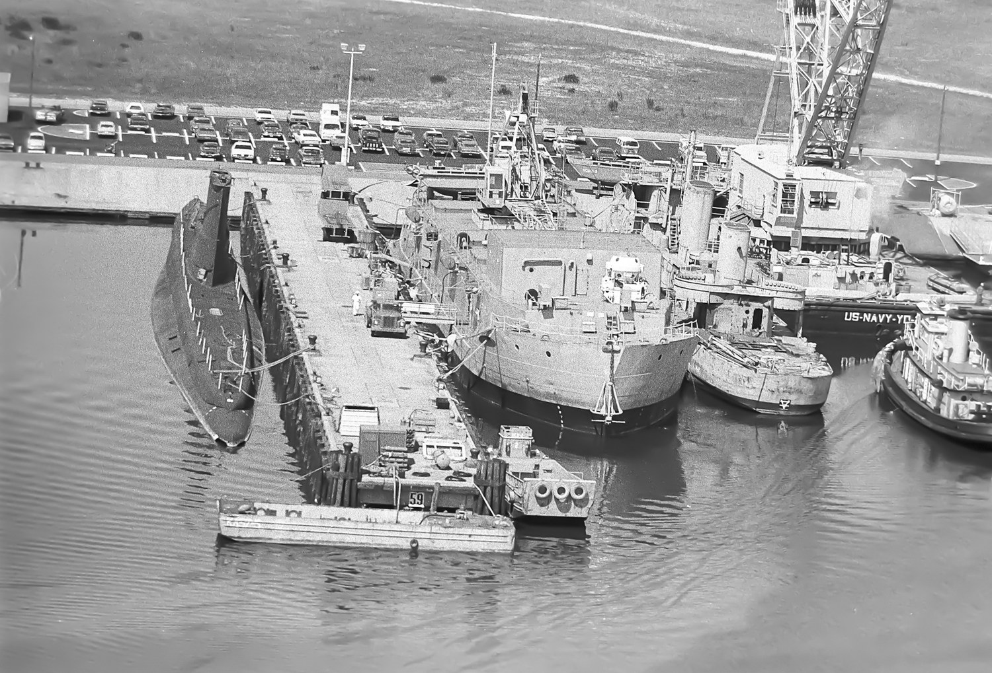  The Norfolk & Western wetslip from above, with barges, tugs and crane barge working the clearance. The scale of the obstruction that had to be removed before dredging could begin is plain. | 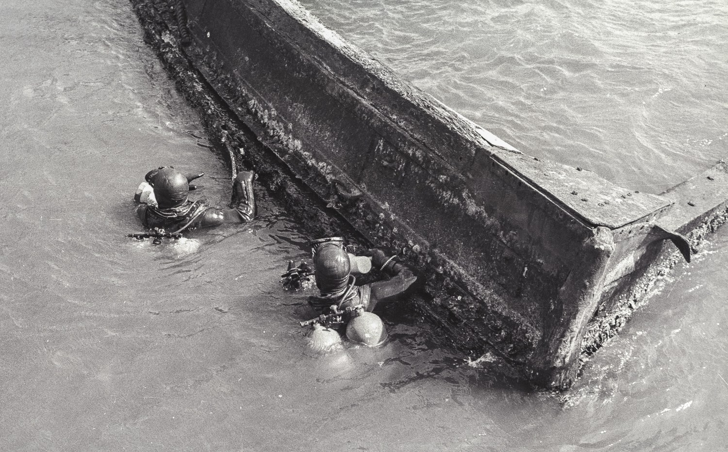  Divers in the water alongside a partially raised wooden hull. The clearance was carried out through the winter and early spring of 1974, at times under difficult conditions.
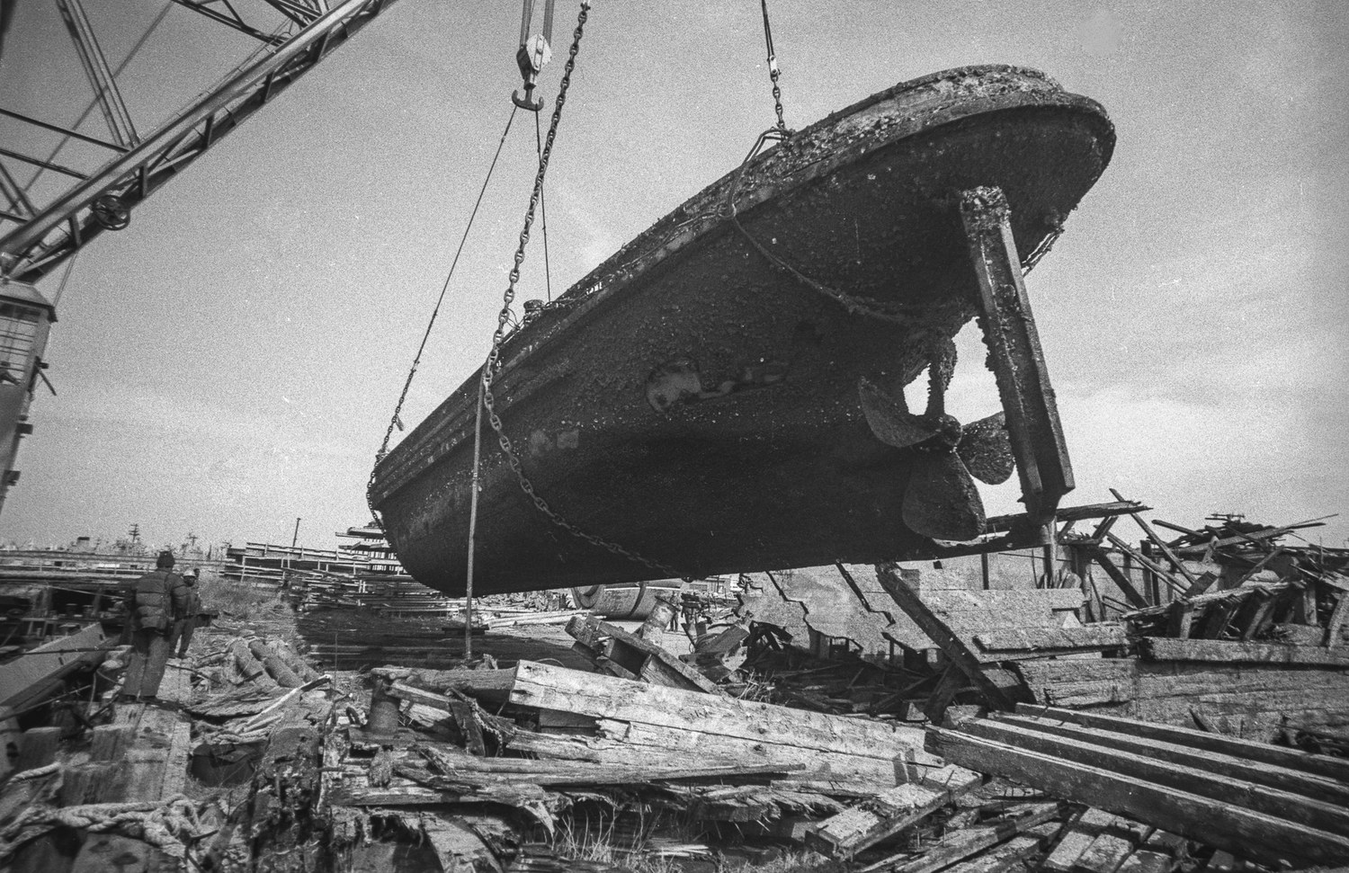  A recovered hull lifted clear of the water over the debris field, silt still streaming from the timbers. | 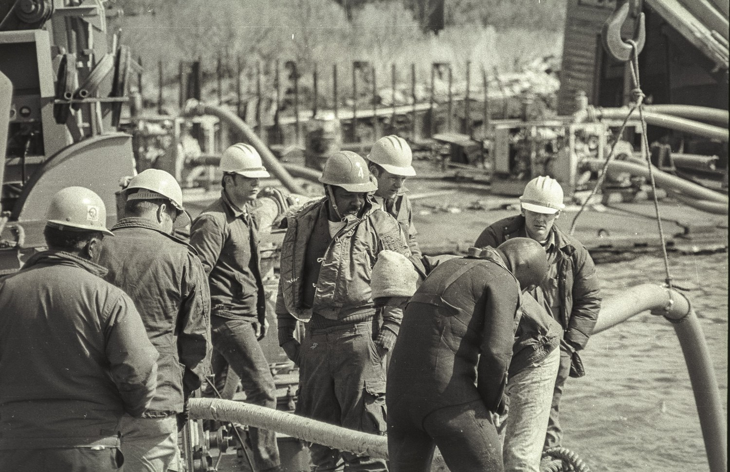  Harbor Clearance Unit TWO personnel at work on the barge deck during the clearance operation.

The World Record Dive — 1,148 Feet
The defining event of his Atlantic Fleet tour came in June 1975 — and the way he got there says as much as the record itself. HCU-2 operated the Navy's Mark 1 Deep Dive System (Mk 1 DDS), installed aboard the diving tender YDT-16 — a 2,000-ton, 260-foot barge equipped with deck decompression chambers, a personnel transfer capsule, helium reclamation, and gas mixing plants. In March 1975 the salvage ship USS RECOVERY (ARS-43) towed YDT-16 from Little Creek to Panama City, Florida, and through April and May the HCU-2 crew performed work-up dives and saturation diving training.
ApMadoc deployed with the system on independent duty — as a Personnelman Seaman, an E-3. For a seaman not yet a petty officer to be assigned independent duty, serving as the deployment's only personnelman/yeoman with no supervisor of his rating anywhere aboard, was beyond rare; independent-duty billets are normally the province of seasoned petty officers. It was an extraordinary statement of the trust his superiors placed in him. He stood radio and security watches, ran the mail, built an administrative office from scratch, and served as ship's photographer, all while the most ambitious diving operation in the Navy's history assembled around him.
On June 3, 1975, a joint team of U.S. Navy and Royal Navy saturation divers left the surface in the Mk 1 DDS deck chambers. Over the following days, operating about 80 miles southwest of Panama City in the Gulf of Mexico, the team shattered the world open-sea diving record — not once but three times in a single day. EN2 Joseph L. Bennoit swam out of the personnel transfer capsule at 1,030 feet, exceeding the previous U.S. Navy open-sea record of 1,010 feet; HMCS Lowell E. Burwell then exited at 1,130 feet; and ETC William R. Rhodes logged the deepest dive to date at 1,148 feet, joined in the record series by CPO Victor J. Humphrey of the Royal Navy. The divers surfaced on June 18, 1975, after fifteen days in the system, eleven of them spent in decompression. The Navy's official account of the dive lists PNSN W. T. ApMadoc among the HCU-2 support personnel who made the record possible.
Congratulations poured in from the very top of the Navy. The Commander in Chief, U.S. Atlantic Fleet — Admiral Isaac C. Kidd Jr. — signaled on June 17:
To the U.S. and British divers and support personnel of the Mark 1 Deep Dive System, I extend my admiration and congratulations. The completion of your saturation dive to 1148 feet marks the Navy's deepest penetration of inner space and an important step toward our ultimate goal of 2000-foot dives... Long have I recognized that saturation diving requires an all-round man with multiple skills. These skills, acquired and maintained through rigorous daily regimen, have enabled you to accomplish this momentous achievement in a routine fashion. The entire Navy is proud of your accomplishment. Bravo Zulu.
— Admiral Isaac C. Kidd Jr., Commander in Chief, U.S. Atlantic Fleet (CINCLANTFLT), naval message, June 17, 1975
The Commander, Naval Sea Systems Command signaled his own congratulations:
[The achievement is] noted with a sense of great personal pride in our diving Navy. This is the first time man has reached this depth at ambient pressure... Please express my personal well done to all hands that have made this achievement possible.
— Commander, Naval Sea Systems Command, naval message, June 1975
The Navy Experimental Diving Unit added its congratulations 'to the officers and men of Harbor Clearance Unit TWO on the achievement of the world's open sea diving record... Bravo Zulu.' And the Commander, Service Squadron EIGHT addressed every member of the unit directly:
This achievement reflects the professional efforts of many... To each and every man of HCU TWO, diver and support personnel, I congratulate you on a job extremely well done.
— Captain G. E. Jacobsen Jr., Commander Service Squadron EIGHT, naval message, June 16, 1975
On July 29, 1975, the Officer-in-Charge of YDT-16 issued ApMadoc a personal letter of appreciation for outstanding performance during the record dive:
The motivation displayed by you as a part of the Mark One team to successfully complete a satisfactory record dive is viewed with appreciation and congratulations... Your long hours of training and hard work plus the can do attitude displayed the mark of a superior sailor. You are to be proud of your accomplishments of the Mark One Deep Dive System.
— D. R. Roberts, CWO2, USN, Officer-in-Charge, YDT-16, letter of appreciation, July 29, 1975
Several of his photographs from the deployment were later submitted to ALL HANDS, the Navy's magazine, for a story about the Mark 1 Deep Dive System, and others were selected for use by Navy recruiting offices.

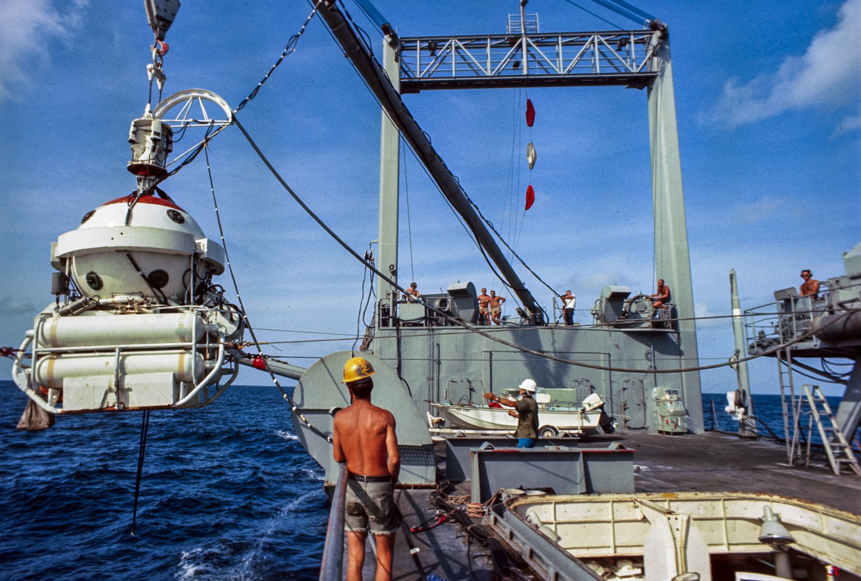  The Personnel Transfer Capsule suspended outboard of YDT-16, the deck gantry and support crew visible aft. The capsule carried divers between the deck decompression chambers and working depth. | 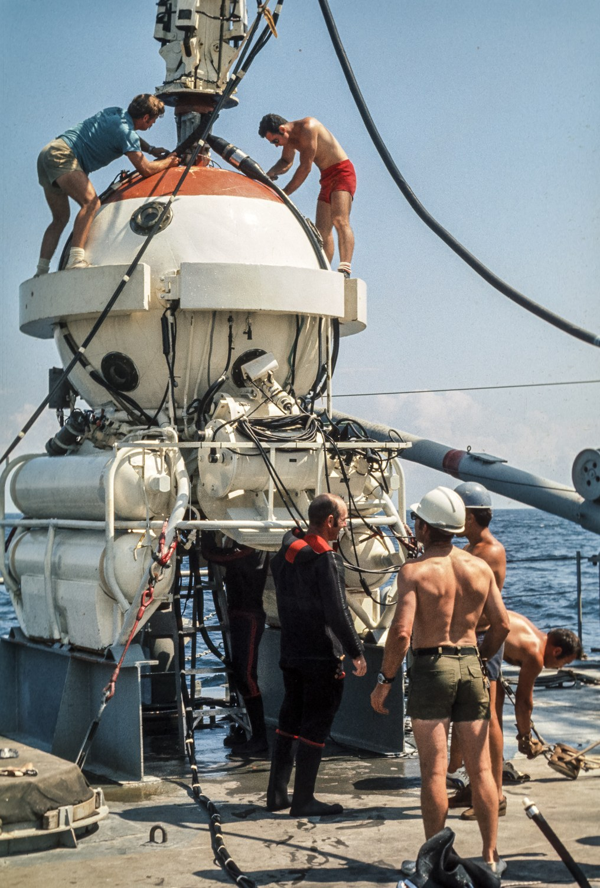  Crew working atop the Personnel Transfer Capsule on deck between dives, the ballast cylinders and mating hatch clearly visible.
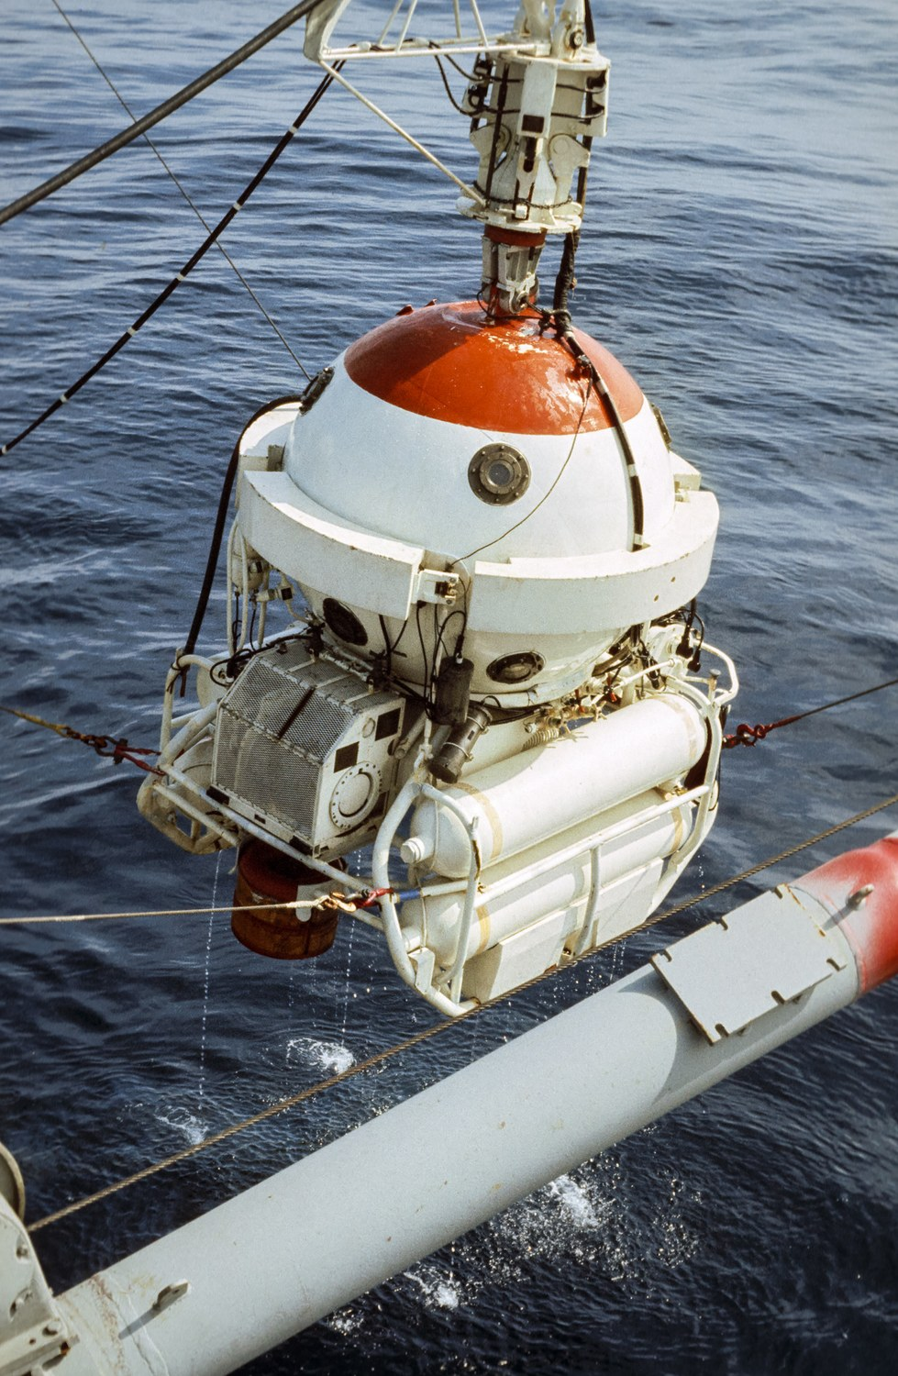  The capsule alongside, riding just above the surface as it is recovered from the water in the Gulf of Mexico. | 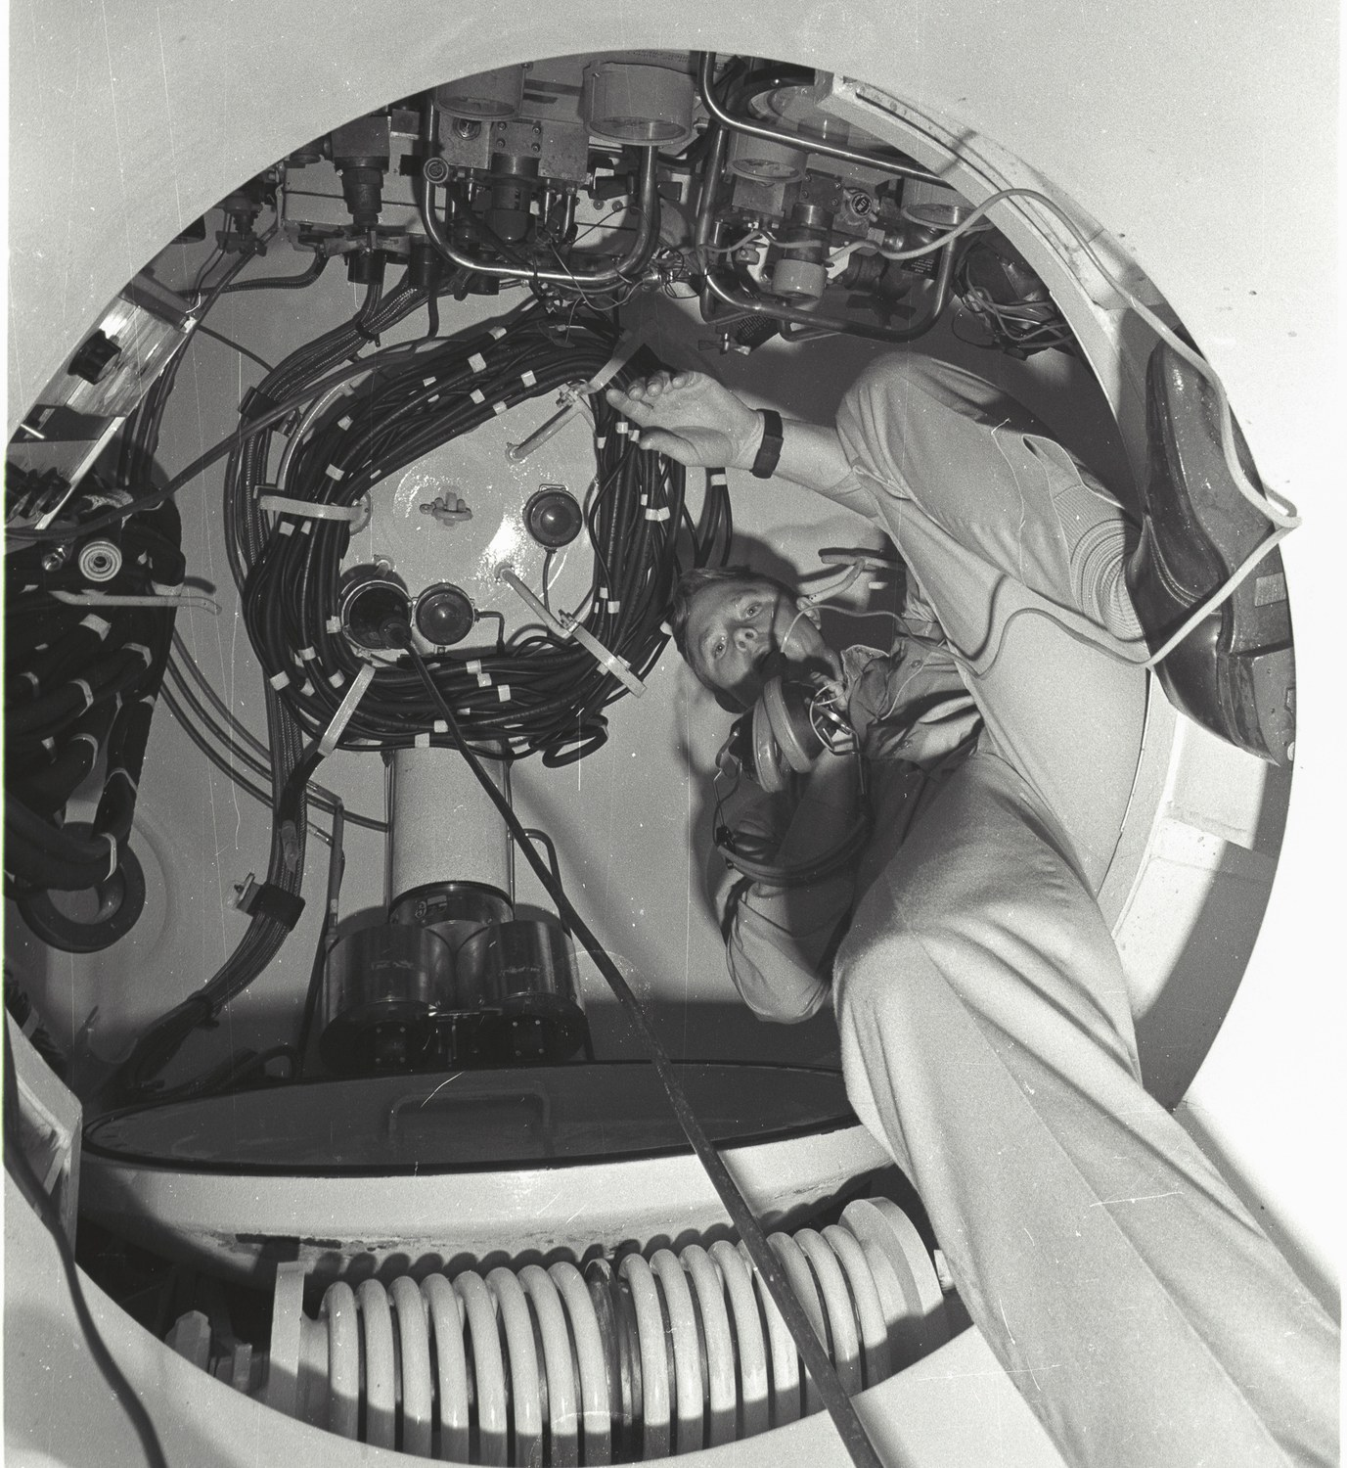  Inside the system: divers at work within one of the pressure chambers of the Mark 1 Deep Dive System.

Hurricane Eloise
The Mark 1 Deep Dive System stayed on at Panama City through the summer, and in September 1975 the Gulf of Mexico produced a hazard no amount of saturation training had prepared the crew for. Hurricane Eloise — which had formed east of the Virgin Islands on September 13, crossed Hispaniola and Cuba, and then re-intensified over the warm water of the southern Gulf — turned northeast and set course for the Florida Panhandle.
Navy practice in the face of an approaching hurricane is counterintuitive to anyone who has not thought it through: ships are not left in port. A vessel tied to a pier in a major storm is a vessel being driven against concrete and pilings by storm surge and wind, and the safest place for a hull is open water, where it has room to ride the weather out. So the fleet sorties — it puts to sea, deliberately, as the storm comes in.
For YDT-16 this doctrine had an unusual consequence. The diving tender was a 2,000-ton, 260-foot barge — no engines, no way to steer herself, and no ability to outrun anything. Getting her out of harm's way meant taking her under tow, and towing her clear of Panama City meant towing her out into the Gulf and directly into the path of the oncoming hurricane, with the crew aboard. Eloise came ashore near Panama City on the morning of September 23, 1975, a Category 3 storm with sustained winds of 125 miles per hour, gusts recorded near 155, and a storm surge that tore out piers and flattened beachfront buildings along the coast they had just left. Some 100,000 people evacuated the Gulf Coast ahead of it. The men aboard the Navy's deep dive system rode it out on the water.

Leading Personnelman at Twenty-Three
Promoted to Personnelman Third Class on July 16, 1975, and back at Little Creek once the Gulf deployment ended, ApMadoc shifted to the salvage craft tender YRST-2 as the only personnelman aboard, in charge of an office handling 110 staff records and 30 student records while standing quarterdeck watches. His commanding officer's evaluation for the period ending January 31, 1976 — a report whose marks reached 4.0 — captured both the workload and the way he carried it:
During this reporting period PN3 ApMADOC's performance has continued to improve. While with YDT-16 he carried out his responsibilities diligently as the only PN/YN onboard. He carried out duties in addition to his own by screening/pick-up of surplus items at DPDO's; he promoted education services by building a library of college catalogs onboard, and drove many times to Pensacola, Florida to pick up correspondence courses for members to work on while out to sea. He has accepted the responsibility of being Leading Personnelman of the personnel office onboard YRST-2 without complaint. Recently, given only 2 weeks in which to prepare the personnel office for an admin inspection, he willingly worked late many nights verifying all records. As a result, the command received a satisfactory grade upon inspection. He has maintained and refined his knack of obtaining answers to very unusual questions and problems posed.
— J. F. McColgan, LCDR, USN, Commanding Officer, Harbor Clearance Unit TWO, enlisted performance evaluation, period ending January 31, 1976
The external inspectors agreed. In May 1976 the Transient Monitoring Unit of the Enlisted Personnel Management Center inspected Norfolk-area naval activities and reported of HCU-2's personnel office:
Finding: Publications needed in the Personnel Office were updated, available, and followed. The PN3 responsible for the Personnel Office had recently corrected errors in the EDVR and service records. This activity is performing all functions well. Recommendation: Keep up the good work.
— Transient Monitoring Unit inspection report, Enlisted Personnel Management Center, May 10, 1976; forwarded by J. F. McColgan, LCDR, USN, Commanding Officer, Harbor Clearance Unit TWO: “Delivered with my sincere congratulations and pleasure.”
Three separate Navy finance centers commended the command for the excellence of its JUMPS optical character recognition forms during his tenure — the Navy Finance Center Cleveland in August 1974 and February 1976, and the Navy Regional Finance Center San Diego in November 1976 — a paper trail of error rates driven down by a junior petty officer's redesign of the office's workflow. On May 16, 1976, he was advanced to Personnelman Second Class, having scored 'Superior' in seven of nine test areas on the February 1976 advancement examination.

The Letter of Commendation
His Harbor Clearance Unit tour was ultimately recognized at the fleet level. On December 7, 1976, Rear Admiral D. F. Emerson, Deputy Commander Naval Surface Force, U.S. Atlantic Fleet, approved a formal Letter of Commendation. The citation reads in full:
For professional achievement in the superior performance of his duties while serving as Personnel Office Supervisor in Harbor Clearance Unit Two from 27 September 1975 to 26 May 1976. Petty Officer ApMadoc consistently performed his demanding duties in an exemplary and highly professional manner. Displaying exceptional resourcefulness, perseverance and knowledge of rate, he planned and executed all personnel tasks with uncommon ease. Working out of his rate, he acted as Command Photographer, achieving outstanding results on a level comparable to many of the best photographer's mates within the Navy. His diligent efforts and dedication to duty inspired all who served with him and contributed significantly to the command and its mission. Petty Officer ApMadoc's exceptional professional ability, initiative and loyal devotion to duty reflected great credit upon himself and the Naval Surface Force, U.S. Atlantic Fleet.
— Letter of Commendation, D. F. Emerson, Rear Admiral, U.S. Navy, Deputy Commander Naval Surface Force, U.S. Atlantic Fleet, December 7, 1976

Chapter 4 — The Navy Years: SEAL Team ONE and the Reserve (1976–1979)

SEAL Team ONE
What happened next was, in its own way, as remarkable as the record dive. On June 28, 1976, PN2 ApMadoc reported to SEAL Team ONE at the Naval Amphibious Base, Coronado — one of the Navy's elite special warfare commands. He was one of four sailors in the first group of non-SEAL-trained personnel ever assigned to SEAL Team ONE: this time the trust came from the Bureau of Naval Personnel itself, which selected a twenty-four-year-old second class petty officer to hold the enlisted records of one of the most sensitive commands in the Navy. He served as Leading Personnelman, responsible for the maintenance of 140 service records and supervising two junior men, once again doubling as command photographer. In April 1977 he received a SEAL Team security briefing as part of his duties; the sensitivity of the billet is reflected in the Top Secret clearance investigation completed for him the following year.
Barely three months after reporting aboard, he was asked to participate in Joint Readiness Exercise BRAVE SHIELD XV, deploying from October 4 to 18, 1976, to the Joint Unconventional Warfare Task Force staff. He was the sole Navy enlisted person assigned to the task force planning group, and by far the most junior person on that staff. At the end of the exercise, the task force's deputy commander wrote to him on November 8, 1976:
I wish to extend to you my sincere personal appreciation for your superb performance in the Joint Unconventional Warfare Task Force from 4 Oct to 18 Oct 76 during Joint Readiness Exercise Brave Shield XV... You performed the duties of Navy Plans NCO in an outstanding manner. Your tireless efforts in maintaining the message logs and supervising the distribution of message traffic within the joint operations center undoubtedly contributed to the overall success of the JUWTF mission. Your outstanding contribution reflects credit on yourself, your organization and your service.
— Harlan B. Hume, Colonel, USAF, Deputy Commander, Joint Unconventional Warfare Task Force, Brave Shield XV, November 8, 1976

In January 1977 he received orders to Alaska for the joint winter exercise JACK FROST 77 — the second major joint exercise he sought out in four months, a pattern his evaluators explicitly credited to his zest for challenge. Those SEAL Team evaluations are among the strongest in his record. His reporting senior wrote in the evaluation closing his active service on April 24, 1977:
PN2 ApMadoc is one of the most intelligent, practical and persevering individuals this officer has had the pleasure to work with. He is a particularly trustworthy sailor, and when given a job, not only does he complete it without further supervision, he generally improves upon its original concept. Ratee supervises two other men in the Admin Office, and through his leadership and technical knowledge of the wide field of the personnelman, he has led them through a highly effective and thorough training program. In his duties Petty Officer ApMadoc deals with people from all walks of life and treats each individual with respect and interest. He is highly recommended for advancement and retention.
— Theodore E. Grabowsky, LCDR, USN, SEAL Team ONE, enlisted performance evaluation, April 24, 1977
The justification comments on the same report are a remarkable send-off for a second class petty officer:
As the supervisor of the personnel section of the Admin Office, PN2 ApMadoc has demonstrated a competence that greatly exceeds what would be expected of his paygrade. He makes it a point to involve himself in aspects of his job that are often outside his field, but that are a great assistance to the overall efficiency of the command. He has spent significant amounts of his own time working on a project that would computerize all the training records of this and other commands. His zest for challenge is readily evidenced by his diligent work in such exercises as Brave Shield XV and Jack Frost 77. As a supervisor, he has instructed his juniors in such a manner that the efficiency of the record section was commented upon in this command's Nuclear Weapons Assistance Team (NWAT) inspection. SEAL Team's enlisted diary, which he directly oversees, has not received a discrepancy notice in seven months. Through his personal responsibility and integrity, this ratee has shown himself to be equal to any task, and capable far beyond what would be expected commensurate his time and paygrade in the Navy. His treatment of all individuals is consummately fair; his dedication to duty without parallel. His departure will be a great loss not only to this office, but to SEAL Team ONE, and the Navy as a whole.
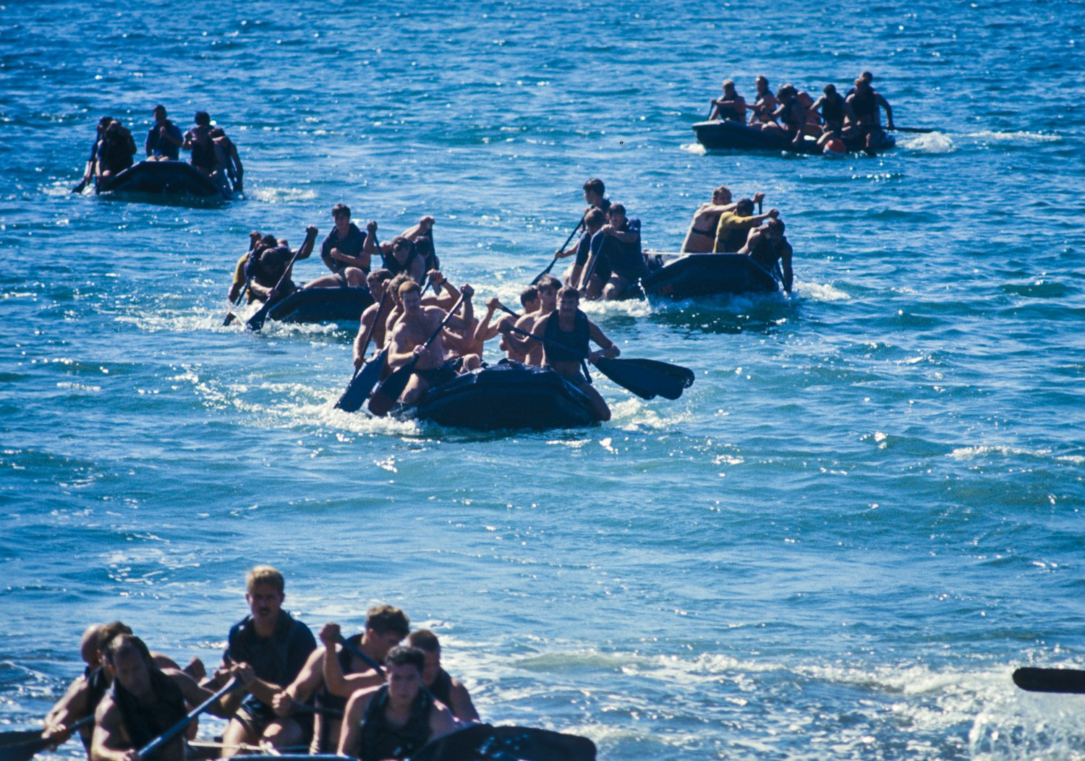  SEAL Team ONE inflatable boat crews under way. Small-boat handling was a constant of the training cycle at Coronado. | 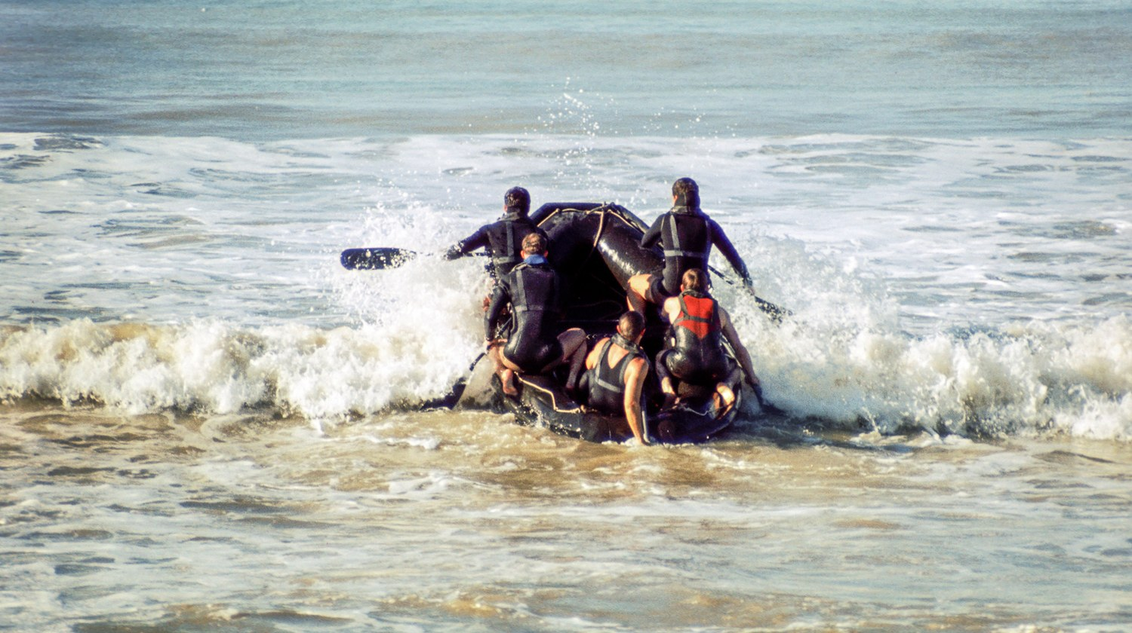  An inflatable boat crew running the surf line, January 1977.
  A freefall parachutist over the mountains east of San Diego during airborne training. |   Canopies descending over the desert drop zone.

The Nuclear Weapons Inspection
One clause in that evaluation deserves more attention than its placement suggests. Recording the effect of ApMadoc's supervision on the records section, Grabowsky noted that its efficiency “was commented upon in this command's Nuclear Weapons Assistance Team (NWAT) inspection.” The sentence reads like routine administrative praise. It is not.
A reader may reasonably wonder why a SEAL team was receiving a nuclear weapons inspection at all. Throughout the Cold War the United States fielded the Special Atomic Demolition Munition — a man-portable nuclear device of roughly 150 pounds complete, with a yield of up to one kiloton — and the units trained to emplace it were drawn from Army Special Forces, Army engineers, select Marines, and Navy SEALs, who trained to deliver them by combat swimming against harbor facilities, tunnels, and coastal infrastructure. The program ran from 1964 into the late 1980s and was not publicly acknowledged until 1984. SEAL Team ONE in 1976 and 1977 sat squarely inside that mission set, and a command with a nuclear weapons role is subject to nuclear surety inspection.
Those inspections do not confine themselves to the weapons. A central element of nuclear surety is the Personnel Reliability Program, which exists to ensure that only those who have demonstrated, in the language of the governing directive, “the highest degree of individual reliability for allegiance, trustworthiness, conduct, behavior, and responsibility” are permitted to perform duties associated with nuclear weapons. Certification under that program — and disqualification from it — is a documentary act. The screening, the certification, and the continuous evaluation are all recorded, and that record is kept in the individual sailor's service record.
Which is to say: the service records that PN2 ApMadoc maintained, and that the junior personnelman under him worked on, were the documentary foundation of who at SEAL Team ONE was cleared to be near a nuclear weapon and who was not. When the inspection team examined his section, it was not conducting a routine paperwork review; it was auditing the paper on which nuclear surety at that command rested. A discrepancy there is not an administrative embarrassment but a surety finding.
What that arrangement implied is worth stating plainly, because the Navy never put it in a citation. A twenty-four-year-old second class petty officer — one of the first four sailors without SEAL training ever assigned to the command — was the man responsible for those records, and had been brought inside an inspection regime built around nuclear weapons. He was not merely permitted to be in the room. His work product was the thing being examined, and the inspectors singled it out for favorable comment rather than writing it up. The Personnel Reliability Program is built on a single word, and the word is trustworthiness. Two years after a commanding officer had described his performance as sporadic, the same man was inside the system the Navy uses to decide whom it can trust with the most dangerous objects it owns.
— Theodore E. Grabowsky, LCDR, USN, SEAL Team ONE, enlisted performance evaluation, April 24, 1977

Release from Active Duty
On April 24, 1977 — four years to the day after his regular Navy enlistment — PN2 William Tudor ApMadoc III was honorably released from active duty at Naval Station San Diego and transferred to the Naval Reserve. His DD-214 records four years of net active service, his rate as Personnelman Second Class (E-5), and the National Defense Service Medal; on his separation date his commanding officer signed his first Good Conduct Award, the certificate reading 'in recognition of faithful, zealous and obedient naval service.' The State of Michigan issued him its Vietnam Era Certificate of Service.
His service record summarized a career compressed into four years: two commands; the fleet Letter of Commendation and a series of personal letters of commendation and appreciation; three finance-center commendations; schools completed with distinction (the officer-level Personnel Administration course at Fleet Training Center Norfolk, finished at 92%; Naval Manpower Information System Procedures; damage control team training); and a stack of correspondence courses — Basic Military Requirements, Seaman, Personnelman 3 & 2, Military Requirements for Petty Officer 3 & 2, General Oceanography (3.8), Postal Officer (3.7), and the Air Force's Principles and Techniques of Instruction — plus an Introduction to Psychology course at Tidewater Community College, completed with a B while on active duty.

The Naval Reserve and London
Reserve service took him somewhere few personnelmen go. In April 1978 he received reserve orders to London, assigned to Commander in Chief, U.S. Naval Forces Europe (CINCUSNAVEUR), Command and Support Operations — where the Navy put his emerging computer skills to work on the World-Wide Military Command and Control System (WWMCCS). His assignment: write the Video Input Processor (VIP) User's Manual enabling non-ADP personnel to interface with the CINCUSNAVEUR WWMCCS (Honeywell HIS-6060) computer, covering the Message Output Processor and the Unit Tracking portion of the Navy WWMCCS Software Standardization subsystem — a manual intended primarily for reserve personnel during naval exercises. Commander J. E. Howe evaluated the work:
PN2 ApMADOC has approached his assigned task with the enthusiasm, confidence and determination necessary as to accomplish an outstanding job in a limited timeframe. Petty Officer ApMADOC continually demonstrated his mastery of the VIP device for interfacing with the WWMCCS as well as his mastery of the technical details necessary to be an effective user of basic computer subfunctions. He has proved himself to be an independent worker with the flexibility to accomplish self-training independently or tutored-training on more complex systems... His fair attitude and superb cooperation have made him an integral part of the Command Support Operations team and a genuine pleasure to work with.
— J. E. Howe, CDR, USN, CINCUSNAVEUR, performance evaluation, signed December 29, 1978
A companion evaluation looked beyond the technical work:
PN2 ApMadoc's abilities in self expression, both orally and in writing, and his command of the English language are superior to most. PN2 ApMadoc instantly impressed those he came in contact [with]... It is unusual to find a PO2 who can so competently perform duties in a new environment, dealing with admin matters that he had not been previously involved in... His behavior both during office hours and while off duty in a foreign country have been exemplary... His relations with host nationals made him an ideal representative of the United States and the Navy... His performance in all areas during this period were so impressive he was strongly recommended for a 90 day TEMAC assignment with CINCUSNAVEUR Staff to assist in Reserve mobilization manpower documents and support for the forthcoming MOBEX NIFTY NUGGET. PN2 ApMadoc is highly recommended for promotion to PN1.
— P. J. Garfield, CDR, USN, CINCUSNAVEUR, performance evaluation, period of report June 4–16, 1978
On December 20, 1978, he was granted a final Top Secret clearance, certified by the Commanding Officer of the Naval Reserve Center, Southfield, Michigan. His reserve obligation ended on April 24, 1979, and his honorable discharge certificate was forwarded in July 1979, closing six years of naval service.

Chapter 5 — Central Michigan, Second Act (1977–1981)
Home from the Navy, Tudor returned to the two institutions of his pre-service life: Camp Mahn-Go-Tah-See, where he worked the summers of 1977 through 1980, and Central Michigan University, where he re-enrolled in the fall of 1977. From January 1978 to June 1979 he worked at the Oakland County Children's Village as a child supervisor, working with juvenile delinquents as well as abused and neglected children — the same instinct for service that his Navy evaluators had noticed applied now to some of the most vulnerable kids in his home county.
In 1979 he returned to CMU full time with a new major: computer science. The biology honors student who had written a WWMCCS user's manual for the Navy now made the switch official. He drove a school bus for the Mt. Pleasant Michigan Schools to help pay his way.

Mayfest and Autumn Rock Fest
The other thing he threw himself into was the concert business. He served on the Mayfest committee, handling advertising, media, and accounting for Mayfest Mountain Jam — a large outdoor spring concert held yearly on the Central Michigan campus, featuring seven bands and growing to a crowd of 14,000, with proceeds going to support Special Olympics. It was, in effect, a student-run music festival at a scale most professionals never touch: ticketing, liquor licensing, backstage credentialing, press relations, band contracts, and a five-figure gate, produced by undergraduates.
The spring Mayfest was only half of it. The same organization mounted a fall counterpart, and over three consecutive Septembers it ran Autumn Rock Fest I (1979), Autumn Rock Fest II (1980), and Autumn Rock Fest III (1981), with a separate festival, Rock-A-Festa, also staged in September 1981. Between the spring and fall shows, the committee was effectively producing two major outdoor concerts a year.
The bands they booked were not only local. Autumn Rock Fest I in September 1979 brought in Black Oak Arkansas, the Southern rock band whose “Jim Dandy” had been a national hit, along with the Epic Records progressive rock act Starcastle. Autumn Rock Fest II in 1980 was the strongest bill of all: Rare Earth, Motown's first successful rock act — the label's rock subsidiary was named after them, and their cover of “Get Ready” had gone to number four on the Billboard Hot 100 — together with Mitch Ryder, whose “Devil with a Blue Dress On” and “Jenny Take a Ride” made him Detroit rock royalty; Head East, of “Never Been Any Reason”; The Look; and Cub Koda, who had fronted Brownsville Station on “Smokin' in the Boys Room.” Rare Earth returned for Autumn Rock Fest III in 1981, on a bill that also included Rob Tyner's National Rock Show — Tyner having been the lead singer of the MC5, one of the most influential bands ever to come out of Michigan.
Around those headliners played a deep roster of Michigan and campus bands across the festivals of 1978 through 1984: Catfish Hodge, Johnny D and the Stains, the Jelly Roll Blues Band, Newt and the Salamanders, the William Lewis Group, Nimbus, Mugsy, ON XYZ, The Weeds, The Urbations, Judy's Tiny Head, and Studio 12, who appeared at four separate Mayfests. For a computer science student paying his way driving a school bus, it was an education in logistics, promotion, and money that no course offered — the same combination of technical work, organization, and showmanship he had been assembling since the Audio-Visual Club in ninth grade.
The programming was not confined to the classroom. During these years he did custom programming on the side — most notably customer payroll programs for companies with as many as 200 employees, real production software carrying real paychecks. Within the department, he assisted computer science professors by creating programs to demonstrate specific techniques for their classes, the same instinct for teaching that had put him in front of a zoology lab a decade earlier.

A Byline in the ACM
That work for the faculty left a small mark on the academic literature. Professor Robert N. Cook's paper 'Structured Programming Using BASIC,' published by the Association for Computing Machinery in 1980 (SIGCSE), demonstrated structured programming techniques through two example programs written by students in CMU's introductory computer science classes. The first — a loan interest payment program written in Radio Shack TRS-80 Level II BASIC, its header reading 'PROGRAM TO COMPUTE INTEREST PAYMENTS ON A LOAN, WRITTEN BY TUDOR APMADOC' — appears in full in the paper. Cook's acknowledgements read: 'Thanks are due to Mr. Tudor ApMadoc and Mr. David Sundberg, students at Central Michigan University, who wrote the example programs.' It is a neat piece of foreshadowing: the student credited in an ACM paper for exemplary TRS-80 BASIC would, within a year, be working for the company that made the TRS-80.
In the summer of 1980 he interned with the Texas Instruments Communication Group, part of a team writing custom packet-switched network code — code belonging to the family of technologies that became part of the core infrastructure of today's internet. He studied computer science at CMU through 1981, and then the industry came calling.

Chapter 6 — Four Decades in the Computer Industry (1981–2022)
Tudor ApMadoc's professional career spans the entire arc of modern computing: from the TRS-80 microcomputer boom, through Unix multiprocessors, network servers, enterprise storage and backup, to cloud-era cybersecurity. Across forty-one years, from Tandy to Dell, the through-line is the same one his Navy evaluators identified — the man with a knack for obtaining answers to very unusual questions, deployed at the border between engineering and the customer. The recommendations quoted throughout this chapter are drawn from the forty-eight written recommendations on his LinkedIn profile and from contemporaneous letters preserved in his files.

Tandy Corporation / Radio Shack (1981–1984)
He joined Tandy Corporation / Radio Shack in January 1981, in the thick of the personal computer explosion. As Trade Show Coordinator for the Midwest Division (January–July 1981), he supervised assembly and show teams, logistics, and planning for shows in 21 cities over 16 weeks. District managers took notice. After the Cleveland Computer Show, District Manager Mark D. Wolfe wrote in March 1981:
I wish to express my sincere appreciation for the professionalism and effort put forth by the Divisional Blitz Team at the Cleveland Computer Show. The knowledge, experience and dedication demonstrated by you was impressive and invaluable... I have been told by Mr. Bourland, Mr. Nohavel, Mr. Alias and perhaps, even more importantly, by customers that the Blitz was well organized, exciting and attractively displayed as well as staffed by professionals — I agree!
— Mark D. Wolfe, District Manager, Radio Shack, March 1981
The Indianapolis Computer Center's manager likewise thanked him by name:
The Blitz showed the Indianapolis business community how professional Radio Shack is.
— Ted Stewart, Computer Center Manager, Radio Shack Computer Center, Indianapolis, 1981
As Detroit Support Group Coordinator (July 1981–March 1982) he created a regional support operation for Michigan and Indiana with a staff of five, running customer satisfaction surveys, standard demo software, national account support calls, and training. Promoted to Computer Customer Service Training Coordinator (March 1982–March 1983) at headquarters in Fort Worth, he developed and executed a training program for 50 headquarters and 200 field customer service representatives drawn from the U.S., Canada, Australia, and Europe — developing curriculum, training the educators, handling road-training logistics in five cities, and supervising creation of a permanent classroom facility at corporate headquarters, with a staff of six.
His final Tandy role was National Account Support Group Manager (March 1983–January 1984), leading a four-person group providing hardware and software technical support to Fortune 500 corporations. LinkedIn did not yet exist to collect recommendations from this era, but the customer letters preserved from it serve the same purpose. Grumman Data Systems wrote to Radio Shack's director of computer customer services in November 1983:
Mr. ApMadoc was able to help us resolve the problem of communicating with our mainframe computers. He was also most helpful in providing additional insight concerning the TRS-80 Model 16 XENIX Operating System... we appreciate... meeting an individual of Mr. ApMadoc's caliber.
— Director, Program Planning & Control, Grumman Data Systems, November 1983 (signature initials JSP; name not legible on the surviving copy)
Software vendor SNAPP-WARE, after a difficult UART board problem on the Model 16, asked Tandy's director of merchandising to recognize the support team:
Please extend my personal thanks [to the support team] for the extra effort put forth during this trying period... [Transmitting the corrected system files via UUCP] was both a testimony to the power and value of the XENIX system and the customer service dedication of your staff.
— Bob Snapp, SNAPP-WARE, 1983
And in January 1984, Senior Vice President Ron G. Stegall personally thanked him among the handful of people behind the launch of the Tandy 2000 at COMDEX '83 and the product announcement at Caesars Palace:
For this type of an effort to come off without one hitch required a lot of extra hours and effort behind the scenes.
— Ron G. Stegall, Senior Vice President, Tandy Corporation, January 1984

Altos Computer Systems (1984–1987)
In January 1984 he moved to Altos Computer Systems as a Senior Systems Engineer, supporting four salesmen on pre- and post-sales work with OEM customers including Tandem, Bunker Ramo, and TWA. He was named Altos's Outstanding Systems Engineer for 1985. Two colleagues from those years later wrote on LinkedIn:
I worked with Tudor at Altos and we have kept in touch since. I found Tudor to be an excellent engineer, person and professional. He is excellent with clients, sales and engineering professionals and loyal to the company and professionals he represents and works with.
— James Rafferty, Roy Talman & Associates (formerly Altos Regional Sales Director)
I am more than happy to recommend Tudor. I worked with him at Altos Computer Systems and managed him at NetFRAME. Tudor performed outstanding work with little supervision. He was also quick to see needs and volunteer for projects which could be leveraged throughout sales and engineering organizations. I am sure that Tudor would be a valued resource to any organization.
— Ric Tappero (worked with him at Altos; managed him at NetFRAME)
The contemporaneous letters match. The National Easter Seal Society wrote to Altos's vice president of marketing in June 1984 after a day of Unix shell programming demonstrations:
We found Tudor to be knowledgeable, bright, and personable; the training session was certainly helpful to our technical staff, and we generally regard this as one of the more positive contacts we have had with Altos.
— Director, Management Information Systems, National Easter Seal Society, June 1984 (signature initials RMG; name not legible on the surviving copy)
An internal memo from January 1987, after the Uniforum trade show in Washington, D.C., reads like a fan letter:
Tudor was an outstanding resource and I would go so far as to say that many products would not have been up and running if it were not for Tudor's presence. Even during the most trying times Tudor remained cool and pushed things forward to completion... If I could hand pick the people I work with in the future, Tudor would definitely be at the top of the list (the man is on the ball). We need more Tudor's around!!
— Chuck Berman, Altos Computer Systems, internal memo, January 28, 1987

Wyse Technology (1987–1993)
At Wyse Technology, which he joined in May 1987, he rose through three roles in six years. As Area Manager, Technical Sales Support (1987–1990), he was responsible for six regional systems engineers and pre-sales support for two major-account development representatives across the East area. As National Systems Engineering Manager, Advanced Products (1990–1991), he owned pre- and post-sales support for Wyse's line of symmetric multiprocessing computers — systems scaling from 16 to 256 users and one to eight CPUs — working with engineering to help define the hardware, software, and service plans and training both Wyse and distributor technical staff. As Senior Systems Engineer, OEM Sales (1991–1993), he supported OEM sales to customers and prospects including Datapoint, Texas Instruments, American Airlines, NCR, Zenith, Intergraph, Anheuser-Busch, and Tandem. Wyse named him Outstanding Systems Engineer in 1988 and selected him for the All Star US Sales Support team in 1989. From his LinkedIn recommendations:
I worked with and later managed Tudor for 4 years at Wyse. He was a superstar SE and manager that always gave 110% to winning the deal at hand and ensuring customer satisfaction at every step of the way from pre-sale demonstrations to post sale support. Tudor was always our troubleshooter for the most difficult accounts and technical issues. His enthusiasm, communications skills, technical knowledge and business acumen were second to none. He was universally liked and in constant demand by the sales team. If I had the opportunity to hire Tudor to work for my company in any customer facing role, I would not hesitate for a second.
— Tom Offutt (worked with and later managed him at Wyse Technology)
I worked with Tudor at Wyse Technology during my long tenure there. Tudor is a results-oriented Manager (with a technical background) who will accomplish the goals for company success.
— Roy Robinson, IT and IS support (colleague at Wyse Technology)

Ferndale, 1991
The Wyse years also brought the most important partnership of his life. On August 4, 1991, in Ferndale, Michigan, Tudor married Colleen Gail Hines. Born in Detroit on January 16, 1954, and a 1972 graduate of Manzano High School in Albuquerque, New Mexico, Colleen brought two sons, Jason and Kevin Matthew DeKeyser, to the marriage. The couple made their home at 25 Oakdale in Pleasant Ridge, Michigan, through 1997, then moved to Farmington Hills — the base from which the rest of this story, the Veritas decades, the photography, and the travels, unfolded.

NetFRAME Systems (1993–1995)
From July 1993 to November 1995 he was Senior Systems Engineer for NetFRAME's Great Lakes Region, supporting three sales representatives selling network superservers to major corporations consolidating their server environments. NetFRAME's radically non-traditional hardware made for a deeply technical sale, and his efforts were essential in closing major deals including Blue Cross of Nebraska, Ohio State Teachers Retirement System, GMAC, and Penton Publishing. He made Quota Club in both 1994 and 1995. From his LinkedIn recommendations:
As an SE at NetFRAME, Tudor did a great job supporting his sales team and reseller partners to consistently exceed sales goals at a fast growing company. Tudor had the unique ability to discuss very complex solutions with our prospects in [a] way where they could understand not only the technology, but the business benefits as well. With his knowledge of the industry and our competition, I would frequently discuss new product and sales strategies with Tudor to make sure that what we were planning back in HQ would actually be effective out in the field.
— Jeff Sinnott, Vice President, Worldwide Sales, Index Engines (formerly NetFRAME)
I've worked with Tudor for 5+ yrs at NetFRAME in the roles of Pre-sales Consulting Systems Engineer. Tudor has demonstrated great technical knowledge in Networking, Security and Enterprise Application domains. He is extremely motivated and independent. I endorse Tudor wholeheartedly and would recommend highly.
— Chris Andrews, SVP Worldwide Sales (formerly NetFRAME)

VERITAS Software and Symantec (1995–2016)
The longest chapter of his career began in November 1995, when he joined VERITAS Software — the storage-management company that would merge with Symantec in 2005 and later re-emerge as Veritas Technologies. Over more than twenty years he held four roles of increasing scope.
As Senior Staff Systems Engineer (1995–2000) he provided pre-sales support across the VERITAS product line, primarily NetBackup, and helped recruit and train resellers, earning Quota Club honors in 1998 and recognition as Systems Engineer of the Year. As Principal Staff Engineer in the Appliance Software Division (2000–2001) he worked directly for engineering, shaping a new software-based NAS and SAN product toward launch — gathering customer requirements in the field, feeding them to engineers and product managers, working the beta cycles, and delivering the first customer installs. As Principal Product Specialist in Emerging Technology Sales (2001–2003) he took new products — primarily a NAS backup-storage appliance — and established them in the field with installed base, run-rate sales, and reference sites.
From August 2003 to May 2016 he served as Global Solution Architect on the team dedicated to EDS (later HP Enterprise Services) — one of the top three Veritas accounts worldwide. His role was to work with HPES engineering and architecture groups to embed Symantec/Veritas products in their portfolio and packaged solutions, driving technical issues and carrying data-center-scale requirements back into Symantec's product organizations. A key effort was a remote-office deduplicated backup solution developed with HP. He worked the largest single NetBackup opportunity in the company's history — worth over $35 million — and carried a yearly quota that peaked at $100 million. Symantec recognized the work with Quota Club honors in 2010, 2011, and 2012, and Account Team of the Year awards in 2010 and 2012.

In the Words of Fellow Employees
Tudor was one of the star technical people in the VERITAS field organization, known by many for his deep knowledge of our products and his passion for quality. He was a much sought after resource in our engineering organization to help to provide feedback on existing products and input on new products and features. He definitely was perceived as one of the important technical leaders in the company.
— Fred van den Bosch, executive, VERITAS Software
Tudor is a great business development catalyst, going to great lengths to understand the nuances of his customer's business model, and working with internal resources to flex the company's offerings in creative ways to help his customers drive innovation in the marketplace. As an example of this, through Tudor's strong leadership we have enjoyed improvements in NetBackup's deduplication capabilities which have helped position HP/EDS as leader in providing backup services to its customers while positioning Symantec for greater success in the competitive dedupe market.
— Paul Mayer, NetBackup Product Manager, Symantec
Tudor belongs to the top group of storage experts in our industry. If Tudor does not know it, it must be something extremely exotic, and probably does not work anyway. When I have worked with Tudor at [the] VERITAS Advanced Product Team (APT), he was (as I believe he is today) a go-to expert in our field. Tudor's role was to boldly go and win business where no VERITAS field SE could venture to go, and to present/demonstrate our then-cutting-edge products. Our customers, partners, and VERITAS engineers benefited from Tudor's expertise, his willingness to help and guide, his “can-do” attitude, and “refuse-to-lose” approach to business... I would trust my most critical customers and partners to him — need I say anything else?
— Igor Saulsky, VERITAS Advanced Product Team
I have worked with Tudor over many years and always enjoyed working with him from my perspective as a GM and Product Management leader because he is a strong advocate for the business partners he represents. He helped ensure the product teams had clear understanding of, not just the partners' solutions and technology, but also their business model, practices, processes and key interaction and integration points. I could always rely on Tudor to ensure if we had questions he['d] be able to answer them diligently and introduce [us] to key people to drive collaboration and execution with our partners.
— Simon Jelley, Vice President of Product Management

In the Words of Customers
I had the opportunity to work with Tudor between 2002 and 2007 while I was at EDS and Tudor was at Symantec. As a partner to EDS' hosting business, Symantec placed some of their best people on the account team. Tudor was at the top of that list. He is well versed in all areas of technical and product discussions surrounding the data center tooling and security environments and I would personally welcome a future opportunity to work with Tudor again.
— Larry Lozon, Chief Technology Officer (formerly EDS)
Tudor uses his broad base of technical depth to help integrate multiple vendor products into new solution offerings. I highly recommend Tudor for his personal commitment to help design, implement and support complex product solutions.
— Gary Baker, Chief Storage Architect, EDS/HP
I had the pleasure of working with Tudor during my EDS Portfolio years on a couple of storage and data management initiatives. His expertise in these areas and the deep insight into our business have been extremely helpful in determining and executing new EDS services based on joint solutions. Tudor was a great source for feedback and future development features, and always helped us to express our needs into Symantec.
— Hans Beierle, EDS Portfolio
I've known Tudor for a number of years. Initially I was a customer. I quickly realised that he has a great deal of integrity and I could trust what he was telling me. Also, even though I'd give him something difficult to find out, he'd get me an answer and, if he knew it didn't meet my needs, he'd connect me to the person I needed to influence.
— Siobhan Ellis (initially a customer)

Dell Technologies (2016–2022)
In June 2016 he pivoted from storage to security, joining Dell as a Senior Sales Engineer covering Dell's enterprise security products — Cylance, CrowdStrike, Carbon Black, Absolute, Netskope, and data encryption — across a territory spanning Michigan, Ohio, and New York, from small companies to Fortune 10 accounts, handling presentations, proofs of concept, and problem escalations. From his LinkedIn recommendations:
Tudor and I worked alongside each other for 2 years and [I] was impressed by Tudor's ability to deal with even the toughest challenges and projects — effortlessly. That skill often takes years to develop among consulting professionals, but it seemed to come perfectly naturally to him. Tudor is passionate about security and always goes the extra mile. If I had the chance, I['d] work with Tudor again.
— E. Phillips, Associate Partner, IBM
Tudor is very detail oriented and process strong. He excels in his technical capabilities which provide his customers with a great level of service. He is forward thinking when it comes to strategy and opportunities.
— Robert Lynch, Senior Security Engineer (written in April 2016, as ApMadoc made the pivot into security)
He retired from Dell in May 2022, closing a forty-one-year industry career. His LinkedIn profile carries 48 written recommendations and hundreds of skill endorsements — over 88 for storage and 99+ for enterprise software among them. But a forty-one-year career was never the whole of the man. Retirement simply meant that the two oldest threads of his life — the camera and the passport — could finally run full time.

Chapter 7 — The Photographer
Photography is the longest continuous thread in Tudor ApMadoc's life. It begins with the ninth-grade photo club and the Signpost yearbook, runs through the Navy — where a fleet commander's citation formally credited him with photography 'on a level comparable to many photographer's mates within the Navy' — and matures into a second career: Getty Images contributor, award winner, and a photographer whose work has appeared in major magazines, books, and websites around the world.
His own words, from his professional profile, describe the mission: 'I'm a photographer with over four decades of experience capturing the beauty, history, and character of places, people, and stories... Whether I'm documenting an abandoned factory, a landmark building, or a fleeting moment of light, my goal is to create images that tell genuine, visually compelling stories.' His primary subjects are landscape, architecture, and candids, with a particular passion for urban exploration around Detroit — the abandoned theaters, factories, and schools of a great American city in transition.

Two Decades on Flickr — By the Numbers
He joined Flickr on February 18, 2006, and his account (flickr.com/photos/tudorapmadoc) has grown into a major archive: 29,941 photographs that together have drawn over 10 million views, along with 42,994 favorites and 1,855 comments. The most viewed single image, a December 2017 photograph of Tawas Point Lighthouse, has drawn over 84,000 views, 548 favorites, and 95 comments on its own. His December 2021 documentation of the abandoned Highland Park High School / Junior College complex accounts for more than half of the top twenty most-viewed images — evidence of how deeply his Detroit-area urban exploration work resonates. Other perennial favorites include the Pere Marquette 1225 steam locomotive — whose design and schematics were used for the locomotive in The Polar Express — Detroit sunrises shot by drone, the Ambassador Bridge, Hunts Mesa in Monument Valley, and Michigan's lighthouses and beaches. Top-ten tables by views, favorites, and comments appear in Appendix C.

YouTube
His YouTube channel, active since March 2006, holds 233 videos that together have earned 145,883 views, more than 3,118 hours of watch time, over one million impressions, and 318 subscribers. The catalog mirrors his life: drone tours of Detroit and northern Michigan, 4K explorations of Detroit's historic churches and the Book Tower, the Pere Marquette 1225 Polar Express runs, timelapses of Australia and New Zealand, hot air balloon launches — and, tellingly, slideshows preserving his Navy years (SEAL Team One: 1976–1977, two Harbor Clearance Unit slideshows, and US Navy Mark I DDS) and his Camp Mahn-Go-Tah-See summers of 1977–1980. The most-viewed video, a 2025 Insta360 X5 film of the Hot Air Jubilee, passed 17,000 views. The top ten appears in Appendix D.

Published Work
As a longtime Getty Images contributor, his photography has been licensed and published across an extraordinary range of outlets. In print, his images appear in books including Abandoned Industrial Places (David Ross, 2020), Lonely Planet's Explore the Americas and California's Best Trips, Victoria Schwab's Our Dark Duet (front cover, Harper Collins, 2017), Panobook 2016 (the world's best panoramic photos), the Epson Pano Awards books of 2022 and 2023, Cal Flyn's Islands of Abandonment (Penguin Random House), and City of Broken Dreams (Michigan State University Press). Magazine credits include Architectural Digest, Newsweek, The Atlantic (both its Indiana and Ohio photo essays in 2020), Coastal Living, and Southern Living. His photographs have also appeared on five music CDs, including Kirk Mosher's Sparkleland and four Doug Fallon albums.
Online, his work has been featured by MSNBC, AOL, HowStuffWorks, The Travel Channel, Lonely Planet, Martha Stewart Weddings, MLive, TripSavvy, Thrillist, PopSugar, The Telegraph, MSN, Yahoo, DPReview (a 2015 Readers' Showcase feature), Only In Your State (including the Michigan and Detroit banner images), and many more — including, fittingly, NavSource's naval history archives, where his photographs document the USS Papago, YRST-2, and YDT-16, the very diving tender aboard which he served during the 1975 world record dive. The complete list of documented credits, with links, appears in Appendix B.

Awards
His competition record includes a Silver Award in the 2022 Epson International Pano Awards (Open Awards) for 'Occulus Ceiling' and a Bronze Award in the 2023 Epson International Pano Awards for 'Great Lakes Freighter turned into a home,' with additional entries earning strong scores in both years. He has been a finalist in the Black & White Spider Awards — the international black-and-white photography awards — six times: Architecture (2017, 2019, 2022), Nature (2018), Silhouette (2019), and Photojournalism (2022).

Chapter 8 — A World Traveler (1985–2025)
Five passports, issued between 1985 and 2024, document forty years of travel: roughly 74 confirmed overseas entries across 21 distinct countries (23 destinations counting Hong Kong and Macau separately) in 27 different travel years, and an estimated 570,000 international air miles from Detroit Metro — likely 600,000 to 650,000 miles actually flown once hub routing is accounted for. The pattern is that of a man who worked globally and vacationed adventurously, camera in hand.
It began with a first passport from the Chicago Passport Agency in August 1985 and a trip to London that September. The Bahamas and Australia followed in 1986, New Zealand in 1987 — the start of a lifelong affection for Australasia that would bring him back to Australia ten times and New Zealand six. The United Kingdom became his most-visited country by far, with 22 entries through Heathrow, Gatwick, and Manchester between 1985 and 2015, many during the years his Global Solution Architect role for the EDS/HP account demanded regular transatlantic work.
The peak years tell their own story. In 2002 he logged an estimated 65,200 international air miles on three great swings: Detroit to Hong Kong, Macau, and Singapore; Detroit to Melbourne, New Zealand, and Sydney; and Detroit to Bangkok — securing visas for China and Thailand from the Chicago consulates that spring. In 2007, his biggest year at 82,200 estimated miles, he made eight overseas round trips, including London (three times), Dublin, Kingston, Prague via Amsterdam, and two Australia/New Zealand journeys. Jamaica appears three years running (2005–2007); Brussels, Amsterdam, Frankfurt, Stockholm, Paris, and Tunis all collected stamps; and Brazil issued him multiple-entry visas in 2008 and again in 2016 — the latter valid a full ten years.
Retirement did not slow the wandering so much as redirect it toward the remote: Mongolia in August 2019 (entering through Ulaanbaatar's Buyant-Ukhaa airport), the Republic of Georgia for two weeks in September 2023, and Moldova in 2025, crossing at Sculeni on the Romanian border — the newest stamp in the book, forty years and some six hundred thousand miles after the first. The complete travel record — passports, entries by year, country rankings, visas, and estimated international air miles — appears in Appendix E.

Epilogue — The Trusted Resource
It is tempting to see several different men in these records: the turtle-selling lake kid; the AV-club president photographing his classmates; the seaman apprentice whose first evaluation called him 'sporadic' and whose last called his dedication 'without parallel'; the personnelman who supported a world-record dive; the CMU student credited in an ACM paper; the engineer trusted by Fortune 500 customers for four decades; the Getty photographer with over ten million views; the traveler with a Mongolian entry stamp. But read end to end, the records argue that it was always one man, and that the constant in his story is a single word: trust.
Consider how the Navy expressed it. In the military, trust is not a sentiment. It is a decision with consequences, made in writing, by people who answer for the outcome. In 1975, HCU-2 sent a Personnelman Seaman — an E-3, not yet a petty officer — on independent duty as the sole personnelman and yeoman of the platform attempting the deepest open-sea dive in history. Independent duty is normally reserved for seasoned petty officers; giving it to a seaman was beyond rare, and it meant that while the world watched divers descend past 1,100 feet, the Navy had already made a quieter bet on the twenty-three-year-old running the ship's office, its mail, its watches, and its camera. A year later the Bureau of Naval Personnel made a bigger one, selecting him as one of the first four non trained SEAL sailors ever assigned to SEAL Team ONE, and handing him the service records of one of the most sensitive commands in the fleet. The clearances tell the same story in bureaucratic shorthand: Secret at twenty-one, Top Secret at twenty-six, London and the WWMCCS command-and-control system in between. Lieutenant Commander Grabowsky's evaluation reduced it to a phrase that could stand as the thesis of this book: 'a particularly trustworthy sailor.'
Industry expressed the same judgment in its own currencies. Companies measured it in what they handed him: having him create a national account support team for Fortune 500 customers at Tandy; a $100 million quota and the largest NetBackup opportunity in company history at Symantec; the security portfolio for Fortune 10 accounts at Dell. Colleagues measured it in access — Fred van den Bosch's engineers seeking him out for product feedback, Jeff Sinnott testing headquarters strategy against his field judgment before committing to it, Simon Jelley relying on him to be the honest channel between product teams and partners. And Igor Saulsky said it outright, in almost the same words the Navy had used thirty years earlier: 'I would trust my most critical customers and partners to him — need I say anything else?'
The customers may be the most telling witnesses of all, because customers have the least reason to extend the benefit of the doubt. Over the decades he became the consummate trusted resource — the person customers reached out to across an unusually wide range of needs: support issues when something broke, product issues when something fell short, future product enhancements when they needed a voice carried back into engineering, best practices when they were designing something new, and strategy when the question was bigger than any single product. Grumman called on him to reach their mainframes; the Easter Seal Society to learn Unix; EDS's chief technologists — Larry Lozon, Gary Baker, Hans Beierle — to design, defend, and evolve the backup architecture of one of the world's largest hosting businesses. Siobhan Ellis, who began as a customer, described the mechanism precisely: he had integrity, so she could trust what he told her; he got answers to hard questions; and when the answer didn't solve her problem, he connected her to the person who could. That last clause matters. A salesman's instinct is to keep the customer close; a trusted resource's instinct is to get the customer helped, even if the help comes from someone else.
Where does such a reputation come from? The records suggest it was built, not born. The first evaluations in his file are the proof: 'sporadic, ranging from good to below average.' Nothing was handed to him on arrival. What followed was a method, visible in document after document across fifty years: learn the system deeply enough to answer the unusual questions; improve it rather than merely operate it; document it so others can use it; teach it — to junior sailors, to customer service reps from four continents, to customers' technical staffs; photograph it, because the record matters; and treat every person, as Grabowsky wrote, 'with respect and interest,' and, as another evaluation put it, with a fairness that was 'consummate.' Trust followed the method the way the commendations followed the work.
The deepest dive in naval history lasted fifteen days; the trust that put a seaman on that barge lasted a career. Admirals, bureau selection boards, engineering vice presidents, chief architects at global corporations, magazine photo editors, and book publishers on two continents all reached the same conclusion about the same man, independently, across half a century: give it to Tudor — he'll get it done, he'll tell you the truth about it, and everyone involved will be better for it. This book is simply the paper trail of that conclusion, assembled from the file drawers where it was recorded — one letter, one evaluation, one recommendation at a time.

A Note on Sources
This biography rests on primary documents. Every quotation is reproduced from the source named, and attributed to the officer or author whose name appears on the original; where a signature is not legible on the surviving copy, the attribution says so rather than guessing. The sources fall into the following groups.
Naval service. His United States Navy service record, including the DD-214, history of assignments, advancement records, security clearance certificates, and school certificates; eleven enlisted performance evaluations recorded between 1974 and 1978, ten of which survive as complete NAVPERS forms; letters of commendation and appreciation from the Commanding Officers of Service School Command NTC Orlando, Naval Station Norfolk, Harbor Clearance Unit TWO, Navy Finance Center Cleveland, Navy Regional Finance Center San Diego, and the Enlisted Personnel Management Center; the Letter of Commendation of 7 December 1976 approved by Rear Admiral D. F. Emerson, Deputy Commander Naval Surface Force, U.S. Atlantic Fleet; naval messages from CINCLANTFLT, COMNAVSEASYSCOM, COMSERVRON EIGHT, and the Navy Experimental Diving Unit concerning the June 1975 Mark 1 Deep Dive System world record dive, together with the Navy’s published accounts of that dive; and the letter of appreciation of 8 November 1976 from the Deputy Commander, Joint Unconventional Warfare Task Force, with its endorsements.
Early life and education. A family biographical outline; the Report of Extra-Curricular Activities (1981); the family’s genealogy database (Family Tree Maker GEDCOM export, July 8, 2026); and Robert N. Cook, “Structured Programming Using BASIC” (Association for Computing Machinery, 1980). Mayfest and Autumn Rock Fest details are drawn from the subject’s own archive of festival advertisements, tickets, backstage passes, band contracts, and contemporaneous coverage in CM Life, the Mt. Pleasant Sun, and the State Journal, published at apmadoc.net/mayfest; chart and career details for the national acts are from published music-industry references.
Career. The subject’s résumé (2022) and work awards record; all forty-eight written recommendations from his LinkedIn profile; and customer and colleague letters preserved from 1981 to the mid-1990s.
Photography and travel. His photography accomplishments record and Epson Pano Awards certificates; a Flickr account export of 29,941 photo records; a YouTube channel analytics export; and a compiled record of passport, visa, and travel-stamp entries covering 1985–2025. The photographs reproduced in this volume are his own.
Historical context. Details of Hurricane Eloise’s formation, track, landfall, and intensity are from the published meteorological record (NOAA Atlantic Oceanographic and Meteorological Laboratory and contemporaneous Florida Panhandle reporting). Context for the Nuclear Weapons Assistance Team inspection — the Special Atomic Demolition Munition program and the role of the Personnel Reliability Program within nuclear surety inspection — is from declassified and published accounts of that program and from Department of Defense and Department of the Navy directives; the fact of the inspection, and of the favorable comment on his records section, is from his evaluation of 24 April 1977.
Passages from recollection. Three accounts rest on the subject’s own recollection rather than on a surviving document, and are identified as such where they appear: his collateral duties during recruit training at Great Lakes; the towing of YDT-16 to sea ahead of Hurricane Eloise, which is consistent with standing Navy practice and with a letter of 28 July 1975 placing the vessel at Panama City that season; and the two photography mentors at The Leelanau School.
Conventions. The spelling of the family name has been standardized to “ApMadoc” throughout, including within quotations where source documents rendered it otherwise. In transcribed evaluations, words that could not be read with confidence on faint carbon or photocopy originals are supplied in square brackets. Chapter divisions and section titles are editorial.

