WILLIAM TUDOR ApMADOC III
A Biography — Volume Two: The Documents
Appendices A through K
The supporting record: service summaries, published credits, statistics, travel and family documentation, and the complete texts of the Navy evaluations and commendations, professional letters, and recommendations quoted in Volume One.

Contents
About This Volume 3
Appendix A — U.S. Navy Service Record Summary 4
Appendix B — Photography Credits 8
Appendix C — Flickr Statistics 11
Appendix D — YouTube Statistics 13
Appendix E — Passport and Travel Records (1985–2025) 14
Appendix F — The ApMadoc Family Tree 17
Appendix G — U.S. Navy Enlisted Performance Evaluations: Full Remarks 19
Appendix H — Navy Commendations and Congratulations: Full Text 26
Appendix I — Photographs from the Navy Years 34
Appendix J — Professional Letters of Thanks and Commendation: Full Text 40
Appendix K — Professional Recommendations: Full Text 44
A Note on Sources 59

About This Volume
This volume contains the documentary record behind the biography of William Tudor ApMadoc III. Volume One tells the story; this volume holds the evidence for it.
The first six appendices are reference material: a summary of his United States Navy service record, the documented credits and awards of his photography, statistics from his Flickr and YouTube archives, a record of forty years of international travel drawn from five passports, and the ApMadoc family tree traced to Wales in 1814.
The remaining appendices reproduce primary material in full, in chronological order. Appendix G contains the surviving enlisted performance evaluations of his Navy service, transcribed from the original NAVPERS forms. Appendix H contains the letters of commendation and appreciation, naval messages, and inspection reports from that service, together with the endorsements added as each passed down the chain of command. Appendix I reproduces twenty-one of his own photographs from the Navy years. Appendix J contains the customer and colleague letters preserved from his forty-one years in the computer industry. Appendix K contains all forty-eight written recommendations from his professional profile.
Several of the Navy documents survive only as faint carbon or photocopy originals. Words that could not be read with confidence are supplied in square brackets, and where a signature is illegible the attribution says so rather than guessing.

Appendix A — U.S. Navy Service Record Summary

Service Dates
Event | Date
Initial enlistment, U.S. Naval Reserve | March 28, 1973
Discharged USNR for enlistment in U.S. Navy | April 24, 1973
Entered active duty (AFEES Detroit) | April 25, 1973
Released from active duty; transferred to Naval Reserve | April 24, 1977
Top Secret clearance granted (final) | December 20, 1978
Reserve obligation ended / honorable discharge | April 24, 1979

Duty Stations
Dates | Station | Role
Apr 25, 1973 | AFEES Center, Detroit, Michigan | Recruit
Apr 25 – Jun 21, 1973 | Recruit Training Command, NTC Great Lakes, Illinois | Recruit training; Recruit Company Master-at-Arms; battalion administrative assistant; after-hours maintenance; Navy Blue Jacket Choir
Jul 7 – Aug 24, 1973 | Service School Command, NTC Orlando, Florida | Student, PN 'A' School
Sep 4, 1973 – May 26, 1976 | Harbor Clearance Unit TWO, Little Creek, Virginia | Personnelman, Photographer
Jun 28, 1976 – Apr 24, 1977 | SEAL Team ONE, NAB Coronado, California | Leading Personnelman, Photographer
1978 (reserve duty) | CINCUSNAVEUR, London — Command & Support Operations | WWMCCS VIP User's Manual author

Advancement in Rate
From – To | Date
Entered service as SA (E-2) | April 1973
SA – PNSA | August 24, 1973
PNSA – PNSN (E-3) | October 16, 1974
PNSN – PN3 (E-4) | July 16, 1975
PN3 – PN2 (E-5) | May 16, 1976

Schooling and Courses
Dates | Course | Result
Jul 9 – Aug 24, 1973 | Personnelman 'A' School (7 weeks) | 94.15 — 1st of 16
May 20–24, 1974 | Naval Manpower Information System Procedures (PAMI, U.S. Atlantic Fleet) | Satisfactory
Nov 17–21, 1975 | Personnel Administration Course (Officer level), FTC Norfolk | Satisfactory / 92%
Apr 26, 1976 | Damage Control Team Training | Satisfactory
Correspondence courses completed: Basic Military Requirements; Seaman; Personnelman 3 & 2; Military Requirements for Petty Officer 3 & 2; General Oceanography (3.8); Postal Officer (3.7, Naval Education Program); Principles and Techniques of Instruction (USAF ECI, 80%). Off-duty education: Introduction to Psychology, Tidewater Community College (B).

Letters of Commendation and Appreciation
Date | From | For
Aug 23, 1973 | CO, Service School Command, NTC Orlando | Graduating first in class
Apr 17, 1974 | CO, Naval Station Norfolk | N&W wetslip barge removal
Aug 19, 1974 | CO, Navy Finance Center, Cleveland | JUMPS OCR error-rate excellence
Jul 29, 1975 | D. R. Roberts, CWO2, OIC, YDT-16 / Mk 1 DDS | Outstanding performance, world record open-sea dive
Feb 4, 1976 | CO, Navy Finance Center, Cleveland | JUMPS OCR error-rate excellence
May 10, 1976 | CO, Enlisted Personnel Management Center | Transient personnel procedures excellence
Nov 8, 1976 | Col. Harlan B. Hume, USAF, Deputy Commander, JUWTF | Outstanding performance as Navy Plans NCO, Brave Shield XV
Nov 11, 1976 | Navy Regional Finance Center, San Diego | JUMPS OCR error-rate excellence
Dec 7, 1976 | RADM D. F. Emerson, Commander Naval Surface Force, U.S. Atlantic Fleet | Letter of Commendation — professional achievement, HCU-2

Awards and Recognitions
- COMNAVSURFLANT Letter of Commendation (December 7, 1976)
- National Defense Service Medal
- Good Conduct Award (first award, period ending April 24, 1977)
- State of Michigan Vietnam Era Certificate of Service (1977)

Evaluation Marks — 4.0 Scale (Harbor Clearance Unit TWO)
Date | Professional Performance | Military Behavior | Leadership | Appearance | Adaptability
Mar 1, 1974 | 3.2 | 3.2 | n.o. | 3.4 | 3.4
Sep 1, 1974 | 3.2 | 3.2 | n.o. | 3.2 | 3.4
Dec 9, 1974 | 3.6 | 3.6 | n.o. | 3.6 | 3.6
Feb 28, 1975 | 3.6 | 3.4 | n.o. | 3.6 | 3.6
Jul 31, 1975 | 3.6 | 3.4 | n.o. | 3.6 | 3.8
Jan 31, 1976 | 3.8 | 3.8 | 3.8 | 4.0 | 3.8

Evaluation Marks — 9.0 Scale
The Navy moved to the NAVPERS 1616/18 evaluation form, scored on a 9.0 scale, for his final Harbor Clearance Unit TWO report, his SEAL Team ONE reports, and his Naval Reserve reports. The three active-duty columns are numeric marks from the service record summary; the two 1978 CINCUSNAVEUR (London) reserve reports were graded in the form's coded marks, which are shown as recorded and explained in the legend below ('n.o.' = not observed; 'n.l.' = mark not legible on the surviving copy):
Trait | May 19, 1976 — HCU TWO | Dec 31, 1976 — SEAL Team ONE | Apr 24, 1977 — SEAL Team ONE | Jun 16, 1978 — CINCUSNAVEUR (Garfield) | Dec 29, 1978 — CINCUSNAVEUR (Howe)
Directing | 9.0 | 8.0 | 9.0 | NOB | NOB
Counseling | 8.0 | 8.0 | 9.0 | NOB | NOB
Individual Productivity | 9.0 | 9.0 | 9.0 | STU | STU
Flexibility | 8.0 | 9.0 | 9.0 | STU | STU
Reliability | 9.0 | 9.0 | 9.0 | STU | STU
Conduct | 9.0 | 9.0 | 9.0 | XEM | XEM
Personal Appearance | 5.0 | 9.0 | 9.0 | EEU | EEU
Cooperation | 8.0 | 8.0 | 9.0 | STU | STL
Equal Opportunity | 9.0 | 9.0 | 9.0 | n.l. | STL
Intercultural Relations | 8.0 | n.o. | n.o. | n.l. | NOB
Overall Performance | 8.0 | 9.0 | 9.0 | STU | STU
Coded-mark legend (as printed on the NAVPERS 1616/18 form): STU = stands out from virtually all others (upper) — the highest mark; STL = stands out from virtually all others (lower); EEU = typically effective (upper); XEM = exemplary (conduct only); NOB = not observed.

Aptitude Scores
AFQT: 93. Basic Test Battery: GCT 64, ARI 64, MECH 68, CLER 69, SONAR 70, ETST 70, SHOP 64 (scores above 64 rated 'high' — approximately the top 7% of all enlisted personnel).

Appendix B — Photography Credits
Each linked title below is a live hyperlink (shown in blue underline). Links are drawn from the subject's own photography accomplishments record; the few located by web search point to official publisher and award sites. Some older links may have moved or been archived by their publishers.

Books
- Abandoned Industrial Places: Factories, Laboratories, Mills and Mines that the World Left Behind — David Ross, 2020
- Explore the Americas — Lonely Planet
- Lonely Planet California's Best Trips — Sara Benson and Nate Cavalieri
- Our Dark Duet — Victoria Schwab, Harper Collins, 2017 (front cover)
- Panobook 2016 — World's Best Panoramic Photos
- Epson Pano Awards book — 2022
- Epson Pano Awards book — 2023
- Islands of Abandonment — Cal Flyn, Penguin Random House
- City of Broken Dreams — Leslie J. Bank, Michigan State University Press

Magazines
- Architectural Digest — 'Detroit's Jefferson-Chalmers Neighborhood Is Declared a National Treasure' (Sep 8, 2016)
- Newsweek — 'Dangerous at Any Speed' (Sep 29, 2017)
- The Atlantic — 'Indiana: Images of the Hoosier State' (Jan 26, 2020)
- The Atlantic — 'Ohio: Images of the Buckeye State' (Apr 5, 2020)
- Coastal Living — '10 Best Little Beach Towns on the Great Lakes' (Mar 20, 2018)
- Coastal Living — 'The Best Little Beach Towns To Visit in Summer' (May 10, 2018)
- Coastal Living — '10 Best Islands for Retirement' (Jul 10, 2018)
- Coastal Living — 'The 10 Most Haunted Beaches in America' (Oct 9, 2018)
- Southern Living — 'The Best Little Beach Towns to Visit in Summer' (Jul 1, 2020)

Websites
- Absolute Michigan — 'Five Things You Need to Know About Michigan: Investing in Our Future'
- AOL — 'Nature reclaiming man-made things and areas' (Feb 2017)
- DPReview — 'Readers Showcase: Tudor ApMadoc' (Nov 15, 2015)
- Green Entrepreneur — 'Michigan Medical Marijuana Market Could Reach $3 Billion in Sales' (Sep 17, 2020)
- Haka Tours — 'These 7 Breathtaking Images Will Make You Visit South Island' (Mar 17, 2014)
- HelloGiggles — 'The Best Small Beach Towns for People Who Want to Escape the Crowds' (Jul 9, 2018)
- Hip Hop Detroit — 'Ayo & Teo Explain Their Face Masks' (Apr 18, 2017)
- HowStuffWorks — 'Sunflowers Really Do Follow the Sun and 9 Other Dazzling Facts'
- Lonely Planet — 'These up-and-coming US travel destinations are not where you'd expect' (Nov 21, 2018)
- Martha Stewart Weddings — '22 Honeymoon Photos That Will Give You Serious Wanderlust'
- Michigan in Pictures — 'Forty Mile Point' (Oct 19, 2013)
- MLive — 'Drone captures spectacular views of Michigan lighthouse'
- MLive — 'How cool is this footage of the Pere Marquette locomotive' (Aug 27, 2017)
- MLive — 'All aboard for Christmas Cheer' (Dec 14, 2016)
- MSN — 'The World's Snowiest Places' (Nov 11, 2017)
- MSNBC (per Getty Images contributor profile)
- MyColumbusPower — 'GM Strike is continuing into Week 2' (Sep 23, 2019)
- NavSource — USS Papago (ATF-160)
- NavSource — YRST-2
- NavSource — YDT-16
- Only In Your State — Michigan banner
- Only In Your State — Detroit banner
- Only In Your State — 'You'll Be In Flower Heaven At This Incredible American Lilac Festival' (Apr 12, 2019)
- PocketMags — 'Dangerous at Any Speed' (Sep 29, 2017)
- PopSugar — 'Planning Your Memorial Day Getaway? Check out 20 of the Best Lake Towns in America' (May 8, 2019)
- PopSugar — 'Have a Blissful Summer Vacation in 1 of These Charming Lake Towns' (May 25, 2019)
- Rodeo Realty — 'The Best Places to Travel in July' (Jun 4, 2018)
- The Telegraph — 'How to explore the most pristine corner of New Zealand'
- This Great Game — Comerica Park photo
- Thrillist — 'Where to Drink Vernors-Based Cocktails This Week' (Jun 7, 2016)
- Travel Channel — '15 Relaxing Fall Getaways'
- Travel Lens — '15 Best Things to Do in Ohiopyle, PA' (Oct 29, 2021)
- TripSavvy — 'The 7 Best Places for Snowmobiling in North America' (Jul 12, 2018)
- TripSavvy — '7 Weekend Trips from Detroit' (Mar 1, 2018)
- TripSavvy — '12 Ways to Have Fun as Summer Ends in Metro Detroit' (Jun 26, 2019)
- TripSavvy — 'Free Louisville Kids Activities' (Jun 26, 2019)
- UP Travel — various photos
- Upper-Michigan.com — Calumet Theatre
- WMMQ — 'Stunning Views of Michigan Lighthouses'
- Yahoo — 'Meet 10 of the places that are, or will be, completely free of cars' (no archived link available)

Album / CD Covers
- Sparkleland — Kirk Mosher
- In Song — Doug Fallon
- Life Everyday — Doug Fallon
- Passing Through — Doug Fallon
- At the Beginning (1950) — Doug Fallon
Doug Fallon album links point to the artist's official music site; the albums are distributed on Amazon per the source record.

Photo Contest Awards
- Epson International Pano Awards 2022 — Silver Award, Open Awards ('Occulus Ceiling')
- Epson International Pano Awards 2023 — Bronze Award, Open Awards ('Great Lakes Freighter turned into a home')
- Black & White Spider Awards 2017 — Architecture, Finalist
- Black & White Spider Awards 2018 — Nature, Finalist
- Black & White Spider Awards 2019 — Architecture, Finalist
- Black & White Spider Awards 2019 — Silhouette, Finalist
- Black & White Spider Awards 2022 — Architecture, Finalist
- Black & White Spider Awards 2022 — Photojournalism, Finalist

Appendix C — Flickr Statistics
Account: flickr.com/photos/tudorapmadoc, joined February 18, 2006. Totals: 29,941 photographs; over 10 million views account-wide; 42,994 favorites; 1,855 comments. Titles below are drawn from each photo's description (or filename where no description was given); dates are the dates the photographs were taken; per-photo counts are from the account export.

Top 10 Most Viewed Photographs
# | Photograph | Date Taken | Views
1 | Tawas Point Lighthouse | 2017-12-17 | 84,002
2 | Highland Park High School / Junior College / Career Academy In many wa | 2021-12-23 | 26,049
3 | Highland Park High School / Junior College / Career Academy In many wa | 2021-12-23 | 17,795
4 | Highland Park High School / Junior College / Career Academy In many wa | 2021-12-23 | 17,405
5 | 2015-10-26_06015_WTA_5DSR | 2015-10-26 | 16,703
6 | Highland Park High School / Junior College / Career Academy In many wa | 2021-12-23 | 16,485
7 | Highland Park High School / Junior College / Career Academy In many wa | 2021-12-23 | 15,438
8 | Pere Marquette 1225 is a 2-8-4 (Berkshire) steam locomotive built for | 2018-12-15 | 14,434
9 | The Capitol Theatre was considered Detroit’s first official movie pala | 2014-05-30 | 13,527
10 | Highland Park High School / Junior College / Career Academy In many wa | 2021-12-23 | 13,503

Top 10 Most Favorited Photographs
# | Photograph | Date Taken | Favorites
1 | Tawas Point Lighthouse | 2017-12-17 | 548
2 | 2015-10-26_06015_WTA_5DSR | 2015-10-26 | 430
3 | Pere Marquette 1225 is a 2-8-4 (Berkshire) steam locomotive built for | 2018-12-15 | 404
4 | Kensington - Sunrise | 2020-05-27 | 372
5 | Beach - Muskegon Beach | 2017-01-01 | 330
6 | Michigan City, Indiana | 2018-04-20 | 275
7 | Light Painting | 2017-10-06 | 238
8 | Ambassador Bridge | 2019-01-06 | 208
9 | New York City | 2021-05-20 | 202
10 | Arizona - 2018 Hunts Mesa | 2018-10-06 | 184

Top 10 Most Commented Photographs
# | Photograph | Date Taken | Comments
1 | Tawas Point Lighthouse | 2017-12-17 | 95
2 | Pere Marquette 1225 is a 2-8-4 (Berkshire) steam locomotive built for | 2018-12-15 | 57
3 | 2015-10-26_06015_WTA_5DSR | 2015-10-26 | 52
4 | Kensington - Sunrise | 2020-05-27 | 51
5 | Beach - Muskegon Beach | 2017-01-01 | 39
6 | Michigan City, Indiana | 2018-04-20 | 27
7 | New York City | 2021-05-20 | 21
8 | Ambassador Bridge | 2019-01-06 | 20
9 | Eastown Theater, 8041 Harper Ave., Detroit, Michigan | 2025-04-11 | 16
10 | Detroit Sunrise | 2018-05-18 | 15

Appendix D — YouTube Statistics
Channel content, March 25, 2006 – June 5, 2026: 233 videos; 145,883 total views; 3,118 hours of watch time; 1,002,390 impressions; 318 subscribers.

Top 10 Most Viewed Videos
# | Video | Published | Views
1 | Hot AIr Jubilee - Insta360 X5 | Jul 21, 2025 | 17,017
2 | The Most Amazing Churches of Detroit - 4K | Jun 2, 2015 | 13,264
3 | Timelapse - Australia & New Zealand | Nov 25, 2008 | 13,197
4 | Mackinac Island Michigan - slide show by Tudor ApMadoc | Dec 15, 2006 | 9,172
5 | Book Tower Building 4k | Nov 7, 2016 | 7,457
6 | Michigan Central Station, Detroit | Aug 27, 2023 | 7,050
7 | Polar Express / 1225 Pere Marquette, December 5, 2021 | Dec 8, 2021 | 6,827
8 | Northern Michigan from the Air - Phantom 4 | May 24, 2016 | 4,871
9 | 2024 Hot Air Jubilee Balloon Launch Timelapse | Jul 21, 2024 | 3,924
10 | Detroit from the air - Mavic 4 Pro | Jun 22, 2025 | 3,757

Appendix E — Passport and Travel Records (1985–2025)

Passports Issued
Issued | Expires | Notes
Aug 15, 1985 | Aug 14, 1995 | Chicago Passport Agency; stamped 'NEW APPLICATION'
Apr 17, 1996 | Apr 16, 2006 | Chicago Passport Agency; stamped 'CANCELLED'
~Jul 2006 | ~Jul 2016 | Amended Jul 28, 2008 to add visa pages (issue date estimated; no data page scan)
Aug 12, 2015 | Aug 11, 2025 | Chicago
Oct 10, 2024 | Oct 9, 2034 | Most recent passport

Summary
21 distinct countries visited (23 destinations counting Hong Kong and Macau separately); approximately 74 confirmed overseas entry stamps; overseas travel in 27 different years; approximately 570,000 estimated international air miles from Detroit Metro (actual flown miles likely 600,000–650,000 after hub routing). Peak years: 2007 (~82,200 miles, eight overseas round trips) and 2002 (~65,200 miles).

Countries Visited, Ranked by Confirmed Entries
Country | Entries | Years
United Kingdom | 22 | 1985, 1990 (×2), 1993, 1996, 1997, 1998, 2001, 2005 (×2), 2006 (×3), 2007 (×4), 2008, 2013, 2014, 2015 — Heathrow, Gatwick, Manchester
Australia | 10 | 1986, 1987, 1992, 1999, 2002 (×2), 2007 (×2), 2008, 2009 — Sydney and Melbourne
Canada | 7 | 1989 (Vancouver), 1996, 2001, 2004, 2008, 2009, 2011 (Toronto)
New Zealand | 6 | 1987, 1990, 1999, 2002, 2007, 2009
Ireland | 3 | 1996, 2007, 2013 — Dublin
Jamaica | 3 | 2005, 2006, 2007 — Kingston
Belgium | 3 | 2006, 2008, 2013 — Brussels
Netherlands | 3 | 2007, 2011, 2013 — Amsterdam Schiphol
Singapore | 2 | 2002 (Changi), 2008
Hong Kong | 2 | 2002 — two entries on one trip
Bahamas | 1 | 1986 — Nassau
Sweden | 1 | 1993 — Stockholm Arlanda
France | 1 | 1997 — Paris CDG
Tunisia | 1 | 2001 — Tunis
China (PRC) | 1 | 2002 — mainland entry via Hong Kong
Macau | 1 | 2002 — Porto Exterior
Thailand | 1 | 2002 — Bangkok
Germany | 1 | 2005 — Frankfurt/Main
Czech Republic | 1 | 2007 — Prague Ruzyne
Malaysia | 1 | 2008 — Kuala Lumpur International
Mongolia | 1 | 2019 — Ulaanbaatar Buyant-Ukhaa
Georgia | 1 | 2023 — Tbilisi
Moldova | 1 | 2025 — Sculeni border crossing

Pre-Issued Visas
Country / Type | Validity | Details
New Zealand (Temporary Entry) | Nov 1985 – Nov 30, 1986 | Visitor permit; employment prohibited
Australia | Dec 12, 1986 – ~Dec 1986 | Temporary entry; Sydney Airport
China (PRC), F category | Apr 30 – Jul 30, 2002 | Single entry, 30 days; issued Chicago
Thailand, Non-immigrant B | May 1 – Jul 30, 2002 | Single entry; issued Chicago
Brazil (VITEM II) | Aug 15, 2008 – Aug 15, 2009 | Multiple entry, 90 days per stay
Brazil (VITEM II, 2nd) | Feb 25, 2016 – Feb 25, 2026 | Multiple entry, 10-year validity
The United Kingdom, Schengen-area countries, Canada, Australia, New Zealand, Jamaica, and Ireland granted entry on arrival by stamp; only pre-issued visa stickers are listed above.

Estimated International Air Miles by Year (from Detroit Metro)
Year | Trips & Destinations | Est. Miles | Running Total
1985 | London Heathrow (RT) | 8,400 | 8,400
1986 | Nassau (RT); Sydney via LA (RT) | 21,800 | 30,200
1987 | Auckland via LA (RT); Sydney (additional leg) | 18,400 | 48,600
1989 | Vancouver BC (RT) | 4,200 | 52,800
1990 | London Heathrow (RT); London Gatwick (RT); Auckland (RT) | 35,200 | 88,000
1992 | Sydney (RT) | 19,400 | 107,400
1993 | Stockholm (RT); London Heathrow (RT) | 17,200 | 124,600
1996 | London Heathrow (RT); Dublin via London (RT) | 16,600 | 141,200
1997 | Paris CDG (RT); London Gatwick (RT) | 17,200 | 158,400
1998 | London Heathrow (RT) | 8,400 | 166,800
1999 | Sydney then Auckland (RT combined via LA) | 20,000 | 186,800
2001 | London Gatwick (RT); Tunis via London (RT) | 19,200 | 206,000
2002 | Hong Kong–Macau–Singapore (RT); Melbourne–NZ–Sydney (RT); Bangkok (RT) | 65,200 | 271,200
2004 | Toronto (RT) | 1,000 | 272,200
2005 | Kingston (RT); London Gatwick (RT); London Heathrow (RT); Frankfurt (RT) | 29,400 | 301,600
2006 | Kingston (RT); London Gatwick (RT); London Heathrow (RT); Brussels (RT); Manchester (RT) | 37,600 | 339,200
2007 | London Gatwick (×2 RT); Dublin (RT); Kingston (RT); Manchester (RT); Prague via Amsterdam (RT); Sydney (RT); Sydney–NZ (RT) | 82,200 | 421,400
2008 | London Gatwick (RT); Toronto (RT); Brussels (RT); Sydney (RT); Kuala Lumpur–Singapore (RT) | 55,400 | 476,800
2009 | Toronto (RT); Auckland–Sydney (RT) | 20,400 | 497,200
2011 | Toronto (RT); Amsterdam (RT) | 9,600 | 506,800
2013 | London Heathrow (RT) + Amsterdam–Dublin–Brussels loop | 9,800 | 516,600
2014 | London Heathrow (RT) | 8,400 | 525,000
Later overseas travel — London (2015), Mongolia (2019), Georgia (2023), and Moldova (2025) — brings the estimated total to approximately 570,000 international air miles over forty years; with hub routing, actual flown mileage is likely 600,000–650,000 miles.

Appendix F — The ApMadoc Family Tree
Compiled from the family's genealogy database (Family Tree Maker GEDCOM export of July 8, 2026, recording 153 individuals and 53 family units). The tables below show the subject's direct paternal and maternal lines and his immediate family.

Direct Paternal Line
Generation | Name | Born | Died
3rd great-grandfather | John Maddock | abt. 1814, Pembrokeshire, Wales | —
3rd great-grandmother | Frances (Maddock) | abt. 1843, Wales | —
2nd great-grandfather | William ApMadoc (baptized William Maddock, 1848); emigrated to Utica, NY, 1864 | Mar 19, 1844, Maesteg, Llangynwyd Parish, Glamorganshire, Wales | Aug 12, 1916, Chicago; buried Mount Hope Cemetery
2nd great-grandmother | Elizabeth Jones | Jan 12, 1843, Ebenezer, Llanddeiniolen Parish, Caernarvonshire, Wales | Nov 19, 1923, Chicago
Grandfather | William Tudor ApMadoc Sr. — University of Michigan, 1896; m. Sep 26, 1908 | Sep 20, 1873, Utica, NY | —
Grandmother | Nelle Ina Gill | May 3, 1882, Prairie City, Iowa | Jun 28, 1963, West Bloomfield Township, MI
Father | William Tudor ApMadoc Jr. — sales representative, Mead Johnson | Dec 21, 1919, Evanston, IL | —

Direct Maternal Line
Generation | Name | Born | Died
2nd great-grandfather | Harvey Mahannah (son of Nicholas Mahanna, b. 1802, Pennsylvania, and Lavina Davis, b. 1813, Pennsylvania) | Feb 24, 1838, Brookfield, Ohio | May 12, 1918, Trumbull County, Ohio
2nd great-grandmother | Margret A. Moore | Pennsylvania | Aug 30, 1878, Bazetta, Ohio
Great-grandfather | Albert Ellsworth Mahannah | Feb 20, 1864, Cortland, Ohio | Oct 10, 1924, Memphis, Tennessee
Great-grandmother | Ida Lorena Davis | Sep 1861, Pennsylvania | Nov 11, 1911, Memphis, Tennessee
Grandfather | Joseph Claire Mahannah | Aug 12, 1890, Ohio | Oct 1963, Bloomfield, Michigan
Grandmother | Fontie Gray Harris | May 3, 1890, Mississippi | abt. 1966, Memphis, Tennessee
Mother | Fontie Claire Mahannah — m. William Tudor ApMadoc Jr., 1949, Commerce, Michigan | May 19, 1922, Memphis, Michigan | Jan 12, 1999, Brevard, NC

Immediate Family
Relation | Name | Details
Sister | Gwen Gray ApMadoc | Born Feb 25, 1951, Pontiac, MI
Self | William Tudor ApMadoc III | Born May 4, 1952, Pontiac, MI
Brother | Gill Claire ApMadoc | Born Feb 27, 1955, Pontiac, MI
Wife | Colleen Gail Hines | Born Jan 16, 1954, Detroit, MI; Manzano High School, Albuquerque, NM (1972); married Aug 4, 1991, Ferndale, MI
Stepson | Jason DeKeyser | Son of Colleen from her prior marriage
Stepson | Kevin Matthew DeKeyser | Son of Colleen from her prior marriage

Residences of Record
Years | Residence
1952–1959 | Walled Lake, Michigan
1959–1973 | 6511 Cranberry Lake Road, Clarkston, Michigan
1985–1997 | 25 Oakdale, Pleasant Ridge, Michigan
1997–1999+ | South Harwich Court, Farmington Hills, Michigan
Note: the genealogy database and the family biographical outline differ on two points — the outline gives his mother's birth date as May 15, 1921 (the database records May 19, 1922) and dates the family's move to Clarkston to 1957 (the database's residence record gives 1959). Both readings are preserved here rather than silently reconciled.

Appendix G — U.S. Navy Enlisted Performance Evaluations: Full Remarks
His service record documents eleven enlisted performance evaluations across his active-duty and Naval Reserve service. Ten survive as complete forms and are reproduced below in chronological order; the eleventh, for the period ending 9 December 1974, is known only from the marks recorded in the service-record summary reproduced in Appendix A. The narrative sections are transcribed from the original NAVPERS forms in his service record; the numerical and coded marks accompanying them appear in Appendix A. These are scanned carbon and photocopy originals, some of them faint: where a word could not be read with confidence it is supplied in square brackets, and where a reporting senior's signature is illegible the attribution says so rather than guessing.

Period 7 September 1973 – 1 March 1974
PNSA, Harbor Clearance Unit TWO — signed G. Whitaker, Commanding Officer, 2 March 1974
Description of assigned tasks: PNSA ApMADOC is assigned with the morning muster report, mail control, personnel office receptionist, controls all aspects of students personnel records including receipts, transfers, re-enlistments and the student diary. He is a qualified Quarterdeck and Sound and Security watchstander.
Since reporting to this command PNSA ApMADOC's performance has been sporadic, ranging from good to below average. He lacks the initiative to “dig in” and complete pending work assignments and to assist with the naturally expected menial tasks. He sometimes becomes over-enthused with a given incident and tends to forget all other projects that must be completed in a day's work. On reporting, he formed a habit of not listening to the direct orders of his senior petty officer when given a task; however, he has improved in this area. While it is evident that his work may not always be the best, it is evident, from his background, that he can produce much better. He is an avid photographer and has produced some top quality photographic work for the command when assigned to do so. He shows much more interest in the photographic field than in personnel work; however, through counselling he has learned to accept the field for which he volunteered and was trained — he attended Class “A” Personnelman School and was Honorman for the class. He has been advised that if his attitude continues to improve he may be considered for recommendation of change in rating to PH if he so desires. He is improving and it is expected that he will make a good Personnelman with more leadership and training.

Period 2 March 1974 – 1 September 1974
PNSA, Harbor Clearance Unit TWO — signed G. D. Thomson, LT, USN, 1 September 1974
Description of assigned tasks: PNSA ApMADOC is assigned to the administrative department and is tasked with the responsibilities of mail control, personnel office receptionist, controls all aspects of students personnel records including receipts, transfers, re-enlistments and the student diary. He is a qualified Quarterdeck and Sound and Security watchstander.
During this reporting period PNSA ApMADOC's performance has remained sporadic. ApMADOC shows little or no motivation for advancement to PN3. He needs supervision to complete work assignments and sometimes drifts from one assignment to another without following up on its completion. PNSA ApMADOC has the ability to become a good Personnelman, but lacks the initiative and drive required. In his military behavior he still has to learn courtesy toward senior personnel. PNSA ApMADOC gets along well with others and promotes good morale. As the command's photographer he has done an outstanding job.

Period ending 28 February 1975
PNSN, Harbor Clearance Unit TWO — signed by the reporting senior, a lieutenant commander whose signature is not legible on the surviving copy, February 1975
Description of assigned tasks: PNSN ApMADOC is assigned to the personnel office. He handles all aspects of students records including receipts, transfers, re-enlistments, discharges.
During this reporting period PNSN ApMADOC's performance has improved greatly, requiring very limited supervision to complete a job. During this reporting period the command was commended for achievement of an error rate of 1.6% in JUMPS procedures, an accomplishment directly related to his efforts. He is quick to help a shipmate in any problem in which he can be of assistance. He has a good ability to get answers to very unusual questions or problems. He still needs to work on his military behavior; he is sometimes too quick to argue with his senior petty officers. He has been trying to improve himself by taking college classes in his off-duty hours. He has acted as the command photographer and continues to do an outstanding job.

Period ending 31 July 1975
PNSN/PN3, Harbor Clearance Unit TWO — reporting senior's signature not legible on the surviving copy, July 1975
During this reporting period PNSN ApMADOC has performed the duties that would normally be assigned to a more senior petty officer. He is assigned to independent duty aboard the YDT-16, where he is the only PN/YN on board and is responsible for all administrative matters. He completed the General Oceanography correspondence course (NAVTRA 10417A) with a mark of 3.8 during this period.

Period ending 31 January 1976
PN3, Harbor Clearance Unit TWO — signed J. F. McColgan, LCDR, USN, Commanding Officer, 31 January 1976
Description of assigned tasks: During the first part of this period PN3 ApMADOC was assigned to the YDT-16/MK1 DDS on independent duty. He stood duty as radio watch and security watch.
During this reporting period PN3 ApMADOC's performance has continued to improve. While with YDT-16 he carried out his responsibilities diligently as the only PN/YN onboard. He carried out duties in addition to his own by screening and pick-up of surplus items at DPDOs; he promoted education services by building a library of college catalogs onboard, and drove many times to Pensacola, Florida to pick up correspondence courses for members to work on while out to sea. He has accepted the responsibility of being Leading Personnelman of the personnel office onboard YRST-2 without complaint. Recently, given only 2 weeks in which to prepare the personnel office for an admin inspection, he willingly worked late many nights verifying all records. As a result, the command received a satisfactory grade upon inspection. He has maintained and refined his knack of obtaining answers to very unusual questions and problems posed. He continues to act as command photographer and does an outstanding job. He was commended by the OIC, YDT-16 for his efforts put forth towards the MK1 DDS reaching its diving goal of 1148 feet, setting a new world record for open sea dives.

Period ending 19 May 1976 (transfer)
PN2, Harbor Clearance Unit TWO — transfer evaluation, signed J. F. McColgan, LCDR, USN, 19 May 1976
Recently advanced to PN2 from the February 1976 exams, having scored Superior in 7 of 9 test areas. PN2 ApMADOC has been on independent duty since March 1975 until recently. He works in the personnel office, handling all aspects of personnel records. He maintains a high degree of professionalism, and is constantly thinking ahead to what jobs are coming up months in advance, which keeps him from being caught short at the last minute. — Continuation (block 2): [His conduct] both on and off duty is a credit to the naval service. He fully supports the Navy's equal opportunity program and its goals. His command of the English language both orally and in writing is truly outstanding; he drafts much of the messages [and] correspondence for the department, including a major message to CHNAVPERS outlining errors and discrepancies in transfer of personnel to second class diving school, with recommendations for alleviating the same. He continued to act as command photographer, recently helping to put together the command slide presentation. Several of his photographs have been submitted to ALL HANDS for use in connection with a story about the Mark One Deep Dive System. He has set up and maintained the command's photographic files. He is considered an asset to the department and the command, and will be missed. He has been recommended for 2625 NEC. — Justification comments (block 56): Starting out on independent duty as a PNSN, PN2 ApMADOC will ultimately have been relieved by a PN1, PN2, PN3, and a PNSN. He has been the only PN onboard for over a year, but through his diligence, perseverance, and meticulous attitude he has managed to keep the work load in the personnel office up-to-date. He is alert and mindful of the ever changing procedures, regulations etc. for his rate. He always correlates those changes to specific ways to help the command. The work flow through the personnel office was rated at 112 hours per week, all of which was handled by himself and a non-designated SN.

Period ending 31 December 1976
PN2, SEAL Team ONE — signed Theodore E. Grabowsky, LCDR, USN
Description of assigned tasks: Petty Officer ApMADOC is Leading Personnelman for SEAL Team ONE. He is responsible for the maintenance of 140 service records and supervises two junior men.
Petty Officer ApMADOC is a highly intelligent, thorough and exceptional Second Class Petty Officer. He has personally initiated a new computerized training records system whereby the training records of an individual and the entire command will be available at fingertip. His zest for challenge is readily evidenced by his diligent work in such exercises as Brave Shield XV and Jack Frost 77. — Justification comments (block 56): Petty Officer ApMADOC is a tireless and exacting personnelman. He has an unquestioned grasp on his job requirements and thoroughly dedicates himself to accomplishing his tasks. He has done a truly outstanding job of updating enlisted [service records] and [n]umerous other publications. He needs no supervision to fulfill his duties and actively seeks out additional projects to improve the administrative performance of the department. He is a highly [innovative] individual who has been a tremendous asset to the department; he has personally initiated a new computerized training records system whereby the training records of an individual and the entire command will be available at fingertip.

Period ending 24 April 1977 (release from active duty)
PN2, SEAL Team ONE — signed Theodore E. Grabowsky, LCDR, USN, 24 April 1977
Description of assigned tasks: PN2 ApMadoc is the personnel section supervisor of the Administrative Office.
PN2 ApMadoc is one of the most intelligent, practical and persevering individuals this officer has had the pleasure to work with. He is a particularly trustworthy sailor, and when given a job, not only does he complete it without further supervision, he generally improves upon its original concept. Ratee supervises two other men in the Admin Office, and through his leadership and technical knowledge of the wide field of the personnelman, he has led them through a highly effective and thorough training program. In his duties Petty Officer ApMadoc deals with people from all walks of life and treats each individual with respect and interest. He is highly recommended for advancement and retention. — Justification comments (block 56): As the supervisor of the personnel section of the Admin Office, PN2 ApMadoc has demonstrated a competence that greatly exceeds what would be expected of his paygrade. He makes it a point to involve himself in aspects of his job that are often outside his field, but that are a great assistance to the overall efficiency of the command. He has spent significant amounts of his own time working on a project that would computerize all the training records of this and other commands. As a supervisor, he has instructed his juniors in such a manner that the efficiency of the record section was commented upon in this command's Nuclear Weapons Assistance Team (NWAT) inspection. SEAL Team's enlisted diary, which he directly oversees, has not received a discrepancy notice in seven months. Through his personal responsibility and integrity, this ratee has shown himself to be equal to any task, and capable far beyond what would be expected commensurate his time and paygrade in the Navy. His treatment of all individuals is consummately fair; his dedication to duty without parallel. His departure will be a great loss not only to this office, but to SEAL Team ONE, and the Navy as a whole.

Period of report 4–16 June 1978 (Naval Reserve)
PN2, USNR — CINCUSNAVEUR, London — signed P. J. Garfield, CDR, USN
PN2 ApMadoc's abilities in self expression, both orally and in writing, and his command of the English language are superior to most. PN2 ApMadoc instantly impressed those he came in contact with. It is unusual to find a PO2 who can so competently perform duties in a new environment, dealing with admin matters that he had not been previously involved in. His behavior both during office hours and while off duty in a foreign country have been exemplary. He made every effort to learn the culture of not only host nationals, but also other foreign nationals. PN2 ApMadoc's relations with both superiors and peers were of the highest caliber. He is a firm believer in team effort. His relations with host nationals made him an ideal representative of the United States and the Navy. People to people is more than an expression to him. His performance in all areas during this period were so impressive he was strongly recommended for a 90 day TEMAC assignment with CINCUSNAVEUR Staff to assist in Reserve mobilization manpower documents and support for the forthcoming MOBEX NIFTY NUGGET. PN2 ApMadoc is highly recommended for promotion to PN1.

Signed 29 December 1978 (Naval Reserve)
PN2, USNR — CINCUSNAVEUR, London — signed J. E. Howe, CDR, USN
Petty Officer ApMADOC has aggressively pursued the accomplishment of his assigned task in support of the Naval Reserves. Working primarily independently, PN2 ApMADOC has interacted with the Command Support Operations staff as required. PN2 ApMADOC has approached his assigned task with the enthusiasm, confidence and determination necessary as to accomplish an outstanding job in a limited timeframe. Petty Officer ApMADOC continually demonstrated his mastery of the VIP device for interfacing with the WWMCCS as well as his mastery of the technical details necessary to be an effective user of basic computer subfunctions. He has proved himself to be an independent worker with the flexibility to accomplish self-training independently or tutored-training on more complex systems. His fair attitude and superb cooperation have made him an integral part of the Command Support Operations team and a genuine pleasure to work with.

Appendix H — Navy Commendations and Congratulations: Full Text
The letters of commendation and appreciation, naval messages, and inspection reports in his service record are reproduced below in chronological order, together with the endorsements added as each passed down the chain of command. Salutations, file and serial numbers, and distribution lists have been omitted; the substantive text is otherwise complete. Where a signature could not be read on the surviving copy, that is stated rather than guessed at.

23 August 1973 — Letter of Congratulations
From: Commanding Officer, Service School Command, Naval Training Center, Orlando. To: Personnelman Seaman Apprentice William T. ApMADOC, USN. Via: Commanding Officer, Harbor Clearance Unit TWO.
You are to be commended for your accomplishment in the Personnelman Class “A” course of instruction, which you completed with an overall academic average of 94.15, standing first in your class of 16. Not only have you earned your instructors' respect and admiration for this achievement, but you have made a distinct contribution to the effectiveness of class instruction through your active and intelligent participation.
It is with great pleasure that I extend my personal congratulations for your accomplishment and the best wishes of the Service School Command staff for continued success in your naval career.
— Signature not legible on the surviving copy. First endorsement, 6 September 1973, G. Whitaker, Commanding Officer, Harbor Clearance Unit TWO: “Delivered with my sincere congratulations.”

17 April 1974 — Removal of submerged vessels and debris from the N&W wetslip
From: Commanding Officer, Naval Station, Norfolk. Forwarded via Commander Service Squadron EIGHT and the Commanding Officer, Harbor Clearance Unit TWO.
[The work] was not only recognized by the Navy community, but received area-wide recognition via the television media. [The officers and men] worked many hours, at times under difficult conditions, to bring the clearance task to a successful, timely completion. The effort applied to subject task completion has saved the Navy many thousands of dollars. Please convey my personal thanks to the officers and men responsible for this splendid performance for a job well done.
Second endorsement, 30 April 1974, addressed to PNSN W. T. ApMADOC III: The contents of the basic letter and first endorsement are noted with pleasure. I wish to add my personal appreciation for a job “Well Done”.
— Basic letter signature not legible on the surviving copy; second endorsement signed G. Whitaker, Commanding Officer, Harbor Clearance Unit TWO

19 August 1974 — Joint Uniform Military Pay System (JUMPS) performance
From: Commanding Officer, Navy Finance Center, Cleveland, forwarded by the Commanding Officer, Harbor Clearance Unit TWO, to five named members of the command including PNSA Tudor W. ApMADOC, USN.
It is gratifying to receive correspondence commending members of this command for their efforts. I wish to add my personal “Well Done” to each of you.
— J. M. Britain, Commanding Officer, Harbor Clearance Unit TWO

17 June 1975 — Mark 1 Deep Dive System operations
Naval message from the Commander in Chief, U.S. Atlantic Fleet, to Harbor Clearance Unit TWO and the Navy Experimental Diving Unit.
To the U.S. and British divers and support personnel of the Mark 1 Deep Dive System, I extend my admiration and congratulations. The completion of your saturation dive to 1148 feet marks the Navy's deepest penetration of inner space and an important step toward our ultimate goal of 2000-foot dives. The immediate tangible benefit of your feat is the proven in-house capability of saturation dives of 1000 feet to accomplish ocean salvage, recovery, inspection and research.
Long have I recognized that saturation diving requires an all-round man with multiple skills. These skills, acquired and maintained through rigorous daily regimen, have enabled you to accomplish this momentous achievement in a routine fashion. The entire Navy is proud of your accomplishment. Bravo Zulu.
— Admiral Isaac C. Kidd Jr., Commander in Chief, U.S. Atlantic Fleet (CINCLANTFLT)

10 June 1975 — YDT-16/Mk 1 DDS diving operations
Naval message from the Navy Experimental Diving Unit, Panama City, Florida.
Congratulations to the officers and men of Harbor Clearance Unit TWO on the achievement of the world's open sea diving record. The Navy Experimental Diving Unit is justly proud of our brother divers in the fleet as this achievement once again puts the U.S. Navy in the forefront of deep saturation diving. Bravo Zulu.
— Navy Experimental Diving Unit, Panama City, Florida

29 July 1975 — Appreciation of outstanding performance
From: Officer-in-Charge, YDT-16. To: PN3 W. Tudor ApMADOC, USN.
This letter of appreciation for your outstanding performance covers the period of 24 March to 18 June 1975 during which a new world record open sea dive was achieved to a depth of 1148 feet by the Mark One Deep Dive System.
You are hereby to be congratulated on the fine efforts put forth in the Mark One Deep Dive System in which an open sea saturation dive completed a new world's record of 1148 feet, 70 miles off the coast of Panama City, Florida on 6 June 1975.
The motivation displayed by you as a part of the Mark One team to successfully complete a satisfactory record dive is viewed with appreciation and congratulations.
Your long hours of training and hard work plus the can do attitude displayed the mark of a superior sailor.
You are to be proud of your accomplishments of the Mark One Deep Dive System.
— D. R. Roberts, CWO2, USN, Officer-in-Charge, YDT-16

4 February 1976 — Joint Uniform Military Pay System (JUMPS) performance
From: Commander Naval Surface Force, U.S. Atlantic Fleet, forwarded by the Commanding Officer, Harbor Clearance Unit TWO, to YN1 Edlin, YN3 Blum, and PN3 W. Tudor ApMADOC.
Delivered with pleasure.
— First endorsement, 12 March 1976, G. D. Thomson, Acting Commanding Officer, Harbor Clearance Unit TWO

10 May 1976 — Report of Transient Monitoring Unit visit to Norfolk naval activities
From: Commanding Officer, Enlisted Personnel Management Center. Forwarded to PN3 W. Tudor ApMADOC, USN.
Finding: Publications needed in the Personnel Office were updated, available, and followed. The PN3 responsible for the Personnel Office had recently corrected errors in the EDVR and service records. This activity is performing all functions well. Recommendation: Keep up the good work.
First endorsement, 13 May 1976: Delivered with my sincere congratulations and pleasure. It is gratifying to receive correspondence commending members of the command for their efforts.
— First endorsement signed J. F. McColgan, LCDR, USN, Commanding Officer, Harbor Clearance Unit TWO

8 November 1976 — Letter of Appreciation, Exercise Brave Shield XV
From: Deputy Commander, Joint Unconventional Warfare Task Force. To: PN2 W. Tudor ApMADOC, USN.
I wish to extend to you my sincere personal appreciation for your superb performance in the Joint Unconventional Warfare Task Force from 4 Oct to 18 Oct 76 during Joint Readiness Exercise Brave Shield XV. You performed the duties of Navy Plans NCO in an outstanding manner. Your tireless efforts in maintaining the message logs and supervising the distribution of message traffic within the joint operations center undoubtedly contributed to the overall success of the JUWTF mission. Your outstanding contribution reflects credit on yourself, your organization and your service.
First endorsement, 15 November 1976, Commander Naval Special Warfare Group ONE: Readdressed and forwarded with pleasure.
Second endorsement, 17 November 1976, Commanding Officer, SEAL Team ONE: Presented with pleasure. Your performance in Exercise Brave Shield XV has brought credit to yourself and SEAL Team ONE. Well done.
— Harlan B. Hume, Colonel, USAF, Deputy Commander, JUWTF; second endorsement signed R. J. McKnight, Acting Commanding Officer, SEAL Team ONE

17 November 1976 — Summary of JUMPS Assistance Visit findings
From: Commanding Officer, SEAL Team ONE. To: PN2 W. Tudor ApMADOC, USN, and two others.
Delivered with pleasure. This continued improvement of JUMPS accuracy is a reflection to your dedication and perseverance to the Navy and the personnel of SEAL Team ONE. Congratulations on a job well done.
— Theodore E. Grabowsky, LCDR, USN, SEAL Team ONE

7 December 1976 — COMNAVSURFLANT Letter of Commendation
The Commander Naval Surface Force, U.S. Atlantic Fleet takes pleasure in commending PERSONNELMAN SECOND CLASS WILLIAM T. APMADOC III, UNITED STATES NAVY, for service as set forth in the following citation:
For professional achievement in the superior performance of his duties while serving as Personnel Office Supervisor in Harbor Clearance Unit Two from 27 September 1975 to 26 May 1976. Petty Officer ApMadoc consistently performed his demanding duties in an exemplary and highly professional manner. Displaying exceptional resourcefulness, perseverance and knowledge of rate, he planned and executed all personnel tasks with uncommon ease. Working out of his rate, he acted as Command Photographer, achieving outstanding results on a level comparable to many of the best photographer's mates within the Navy. His diligent efforts and dedication to duty inspired all who served with him and contributed significantly to the command and its mission. Petty Officer ApMadoc's exceptional professional ability, initiative and loyal devotion to duty reflected great credit upon himself and the Naval Surface Force, U.S. Atlantic Fleet.
Forwarding letter, 29 December 1976, Commanding Officer, SEAL Team ONE: Your exceptional performance and dedication is a great credit to your ability as a personnelman. This command takes pride in your accomplishments and forwards enclosure (1) with pleasure.
— Citation approved by D. F. Emerson, Rear Admiral, U.S. Navy, Deputy Commander Naval Surface Force, U.S. Atlantic Fleet; forwarding letter signed Theodore E. Grabowsky, LCDR, USN

Appendix I — Photographs from the Navy Years
All of the photographs reproduced here were taken by William Tudor ApMadoc. They are a sampling from a much larger body of work, chosen to illustrate three episodes of his naval service: the N&W wetslip clearance at Naval Station Norfolk in 1974, the Mark 1 Deep Dive System deployment aboard YDT-16 in 1975, and the tour at SEAL Team ONE in 1976 and 1977.
He served as command photographer at both Harbor Clearance Unit TWO and SEAL Team ONE, working well outside his rate as a personnelman. The Commander Naval Surface Force, U.S. Atlantic Fleet commended him for precisely this: “working out of his rate, he acted as Command Photographer, achieving outstanding results on a level comparable to many of the best photographer’s mates within the Navy.” Several of his images from the Mark 1 deployment were submitted to ALL HANDS for a feature on the deep dive system, and others were taken up by Navy recruiting offices.
The captions below describe what each photograph shows. They are not original captions; none were recorded at the time.

The N&W Wetslip Clearance, Naval Station Norfolk, 1974
Harbor Clearance Unit TWO surveying and removing submerged vessels and debris from the Norfolk & Western wetslip, clearing the way for the dredging contract that placed the floating drydock AFDM-7 in operation. The Commanding Officer of Naval Station Norfolk wrote that the work received area-wide recognition and saved the Navy many thousands of dollars.
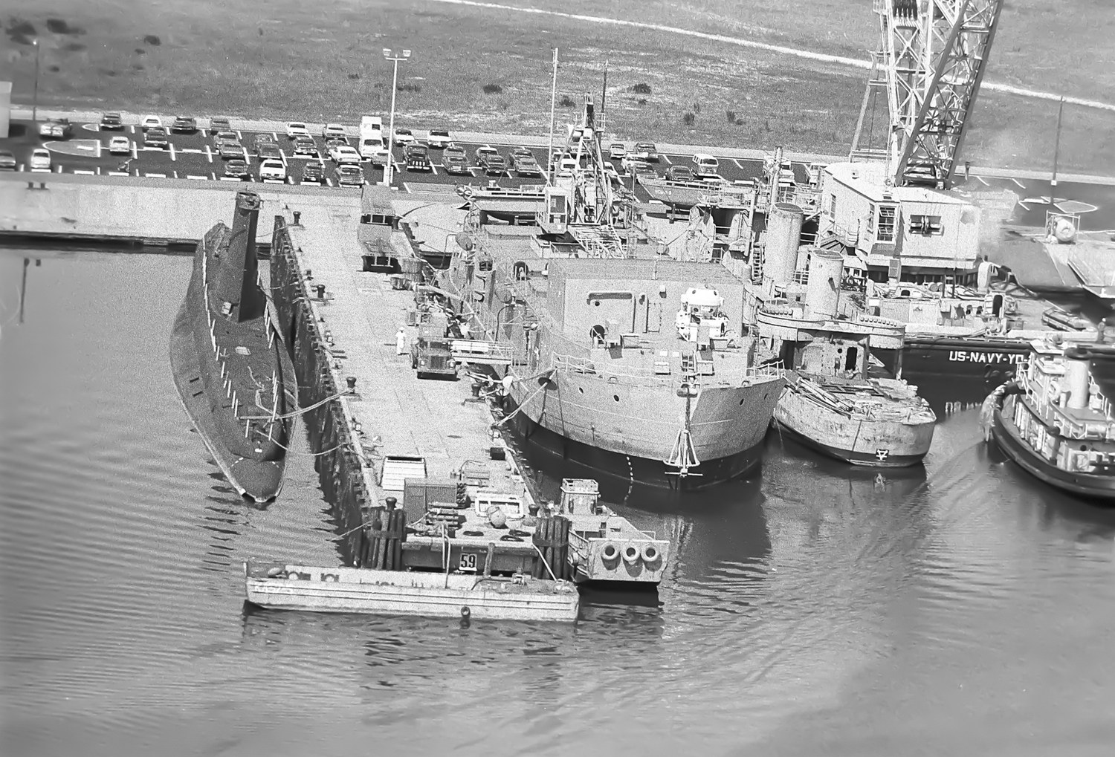  The Norfolk & Western wetslip seen from above: barges, tugs and the crane barge at work. The scale of the obstruction that had to be cleared before dredging could begin is plain. | 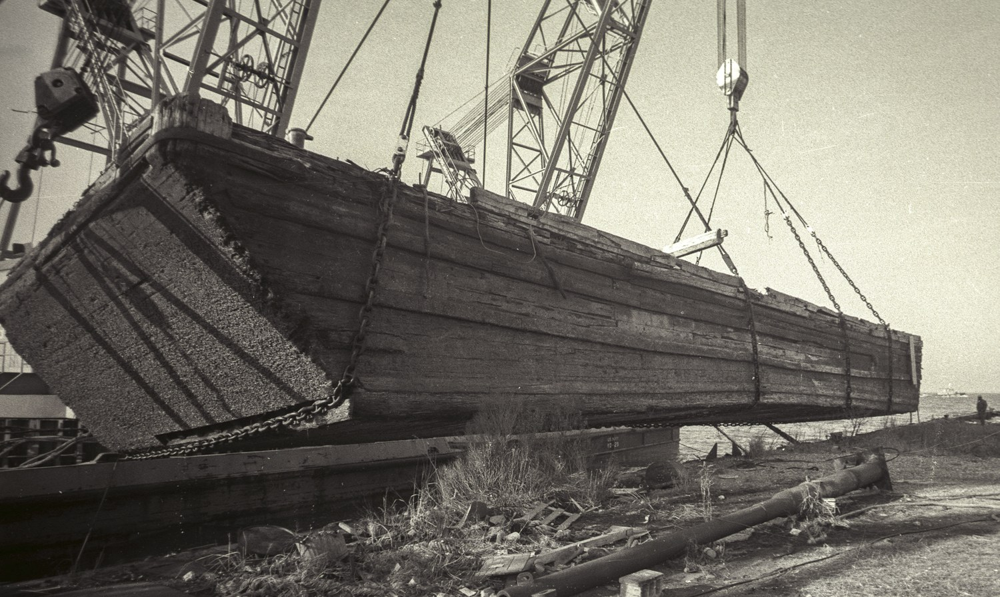  A long wooden lighter hull, its timbers thick with marine growth, hoisted stern-first from the slip and swung out over the debris field on the bank.
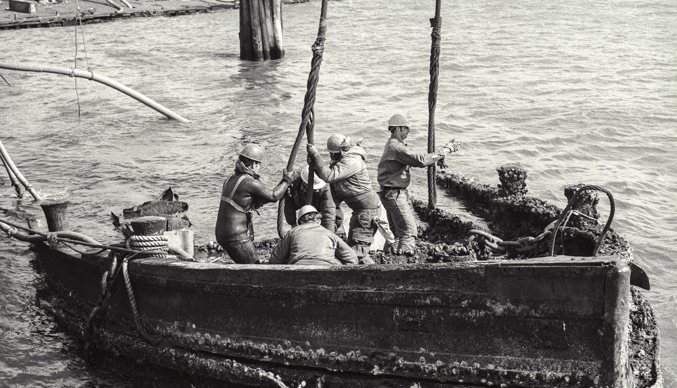  Hard-hatted salvage crew working from the gunwales of a small recovered craft awash alongside, hauling on a lifting strop. Old pilings stand in the background. | 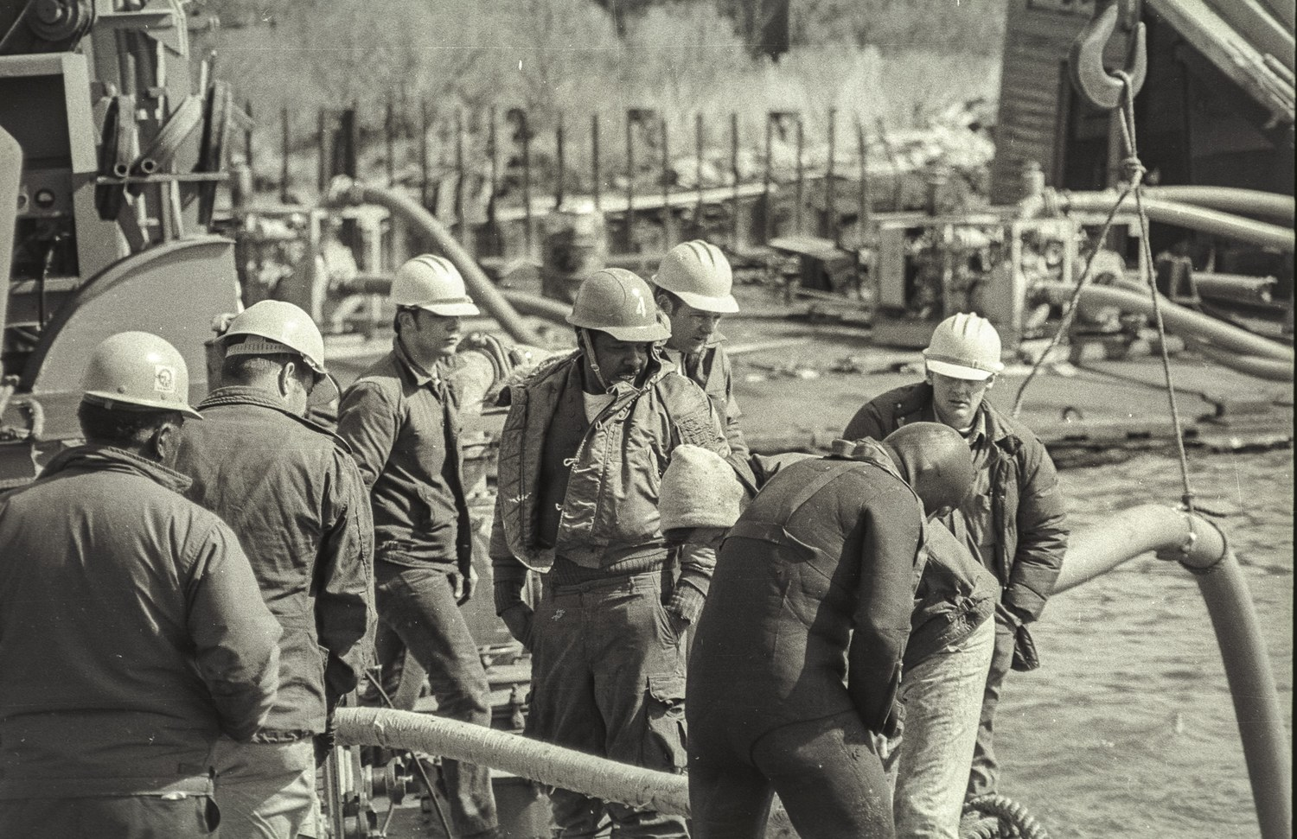  Harbor Clearance Unit TWO personnel on the barge deck during the clearance, hoses running past them to the work going on below.
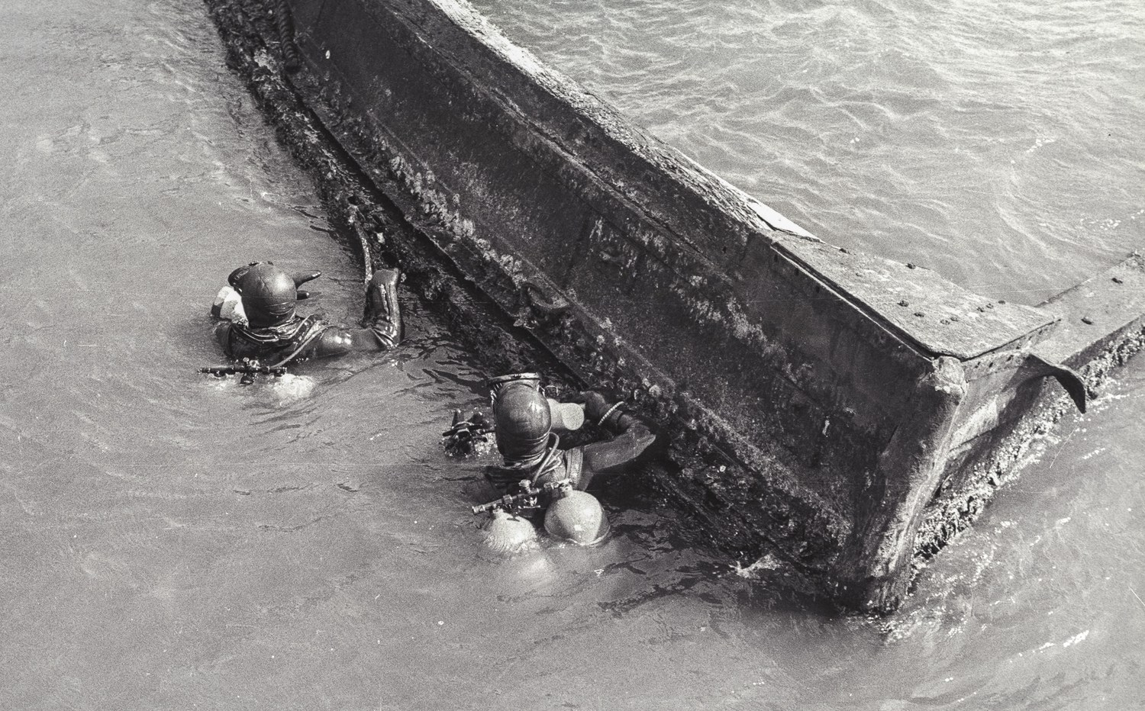  Two divers in the water beside a partially raised hull. The work went on through the winter and early spring of 1974, at times under difficult conditions. | 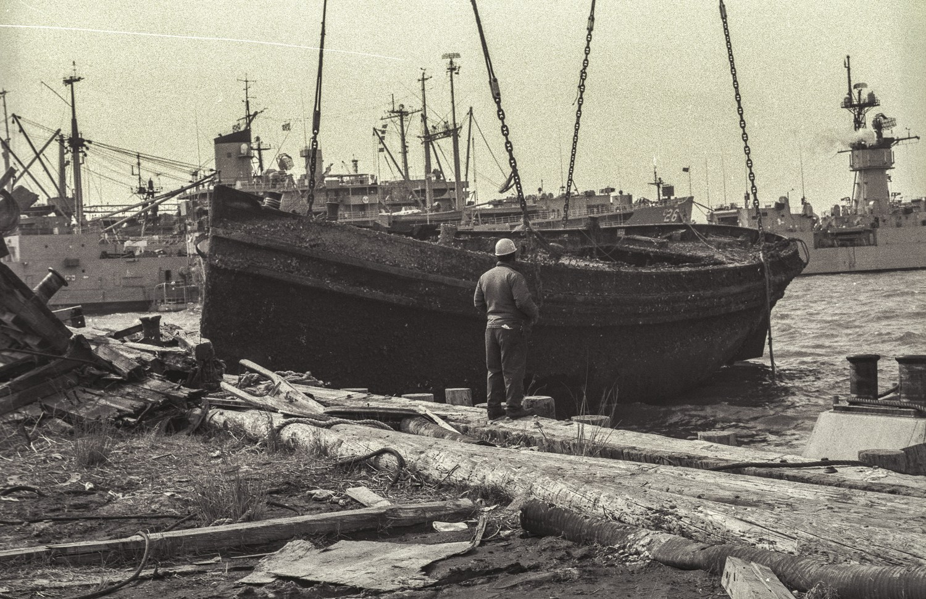  A recovered wooden barge set down on the bank in its lifting slings, a sailor standing alongside for scale. The moored ships of Naval Station Norfolk fill the background.
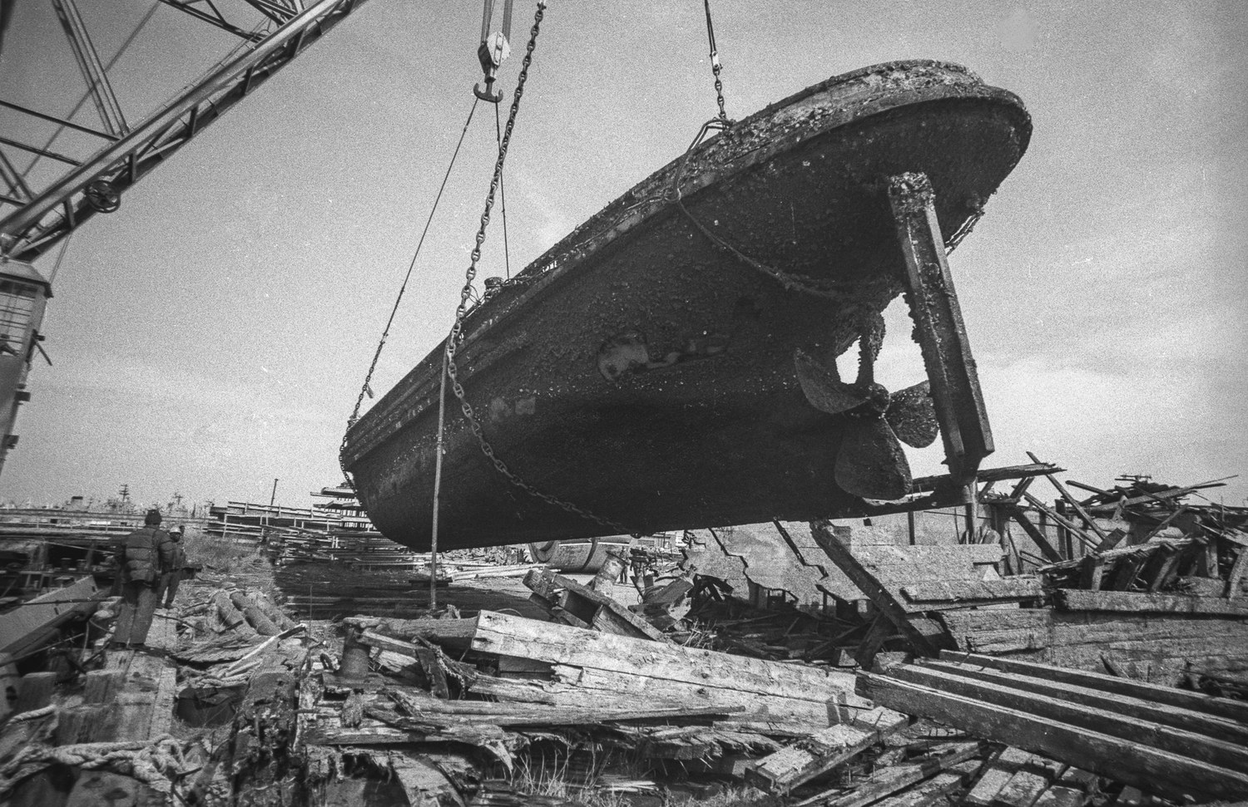  A hull lifted clear of the water over the debris field, silt and water still streaming from the timbers. | 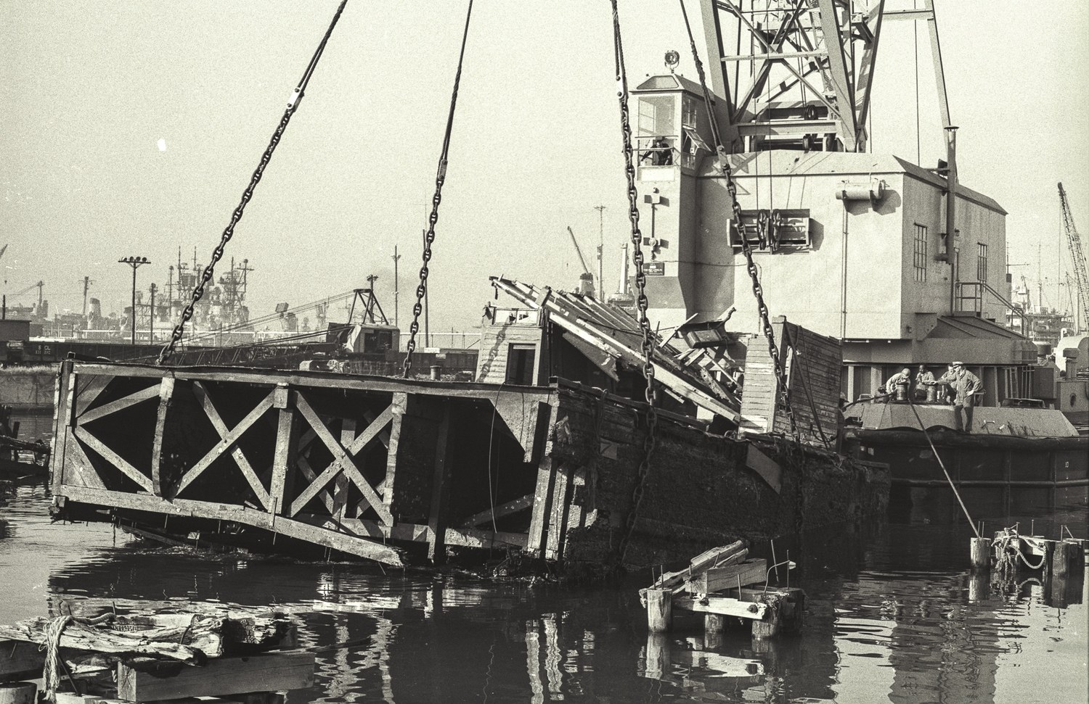  The crane barge lifting a heavy timber crib structure from the slip, a partially sunken vessel listing alongside.

The Mark 1 Deep Dive System and YDT-16, 1975
The Mark 1 Deep Dive System operating from the diving tender YDT-16 off Panama City, Florida, during the deployment that produced the world record open-sea dive to 1,148 feet in June 1975. He deployed with the system on independent duty as its only personnelman and yeoman, and served as ship’s photographer.
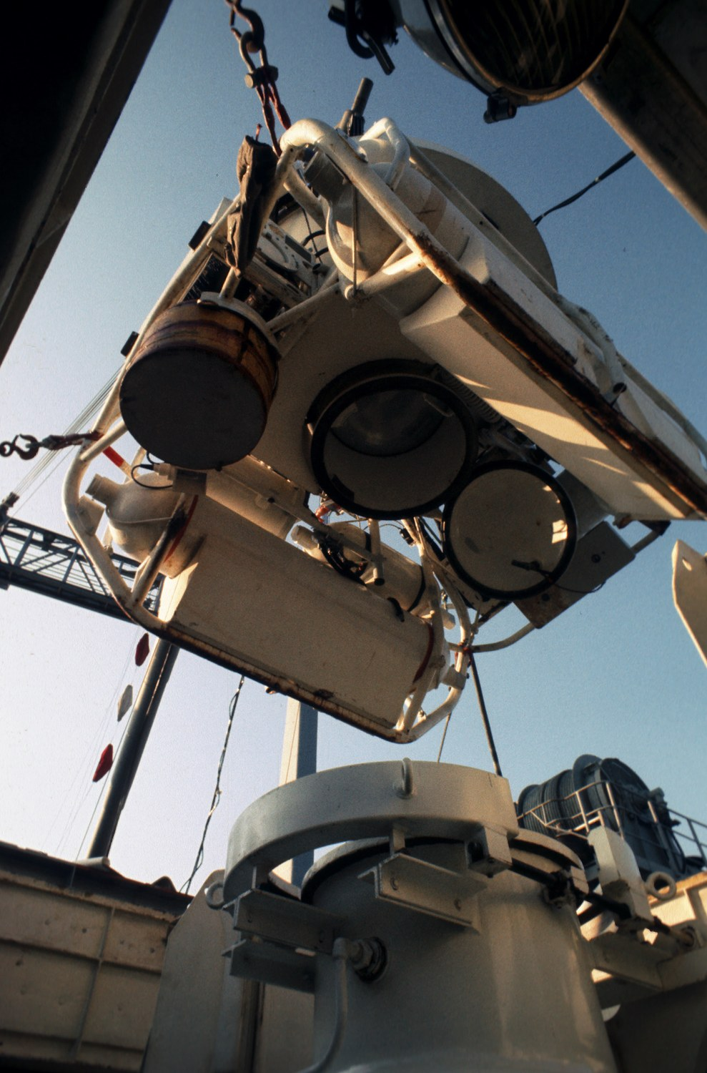  Looking up at the Personnel Transfer Capsule from the deck of YDT-16, its viewports and lower mating flange visible, with the deck chamber trunk below. | 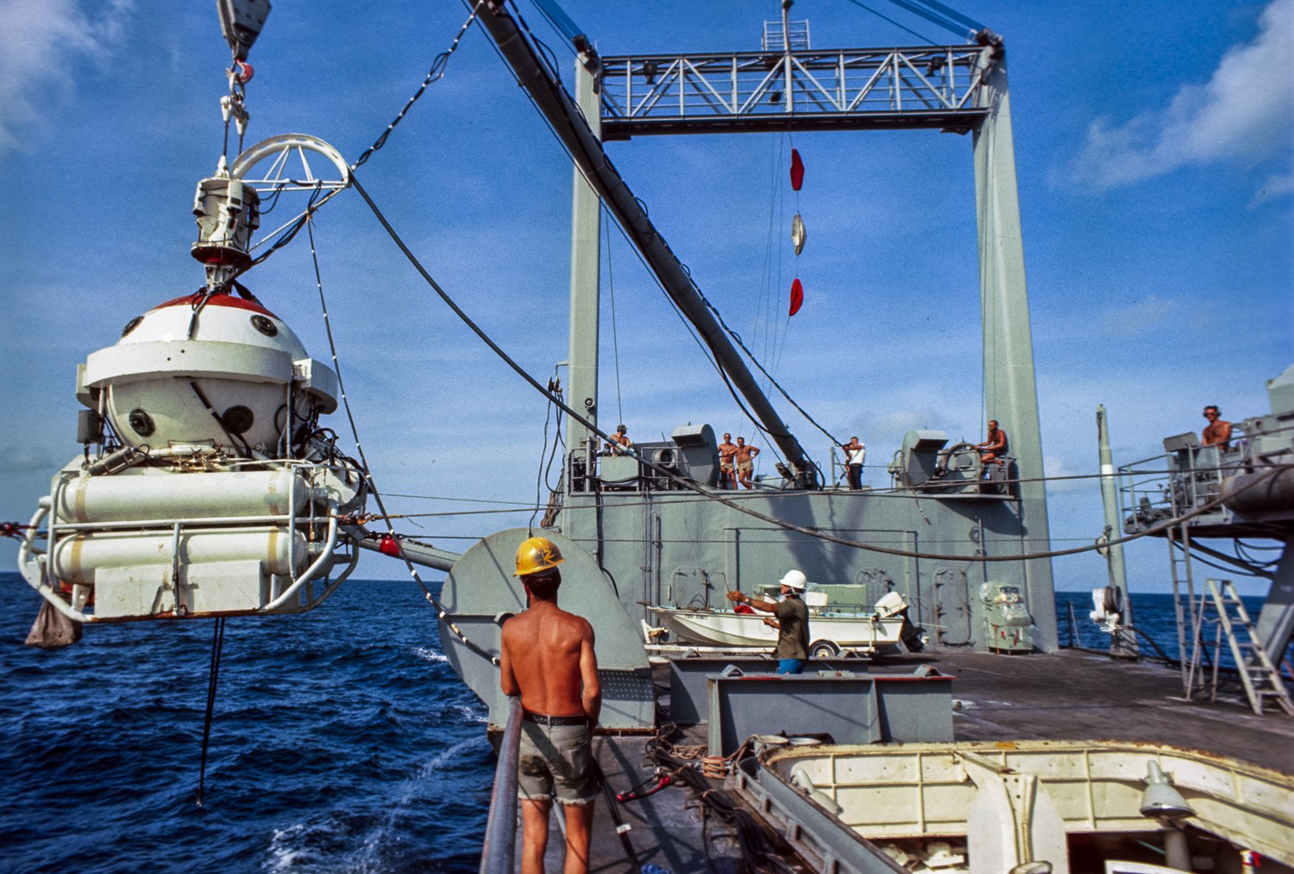  The capsule suspended outboard, the deck gantry and support crew visible aft. It carried divers between the deck decompression chambers and working depth.
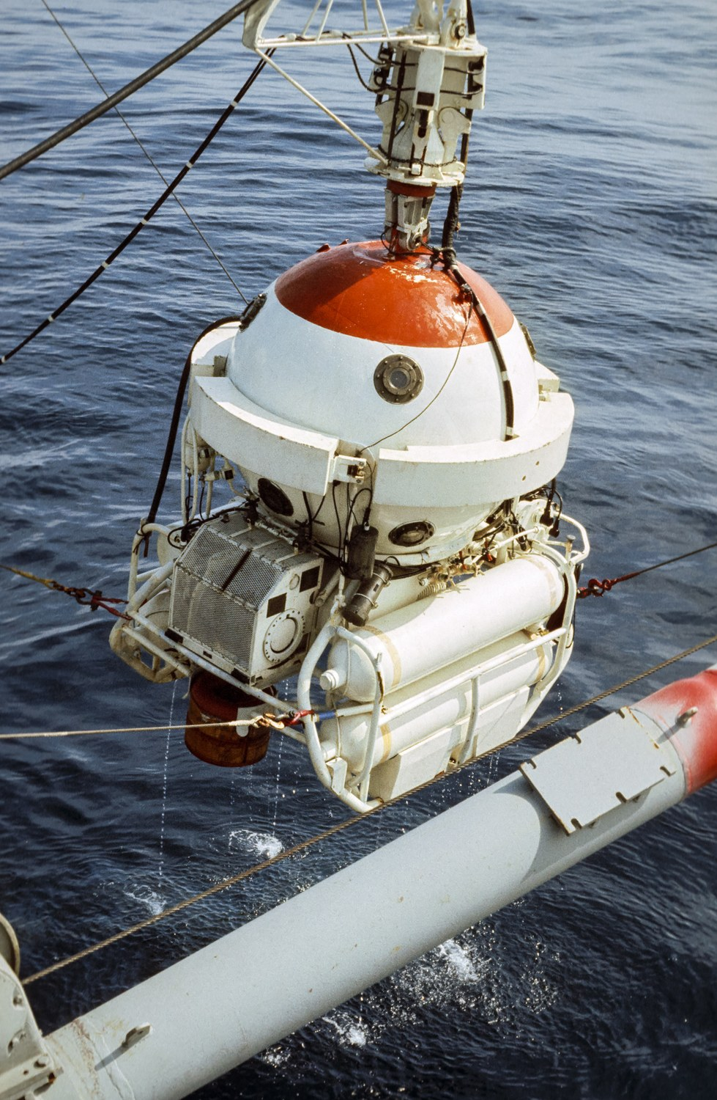  The capsule alongside, riding just above the surface as it is recovered from the water in the Gulf of Mexico. | 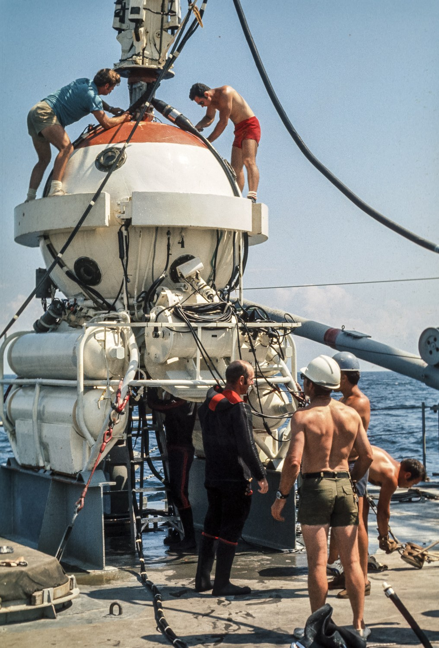  Crew working atop the capsule on deck between dives, the ballast cylinders and mating hatch clearly visible.
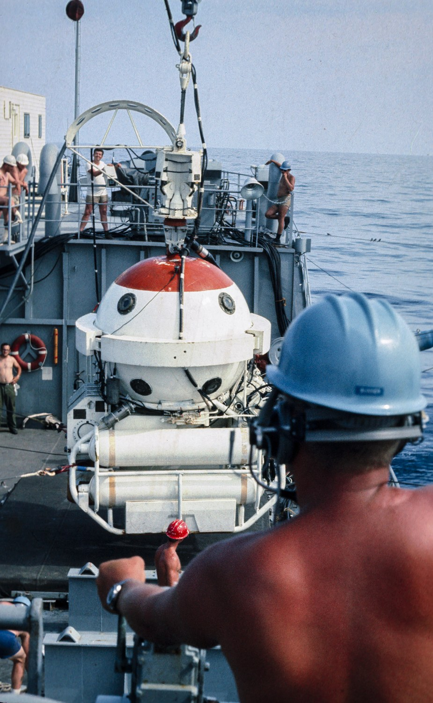  A deck hand steadies the capsule with a tag line as it is brought back aboard. | 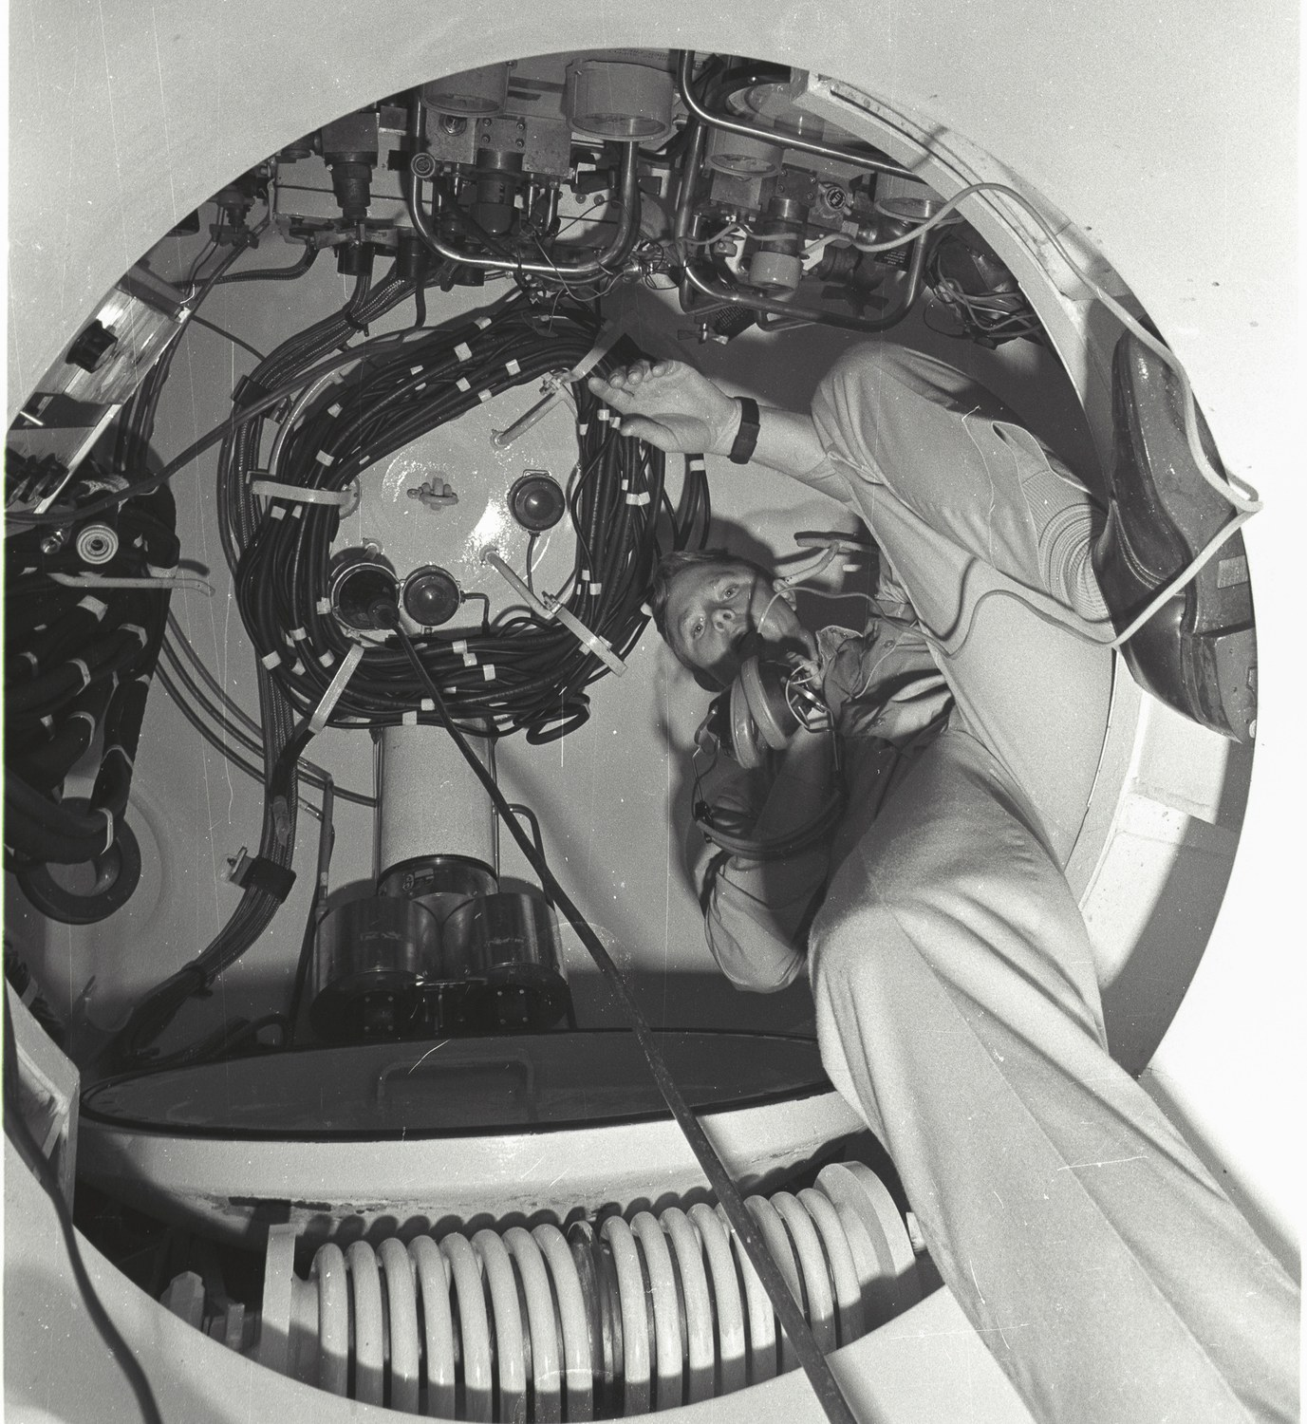  Inside the system: divers at work within one of the pressure chambers of the Mark 1 Deep Dive System.

SEAL Team ONE, Naval Amphibious Base Coronado, 1976–1977
Training operations at SEAL Team ONE during the tour in which he served as Leading Personnelman and command photographer — one of the first four sailors without SEAL training ever assigned to the command.
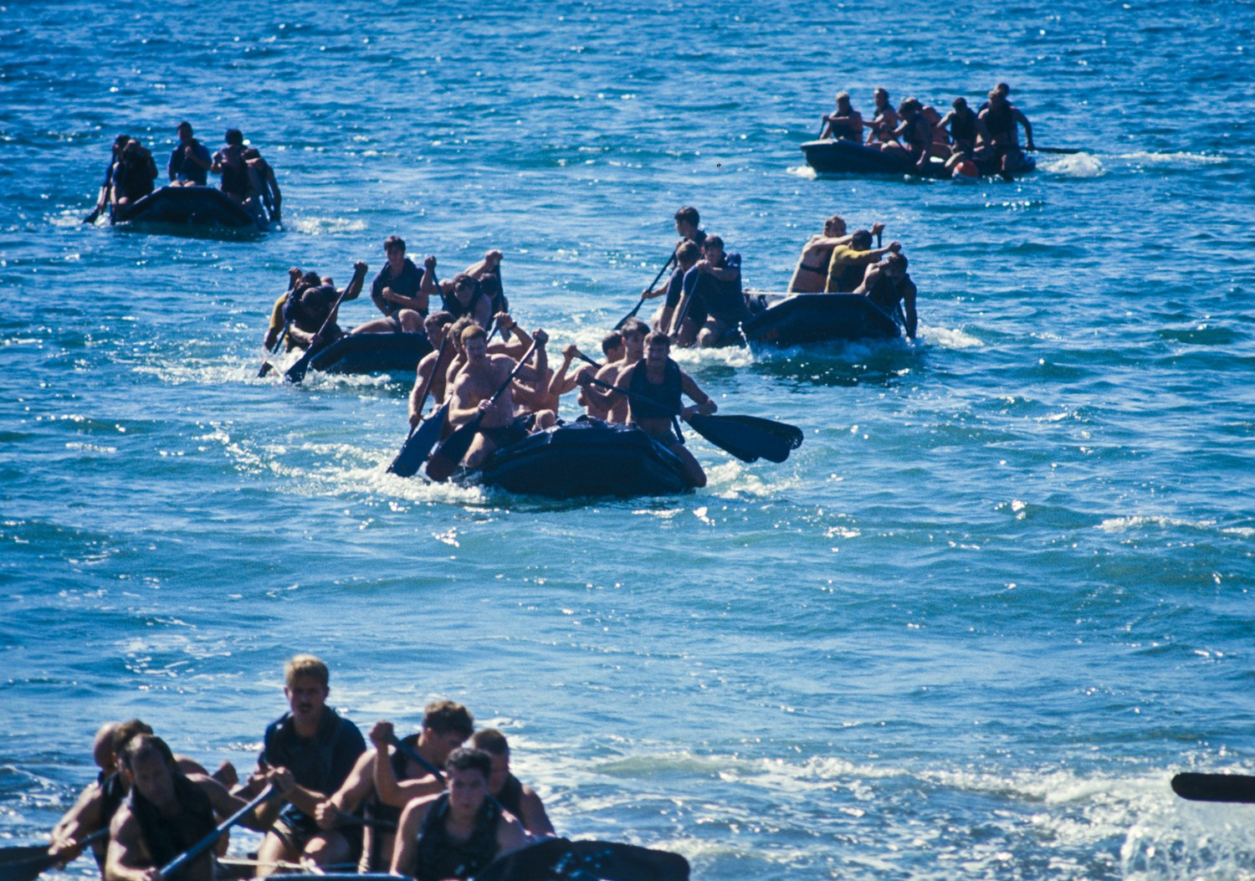  Inflatable boat crews under way on open water. Small-boat handling was a constant of the training cycle at Coronado. | 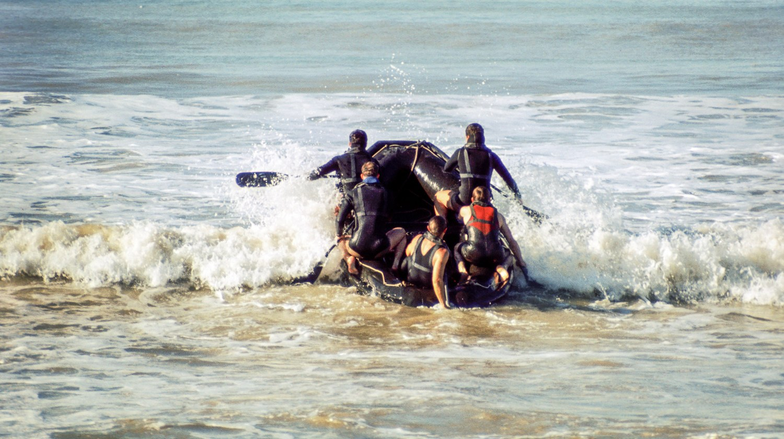  An inflatable boat crew running the surf line, January 1977.
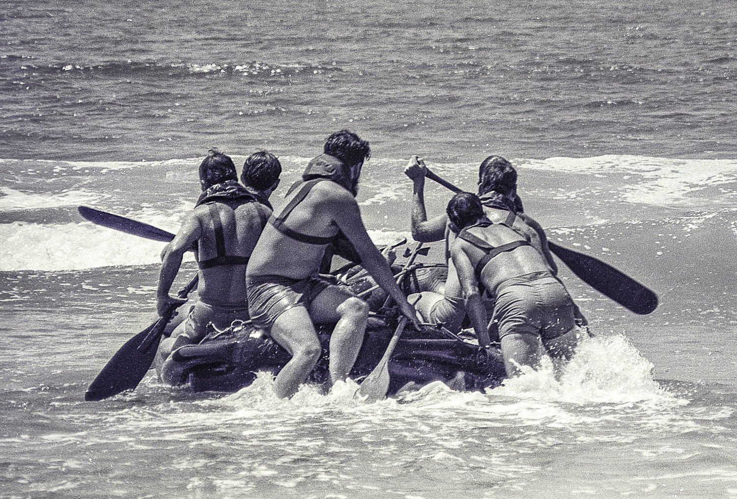  A boat crew paddling hard through breaking surf. |   Exit: a jumper’s legs fill the frame as a second parachutist falls away below, the mountains east of San Diego in the distance.
  A freefall parachutist over the mountains during airborne training. |   A jumper stable in freefall, arms spread, haze-layered ranges below.

Canopies descending over the desert drop zone.

Appendix J — Professional Letters of Thanks and Commendation: Full Text
Customer and colleague letters preserved from his industry career, in chronological order. Addresses, routing blocks, and copy lists have been omitted; the substantive text is otherwise complete. Two letters survive only as photocopies on which the writer's typed name is illegible beneath the signature, and are identified here by title and initials rather than by a guessed name.

16 March 1981 — Cleveland Computer Show
Mark D. Wolfe, District Manager 0542, Radio Shack, a division of Tandy Corporation.
I wish to express my sincere appreciation for the professionalism and effort put forth by the Divisional Blitz Team at the Cleveland Computer Show. The knowledge, experience and dedication demonstrated by you was impressive and invaluable.
I have been told by Mr. Bourland, Mr. Nohavel, Mr. Alias and perhaps, even more importantly, by customers that the Blitz was well organized, exciting and attractively displayed as well as staffed by professionals — I agree! Without your planning and concern, I doubt seriously our show would have been as successful. Thank you again.
— Mark D. Wolfe, District Manager, Radio Shack

4 May 1981 — Computerama '81, Indianapolis
Ted Stewart, Computer Center Manager, Radio Shack Computer Center 7667, Indianapolis.
I wish to thank everyone again for the help and support I received during our very successful “Computerama '81” blitz. The Blitz showed the Indianapolis Business Community how professional Radio Shack is, and how the TRS-80 is the BEST! Thank you again.
— Ted Stewart, Computer Center Manager, Radio Shack Computer Center, Indianapolis

16 November 1983 — “Making Customers Happy”
Bob Snapp, SNAPP-WARE, Cincinnati, Ohio, to Ed Juge, Director of Merchandising, Business Computer Products, Tandy Corporation. Later reprinted in Advanced Computing, February 1984.
“We service what we sell.” A simple phrase indeed. Sometimes, fulfilling that commitment is a task which requires superhuman effort. It is very pleasing to me, as a customer, that you still do your very best to live up to that commitment.
The recent efforts of your staff in resolving the problems with your new UART board for the Model 16 will never be forgotten here. Please extend my personal thanks to Don Stanfield, Dave Krebs, Philip Hurrell, Tudor ApMadoc, David Williams, Ken Brookner, and Ron Light for the extra effort put forth during this trying period.
When the fix for the problem was finally obtained, the act of transmitting the corrected system files to me via UUCP was both a testimony to the power and value of the XENIX system and the customer service dedication of your staff.
My pleasure with the Model 16 with XENIX can hardly be expressed in words. I think that this system is head and shoulders above the competition. Speaking not only as an 'add-on' vendor, but also as a user, I hope that your marketing efforts continue to keep you at the forefront of the microcomputer industry.
— Bob Snapp, SNAPP-WARE. Acknowledged 28 November 1983 by Ed Juge, Director of Merchandising, Tandy Corporation: “How nice to get a positive letter! Thanks very much for your thoughtfulness. I'll see that the other folks involved hear about it too.”

30 November 1983 — Grumman Data Systems
Director, Program Planning & Control, Grumman Data Systems Corporation, Woodbury, New York, to William Wash, Director, Computer Customer Services, Radio Shack.
This is to thank you for the recent visit of Tudor ApMadoc to our facility. Mr. ApMadoc was able to help us resolve the problem of communicating with our mainframe computers. He was also most helpful in providing additional insight concerning the TRS-80 Model 16 XENIX Operating System.
The capability to communicate with our mainframes does make the Radio Shack microcomputer a valuable tool. Again, we appreciate the support provided by Radio Shack and meeting an individual of Mr. ApMadoc's caliber.
— Signature initials JSP; typed name not legible on the surviving copy. Director, Program Planning & Control, Grumman Data Systems

10 January 1984 — COMDEX '83 and the Tandy 2000 launch
Ron G. Stegall, Senior Vice President, Computer Marketing, Tandy Corporation, to five named staff including Tudor ApMadoc.
Now that the dust has settled and our new Tandy 2000 has been successfully launched, I would [like to] take a moment and personally thank each of you for the special effort and time that you devoted to the success of our showing at Comdex and our product announcement at Caesars Palace.
We realize that for this type of an effort to come off without one hitch required a lot of extra hours and effort behind the scenes and for each of your efforts and enthusiasm I would like to say — thank you.
— Ron G. Stegall, Senior Vice President, Computer Marketing, Tandy Corporation

18 June 1984 — National Easter Seal Society
Director, Management Information Systems, National Easter Seal Society, Chicago, to Ron Conway, Vice President of Marketing, Altos Computer Systems.
On Tuesday, May 29, your Dallas Regional Systems Engineer, Tudor ApMadoc, spent the day with the MIS Department of the National Easter Seal Society. Tudor presented a series of demonstrations concerned with programming the UNIX shell.
We found Tudor to be knowledgeable, bright, and personable; the training session was certainly helpful to our technical staff, and we generally regard this as one of the more positive contacts we have had with Altos. Please accept our thanks for Tudor's excellent help.
— Signature initials RMG, Ed.D.; typed name not legible on the surviving copy. Director, Management Information Systems, National Easter Seal Society

28 January 1987 — Uniforum trade show, Washington, D.C.
Chuck Berman, Altos Computer Systems, internal memorandum: “Tudor's outstanding Effort at the Uniforum Show.”
Normally, I don't make any big deal of the assistance I get from an S.E. in setting up and working a booth at a trade show but in Tudor's case I feel it is very warranted. Setting up and showing communications products is not an easy task especially when there are significant roadblocks to be dealt with. Tudor was an outstanding resource and I would go so far as to say that many products would not have been up and running if it were not for Tudor's presence. Even during the most trying times Tudor remained cool and pushed things forward to completion. He offered some very constructive suggestions to improve and alleviate many of the ongoing problems in the trade show environment. All in all a job to be applauded.
I'd also like to say that I am eagerly looking forward to working with Tudor again. If I could hand pick the people I work with in the future, Tudor would definitely be at the top of the list (the man is on the ball). We need more Tudor's around!!
— Chuck Berman, Altos Computer Systems

HunTel Communications seminar, Omaha, Nebraska (NetFRAME years, 1993–1995)
Jennifer Wilcox, Marketing Coordinator, HunTel Communications Inc., Omaha, Nebraska, addressed to Tudor ApMadoc at NetFRAME. The surviving copy carries no year.
I wanted to take the opportunity to express my appreciation to you for presenting at the seminar on June 15th. The information that you shared with the seminar attendees was extremely helpful; all of the comments regarding the content of the seminar and the presentation of that material have been very positive.
Again, thank you for your time. Your assistance to us in our effort to continue to provide our customers with important and timely information was certainly appreciated.
— Jennifer Wilcox, Marketing Coordinator, HunTel Communications Inc.

Appendix K — Professional Recommendations: Full Text
All 48 written recommendations on his LinkedIn profile, in chronological order by the date each was written, spanning June 17, 2009 to November 24, 2020. Each is reproduced in full as written, with the author's job title and organization as recorded on the profile at the time of export. Titles and companies reflect each recommender's position at export, which in many cases is later than the working relationship being described.

June 17, 2009 — Igor Saulsky
GLG Network Member. Consulting IT companies in need to build the best sales organizations. — GLG
Tudor belongs to the top group of storage experts in our industry. If Tudor does not know it, it must be something extremely exotic, and probably does not work anyway. When I have worked with Tudor at VERITAS Advanced Product Team (APT), he was (as I believe he is today) a go-to-expert in our field. Tudor's role was to boldly go and win business where no VERITAS field SE could venture to go, and to present/demonstrate our then-cutting-edge-products. Our customers, partners, and VERITAS engineers benefited from Tudor's expertise, his willingness to help and guide, his "can-do" attitude, and "refuse-to-loose" approach to business. If anybody is looking for an impeccable technical expertise, great communication and customer skills, business savvy and ability to translate technical features into operational and financial benefits, then Tudor is your guy. I would trust my most critical customers and partners to him - need I say anything else? I strongly endorse Tudor as somebody I highly respect, and recommend him to anyone in need of a top technology and IT business expert. Thank you

June 17, 2009 — Howard Silver
Retired — Retired and enjoying Life.
Tudor was part of my Appliance Software Division at VERITAS, and was a great resource for the team. Not only did Tudor do a great job with presales support, but he also can clearly explain the value proposition and technology to prospects. Tudor learns new technology quickly and keeps current with competitive products and technology. Additionally I found that Tudor was a great source for feedback and future development features, and could understand and express the users' needs.

June 17, 2009 — Phil Adair
Sales — Trek Bicycle, Cary NC.
Tudor is one of the brightest and most diligent colleagues I've ever worked with. He was very effective in striking a mutually beneficial balance of vendor and customer's needs. You could always count on Tudor to determine the true requirements of solving the customers challenges. Tudor was a great peer and mentor for those who were associated with him, always willing to pitch in and help out and always focused on helping others raise the level of their game.

June 17, 2009 — Oleg Kiselev
Principal Engineer — Cohesity
Tudor is a highly experienced sales engineer who excels at all stages of the field service and systems engineering process, from pre-sales customer-focused system design to post-sales integration and customer issue resolution. I have interacted with tudor in many customer engagements, across the stages of customer's evaluation and deployment of VRTS produducts. He was always a pleasure to work with, combining customer-centric perspective with technical expertise in the practical deployment and configuration of our software. He particularly excelled at handling new products and new initiatives, playing a key role in improving our software and making it successful in the market despite the usual teething pains such products inevitably have.

June 17, 2009 — Bryan Bergstrom
Sales Leader — CAARMO, Inc.
I worked with Tudor for a few years. He was always an outstanding engineer, great with customers and always willing to help. He help close a few business deals. Great person!!

June 18, 2009 — Ric Tappero
Coach Operator — VTA
I am more than happy to recommend Tudor. I worked with him at Altos Computer Systems and managed hin at NetFrame. Tudor performed outstanding work with little supervision. He was also quick to see needs and volunteer for projects which could be leveraged throughout sales and engineering organizations. I am sure that Tudor would be a valued resource to any organization.

June 19, 2009 — Bob Bates
Business Mentor — SCORE
Tudor is an excellent technition with exceptional customer skills. He is one of those "let me help" type of individuals that will contribute significantly to any team. Bob Bates

June 19, 2009 — Michael Weir
Marketing Consultant — Akeana
Tudor was an awesome SE for us. At a time when we most needed a steady hand, he was there. His attention to detail and organizational abilities were sorely needed for our growing organization. I miss him and wish he was here with me at Cisco.

June 19, 2009 — Chris Horrocks
President — Strategic Advanced Management Systems, Inc.
Tudor is a most enjoyable colleague with whom to work. He is universally respected and his working style - as well as his masterful management of technology is most impressive.

June 19, 2009 — Jeff Sinnott
Vice President, Worldwide Sales — Index Engines
As an SE at NetFrame, Tudor did a great job supporting his sales team and reseller partners to consistently exceed sales goals at a fast growing company. Tudor had the unique ability to discuss very complex solutions with our prospects in way where they could understand not only the technology, but the business benefits as well. With his knowledge of the industry and our competition, I would frequently discuss new product and sales strategies with Tudor to make sure that what we were planning back in HQ would actually be effective out in the field.

June 19, 2009 — John Chun
Program Manager, FDC — Ziply Fiber
Tudor is the consummate professional. Detail-oriented, superb technical skills, outstanding with customers, listens well and follows up! Tudor "gets" the big picture and delivers on what he promises.

June 20, 2009 — Tom Middleton
Founder — Stealth Startup
Storage is a space that requires lots of practical (and sometimes esoteric) know-how across a wide spectrum of vendors, devices, protocols (not to mention versions!) and Tudor has that experience. Tudor was always great to work with, knowledgeable, hardworking and attentive to details. What more can you ask for?

June 20, 2009 — Jim Nolan
Sr. VP, Professional Services and Delivery — Interactions LLC
Tudor’s contributions to Incipient were outstanding on all levels – significance, quality, quantity, touch points. His technical knowledge depth and breadth of experience were key to the organization. Partner and customer respect for Tudor enhanced those relationships. Tudor is unique – he recognizes needs, identifies required course of action, and is in no way bashful about doing what it takes to deliver what is needed. He is a very strong customer advocate and company representative.

June 21, 2009 — William Buie
Strategic Advisor — Aspichi
Tudor has a unique balance of both technical and sales experience which made him a valued resource to Symantec and his alliance partner. Tudor knowledge of the portfolio and of his partner's business made determining and executing joint solutions a much easier task.

June 22, 2009 — Larry Lozon
Chief Technology Officer — Catch Mobile Health and Catch Digital
I had the opportunity to work with Tudor between 2002 and 2007 while I was at EDS and Tudor was at Symantec. As a partner to EDS' hosting business, Symantec placed some of their best people on the account team. Tudor was at the top of that list. He is well versed in all areas of technical and product discussions surrounding the data center tooling and security environments and I would personally welcome a future opportunity to work with Tudor again.

June 22, 2009 — Bryn Jenkins
Group Leader, Developer Platforms Group, Volaris — Volaris Group
Tudor's technical & product knowledge coupled with his market insight made him a valuable weapon for the sales region in which he worked. His personal drive, natural enthusiasm and ability to work autonomously made him a much sought after resource.

June 23, 2009 — Brett Cooper
Senior Manager, Sales Excellence — Deloitte
Tudor is one of the best team players in the technology space that I know. He is able to seamlessly move from the boardroom to the customer meeting room providing value and deep insight into the challenges of the real-world and how to solve them. Tudor is a tireless supporter of the voice of the customer and is adept at both presentations and deep technical architectures. If I had the opportunity to bring someone of Tudor's caliber on within my team I would not hesitate to make it happen.

June 24, 2009 — Jeff DePrato
Private Investor — Atliam, LLC
I had the peasure of working on he same partner team with Tudor for several years. Tudor was a strong asset to our team and always had the customers best interest at heart. His expertise in the storage field is unsurpassed and he would be a complement to any enterprise sales structure. I would recommend him strongly to a high tech company.

June 25, 2009 — James Rafferty
Top 1% of the Top 1% Headhunter — Roy Talman & Associates, Inc.
I worked with Tudor at Altos and we have kept in touch since. I found Tudor to be an excellent engineer, person and professional. He is excellent with clients, sales and engineering professionals and loyal to the company and professionals he represents and works with.

July 1, 2009 — Ajay Behl
Director of Cyber Security — Cogent Integrated Business Solutions Inc.
Tudor is an outstanding SE who can present very well. Tudor is very knowledgeable on Veritas and Symantec products. He has a very good acumen for building very good customer relationships. He works well with other team members and I would recommend him as an out stand SE. AB

July 6, 2009 — Fred van den Bosch
Advisor — Plataine
Tudor was one of the star technical people in the VERITAS field organization, known by many for his deep knowledge of our products and his passion for quality. He was a much sought after resource in our engineering organization to help to provide feedback on existing products and input on new products and features. He definitely was perceived as one of the important technical leaders in the company.

July 7, 2009 — Tony Martin
Information Technology And Services Professional — Western Veterinary Partners
I worked with Tudor for many years at VERITAS. He has a great way of blending knowledge and passion for what he does with a great personality and sense of humor. I can wholeheartedly say that he would be an asset to any team.

July 27, 2009 — Mark Griffiths
Chief Information Officer — Solari, Inc.
Tudor is a great person to work with. His ability to grasp all of the different technologies and see how they can be adapted to the real world to offer true benefit is a great asset. I believe his skills brings the outside world into an organization looking to bring true benefit from their services and products.

August 4, 2009 — Brad Garofalo
Senior Partner — Brett Jennings Real Estate Experts
Tudor is a wonderful guy to work with. He is able to explain himself to less technical people very well, something our customers appreciated. He is a great team player and I would work with Tudor again in a second.

October 26, 2009 — Chris Andrews
SVP WW Sales - Retired October 2024...Advisor — Netskope
I''ve worked with Tudor for 5+ yrs at NetFrame in the roles of Pre-sales Consulting Systems Engineer. Tudor has demonstrated great technical knowledge in Networking, Security and Enterprise Application domains. He is extremely motivated and independent. I endorse Tudor wholeheartedly and would recommend highly.

May 17, 2010 — Tom Offutt
Retired — Retired
I worked with and later managed Tudor for 4 years at Wyse. He was a superstar SE and manager that always gave 110% to winning the deal at hand and ensuring customer satisfaction at every step of the way from pre-sale demonstrations to post sale support. Tudor was always our troubleshooter for the most difficult accounts and technical issues. His enthusiasm, communications skills, technical knowledge and business accumen were second to none. He was universally liked and in constant demand by the sales team. If I had the opportunity to hire Tudor to work for my company in any customer facing role, I would not hesitate for a second.

May 17, 2010 — Hans Beierle
Self-Employed
I had the pleasure of working with Tudor during my EDS Portfolio years on a couple of storage and data management initiatives. His expertise in these areas and the deep insight into our business have been extremely helpful in determining and executing new EDS services based on joint solutions. Tudor was a great source for feedback and future development features, and always helped us to express our needs into Symantec.

May 21, 2010 — Michael Vaughn
Owner/manager — Pie-in-the Sky Orchards
I worked with Tudor Apmadoc for 12 years and found him to be committed to excellence. His work was always incredibly thorough and substantiated with facts and demonstrable example. He showed tireless effort and time commitment to any project assigned. Tudor will always seek to make a product, department and company a higher quality entity with his desire for excellence.

July 24, 2010 — Chuck Wood
Product Marketing — Hewlett Packard Enterprise
Tudor is a bright and highly motivated individual with a "get it done" attitude. He has excellent technical skills, and he has a great understanding of a wide variety of compute and storage technologies. Tudor is an asset to any company as well as a great person to work with.

June 10, 2013 — Judy Allen
Chief Executive Officer — Loving Life 2013- onward
I have had the pleasure of working with Tudor for eight years working with our Alliance partners. Tudor was involved in driving some of our most complex and largest opportunities. He is excellent at explaining complex solutions to customers and partners. He has strong team work skills to make product management, engineering and our clients work together to implement solutions not just design them. Tudor is an excellent asset for our team.

July 5, 2013 — Hitesh Patel
EMEA GSI Lead — Splunk
I have had the great please of having Tudor on the team during my time at Symantec. Tudor is a senior global technical lead with many years of experience. He has aided the team and navigate technical propositions from monotization through to delivery in both storage and security fields. He is a dedicated, self motivated person and great team player. I would highly recommend Tudor to any organization looking for a very talented global technical lead.

July 5, 2013 — Steve Rohr
President — Rohr Woodworking
I had the privilege of working with Tutor during his career at Veritas. He is one of the most technically competent software engineers I know. His ability to explain his own products in both technical and business terms is outstanding. He has excellent presentation skills and every joint customer we had relied heavily on his expertise. He is very well respected in his field. The best of the best.

July 7, 2013 — Roy Robinson
IT and IS support — Self-employed contractor
I worked with Tudor at Wyse Technology during my long tenure there. Tudor is a results-oriented Manager (with a technical background) who will accomplish the goals for company success.

July 8, 2013 — Betty Woychowski
Product Marketing and Product Management — Marketing Consulting
I worked with Tudor for a few years at VERITAS. Tudor was a technical pro with the sales skills and experience to be an excellent resource for identifying new business and enabling complex, large Enterprise deals. He was a great customer advocate into the product teams and someone I would enjoy working with again.

July 9, 2013 — Gary Baker
Retired — Hewlett-Packard
Tudor uses his broad base of technical depth to help integrate multiple vendor products into new solution offerings. I highly recommend Tudor for his personal commitment to help design, implement and support complex product solutions. Gary Baker Chief Storage Architect EDS/HP

July 10, 2013 — Paul Mayer
Senior Staff Product Manager — Cohesity
Tudor is a great business development catalyst, going to great lengths to understand the nuances of his customer’s business model, and working with internal resources to flex the company’s offerings in creative ways to help his customers drive innovation in the marketplace. As an example of this, through Tudor’s strong leadership we have enjoyed improvements in NetBackup’s deduplication capabilities which have helped position HP/EDS as leader in providing backup services to its customers while positioning Symantec for greater success in the competitive dedupe market.

July 10, 2013 — Phil Yaccino
Senior Distinguished Engineer — Cloud Software Group
I have the pleasure of working with Tudor. Tudor is our HP Solution Architect for our GSPS team. He is one of the go-to SEs when it came to working with and evangelizing HP's needs in our organization. Tudor has an excellent combination of deep technical knowledge with business acumen. I would highly recommend Tudor.

August 1, 2013 — Hüseyin Dahlhausen
Strategic Account Executive / AI Security — Proofpoint
I have the great pleasure to work with Tudor at VERITAS Software Symantec. His aim for excellence in whatever task he has to complete is outstanding. He understands customers requirements and needs beyond obvious things and therefore get's quickly accepted by customer as an experienced and knowledgable expert. I`m always impressed by the professionalism and positive attitude. Besides his strong customer and partner focus he is always willing to help others Tudor acts in a matter what's good for the customer and partner and the company. I recommend Tudor to everyone who is looking for a highly motivated team player who can also act in a self paced way with a sound understanding on how to match "revenue" to business needs and benefits. Tudor, keep the fire burning and thanks for all your support.

March 23, 2014 — Keith Mozena
VP Global Alliances — Open Origin
Tudor was a dedicated and focused member of my sales team for 6 years. He has a unique ability to understand the customer or partner's technical problems and provide more that one way to solve them. He has an interesting blend of experience & skills which allows him to think creatively about alternate ways to win new business or create new joint solutions. He is reliable and has a solid work ethic. I would gladly have him on my team again.

May 1, 2014 — Rebecca Caldersmith
Channel Sales Executive — SmiForce Inc.
Tudor is a highly intelligent and knowledgeable Security and Storage Solution Architect with built-in sales intuition as well. His energy and passion for his work emanated throughout our team with the selflessness to assist a colleague at any time. Tudor is adept at strongly aligning himself to key corporate and field stakeholders at a partner and customer level. He is well organized, well-spoken and always willing to take on more responsibilities. I had the pleasure of working with Tudor at Symantec for 12 years and it was an extremely positive and educational experience and I would strongly recommend Tudor to any technical, sales or alliance team.

March 30, 2015 — Bailey Stone
Global Alliance Executive - Retired — Retired
Tudor is one of the most knowledgeable, effective and driven technologists I have ever worked with. His concern for understanding a customer's business needs first then applying the right architecture has resulted in highly successful, global solution offerings that have driven millions in revenue for our team. Tudor and I have collaborated closely for over 15 years. He is both a pleasure to know and work with and an exceptional talent. I highly recommend him.

April 21, 2016 — Robert Lynch
Senior Security Engineer — LevelBlue
Tudor is very detail oriented and process strong. He excels in his technical capabilities which provide his customers with a great level of service. He is forward thinking when it comes to strategy and opportunities.

April 25, 2016 — Omar Dajani
Global Vice President, Enterprise Sales Engineering (ESE) — Datadog
Tudor is a talented, experienced, and innovative Solutions Architect. He has mastered both the Veritas technologies he's responsible for as well as the leading solutions in the industry. This is critical, as success is achieved by finding ways to integrate technologies together from different vendors to create joint offerings that customers want to consume. Tudor is action-oriented and works with great attention to detail. He's an influential thought leader who works tirelessly to advance sales success at Veritas.

May 3, 2016 — John Hilger
Global Solution Architect — Pure Storage
I've worked with Tudor for many years and during that time he has demonstrated deep technical knowledge of Veritas solutions and various industry solutions. Tudor is very customer focused and uses his understanding of customer needs to position appropriate solutions and to ensure customer satisfaction. I would recommend Tudor for any technical sales position.

December 29, 2016 — John A. Costa, VSTP, ITIL v3
Senior Sales Engineer - Public Sector - HEDG — Veritas Technologies LLC
I have worked with Tudor over the many years at Veritas and Symantec. During that time Tudor has demonstrated deep technical knowledge of Veritas technologies as well as other leading solutions in the industry. This includes everything from emerging to mature products technologies. I would highly recommend Tudor for any role as he will make a valuable addition to any team.

December 6, 2017 — Simon Jelley
Vice President of Product Management — Dell Technologies
I have worked with Tudor over many years and always enjoyed working with him from my perspective as a GM and Product Management leader because he is a strong advocate for the business partners he represents. He helped ensure the product teams had clear understanding of, not just the partners solutions and technology, but also their business model, practices, processes and key interaction and integration points. I could always rely on Tudor to ensure if we had questions he be able to answer them diligently and introduce to key people to drive collaboration and execution with our partners.

September 1, 2020 — Siobhan Ellis
Cross Functional EU Data Act Programme Lead — JLR
I've known Tudor for a number of years. Initially I was a customer. I quickly realised that he has a great deal of integrity and I could trust what he was telling me. Also, even though I'd give him something difficult to find out, he'd get me an answer and, if he knew it didn't meet my needs, he'd connect me to the person I needed to influence.

November 24, 2020 — E Phillips
Associate Partner — IBM
Tudor and I worked a long side each other for 2 years and was impressed by Tudors ability to deal with even the toughest challenges and projects – effortlessly. That skill often takes years to develop among consulting professionals, but it seemed to come perfectly naturally to him. Tudor Is passionate about security and always goes the extra mile. If I had the chance. I work with Tudor again

A Note on Sources
This biography rests on primary documents. Every quotation is reproduced from the source named, and attributed to the officer or author whose name appears on the original; where a signature is not legible on the surviving copy, the attribution says so rather than guessing. The sources fall into the following groups.
Naval service. His United States Navy service record, including the DD-214, history of assignments, advancement records, security clearance certificates, and school certificates; eleven enlisted performance evaluations recorded between 1974 and 1978, ten of which survive as complete NAVPERS forms; letters of commendation and appreciation from the Commanding Officers of Service School Command NTC Orlando, Naval Station Norfolk, Harbor Clearance Unit TWO, Navy Finance Center Cleveland, Navy Regional Finance Center San Diego, and the Enlisted Personnel Management Center; the Letter of Commendation of 7 December 1976 approved by Rear Admiral D. F. Emerson, Deputy Commander Naval Surface Force, U.S. Atlantic Fleet; naval messages from CINCLANTFLT, COMNAVSEASYSCOM, COMSERVRON EIGHT, and the Navy Experimental Diving Unit concerning the June 1975 Mark 1 Deep Dive System world record dive, together with the Navy’s published accounts of that dive; and the letter of appreciation of 8 November 1976 from the Deputy Commander, Joint Unconventional Warfare Task Force, with its endorsements.
Early life and education. A family biographical outline; the Report of Extra-Curricular Activities (1981); the family’s genealogy database (Family Tree Maker GEDCOM export, July 8, 2026); and Robert N. Cook, “Structured Programming Using BASIC” (Association for Computing Machinery, 1980). Mayfest and Autumn Rock Fest details are drawn from the subject’s own archive of festival advertisements, tickets, backstage passes, band contracts, and contemporaneous coverage in CM Life, the Mt. Pleasant Sun, and the State Journal, published at apmadoc.net/mayfest; chart and career details for the national acts are from published music-industry references.
Career. The subject’s résumé (2022) and work awards record; all forty-eight written recommendations from his LinkedIn profile; and customer and colleague letters preserved from 1981 to the mid-1990s.
Photography and travel. His photography accomplishments record and Epson Pano Awards certificates; a Flickr account export of 29,941 photo records; a YouTube channel analytics export; and a compiled record of passport, visa, and travel-stamp entries covering 1985–2025. The photographs reproduced in this volume are his own.
Historical context. Details of Hurricane Eloise’s formation, track, landfall, and intensity are from the published meteorological record (NOAA Atlantic Oceanographic and Meteorological Laboratory and contemporaneous Florida Panhandle reporting). Context for the Nuclear Weapons Assistance Team inspection — the Special Atomic Demolition Munition program and the role of the Personnel Reliability Program within nuclear surety inspection — is from declassified and published accounts of that program and from Department of Defense and Department of the Navy directives; the fact of the inspection, and of the favorable comment on his records section, is from his evaluation of 24 April 1977.
Passages from recollection. Three accounts rest on the subject’s own recollection rather than on a surviving document, and are identified as such where they appear: his collateral duties during recruit training at Great Lakes; the towing of YDT-16 to sea ahead of Hurricane Eloise, which is consistent with standing Navy practice and with a letter of 28 July 1975 placing the vessel at Panama City that season; and the two photography mentors at The Leelanau School.
Conventions. The spelling of the family name has been standardized to “ApMadoc” throughout, including within quotations where source documents rendered it otherwise. In transcribed evaluations, words that could not be read with confidence on faint carbon or photocopy originals are supplied in square brackets. Chapter divisions and section titles are editorial.

